25-4-2019

Acme-Hacker Rank

Performance testing

María Jiménez Vega

Álvaro Calle González

Julia García Gallego

Antonio Nolé Anguita

Fernando Manuel Ruiz Pliego

# INTRODUCTION

In the following document we will analyze the maximum performance of our system after performing the performance tests using the jmeter tool.

The document consists of all the test cases carried out, for each test case the characteristics of each computer in which the test has been carried out, a series of captures and a conclusion are explained.

It should be noted that although they have been made on different computers all have run the virtual machine "` **Pre-Production 1.18.2** ".

In the analysis of the tests we have considered that a time superior to 2500 ms in 90% line is not considered acceptable.

# PERFORMANCE TESTING

**Req. 7.1** – An actor who is not authenticated must be able to: Register to the system as a company.

Technical details of the computer on which the test has been executed:

* Ram: 8,00 GB
* CPU: Intel Core i7-7700HQ
* Hard disk: 256 GB SSD + 921 GB HDD
* Network card: Intel(R) Dual Band Wireless-AC 3168

**Test case description**:

* The user goes to register company view.
* The user completes register company form.
* The user log in the system and then, log out.

**Maximum workload test case.** 327 concurrent users and 20 of loop count:

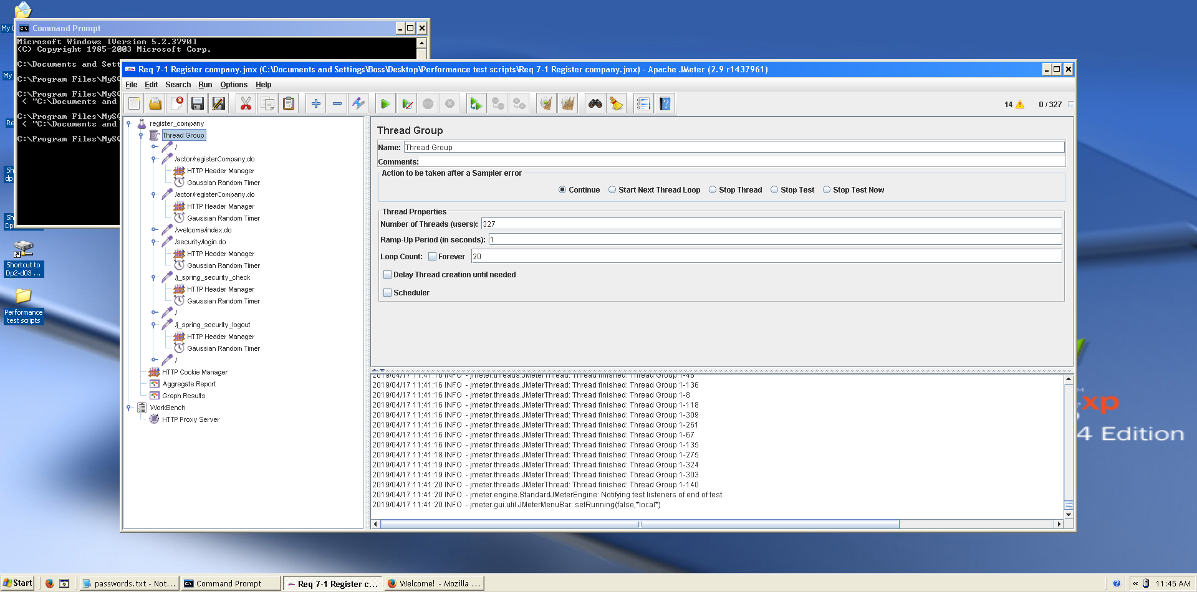

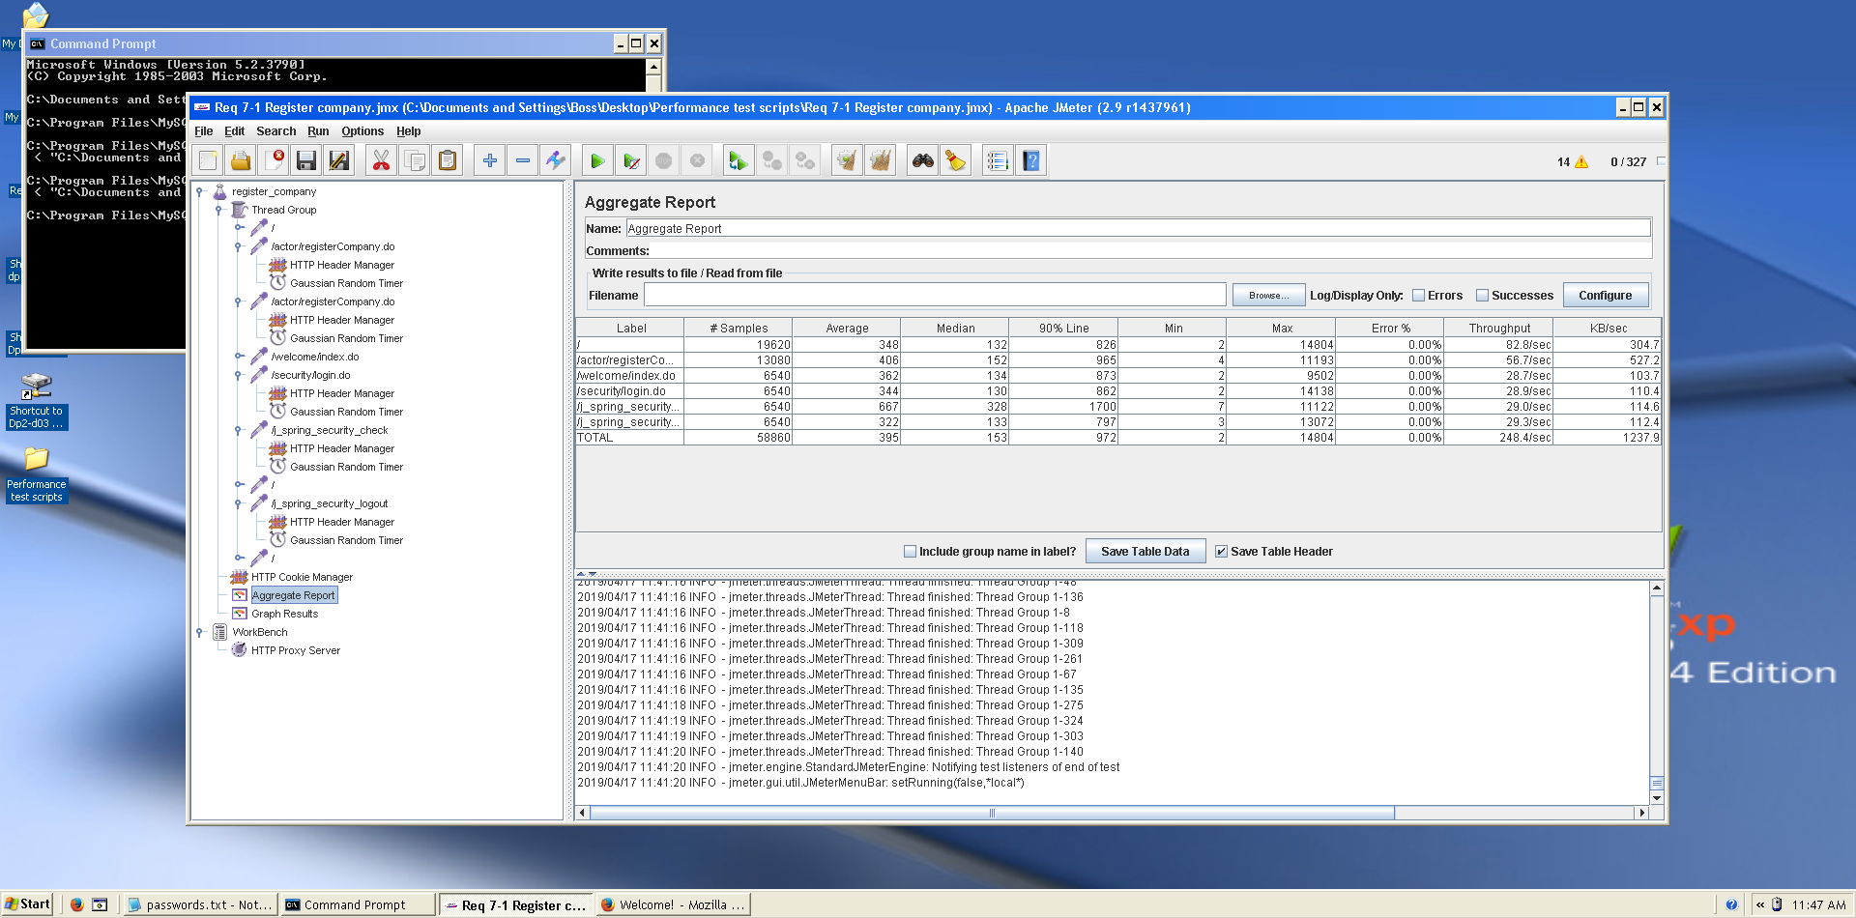This is the maximum workload of the test case without any crash or excesive delay. As we can see in the picture below, we don’t have any errors and the average time per request is pretty acceptable.

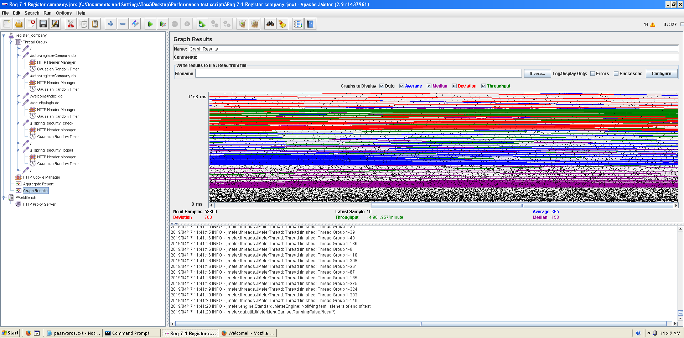

**Overload test case:** 335 concurrent users and 20 of loop count:

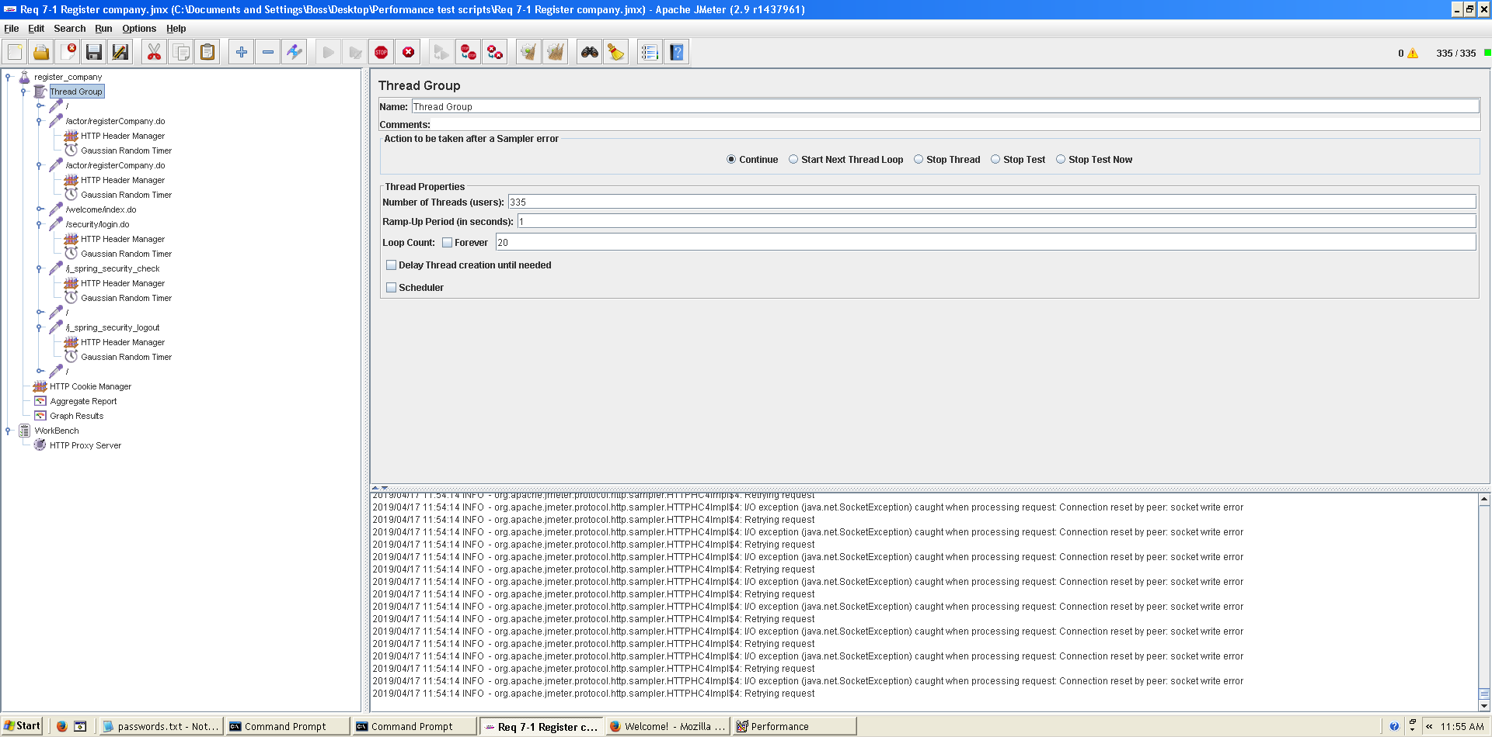

Even though the average time per request is still acceptable, it begins to produce some errors as we can see in the following picture. The errors are always the same: I/O exception (java.net.BindException) caught when connecting to the target host:

Address already in use: connect This exception is not related with the implementation of our application, but with tomcat. The system can’t handle this number of concurrent users properly.

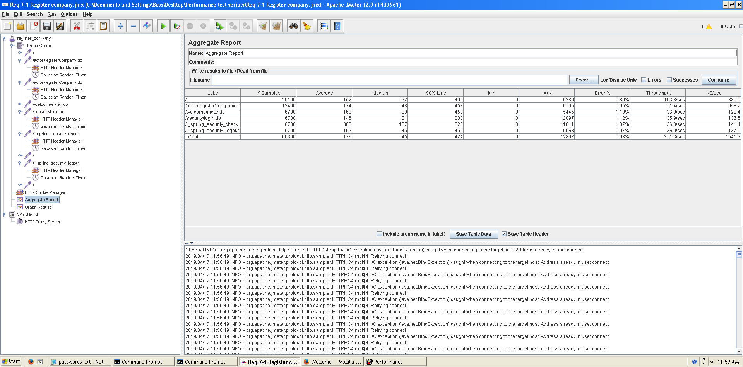

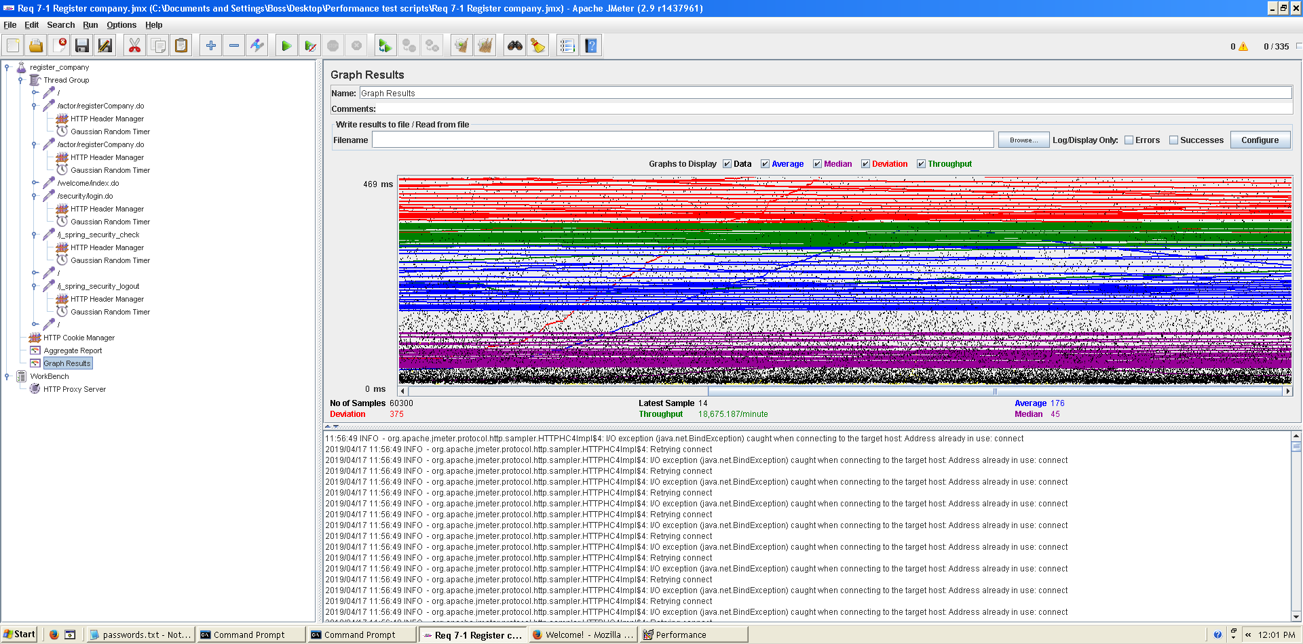

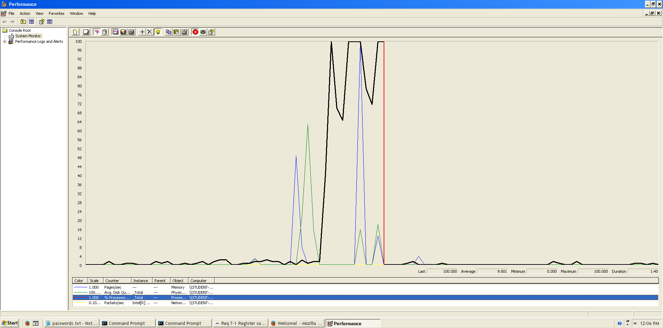As we can see in the graph below, there is a bottleneck with the CPU. Probably we could improve the maximum workload of the application if we assign more processors to the virtual machine.

**Conclusion:** The maximum number of concurrent users supported by this test case is 327 and we could improve it by assigning more CPU’s resources to our system.

**Req. 7.1** – An actor who is not authenticated must be able to: Register to the system as a hacker.

Technical details of the computer on which the test has been executed:

* Ram: 8,00 GB
* CPU: Intel Core i7-7700HQ
* Hard disk: 256 GB SSD + 921 GB HDD
* Network card: Intel(R) Dual Band Wireless-AC 3168

**Test case description**:

* The user goes to register hacker view.
* The user completes register hacker form.
* The user log in the system and then, log out.

**Maximum workload test case.** 340 concurrent users and 20 of loop count:

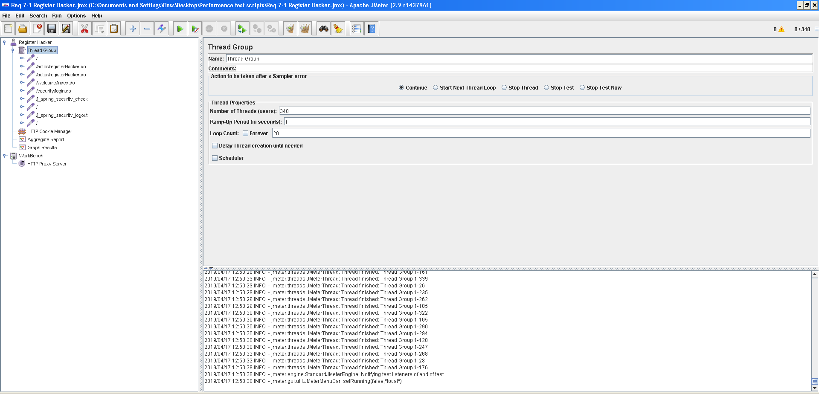

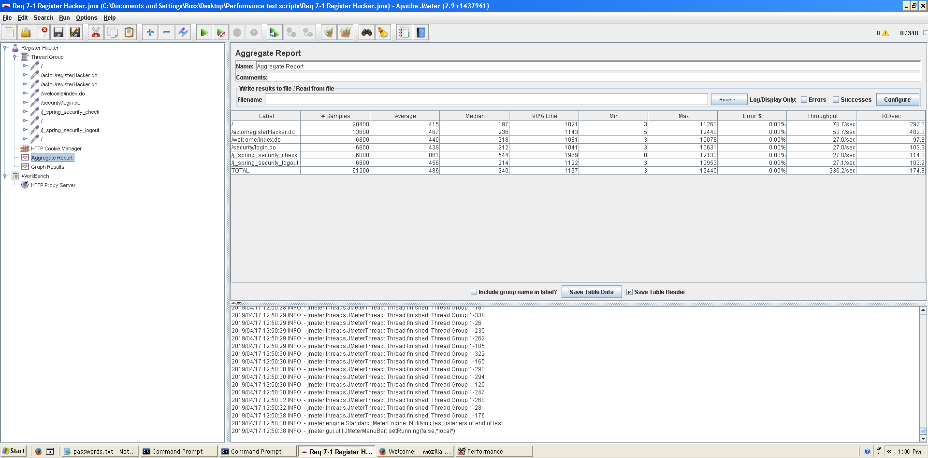This is the maximum workload of the test case without any crash or excesive delay. As we can see in the picture below, we don’t have any errors and the average time per request is pretty acceptable.

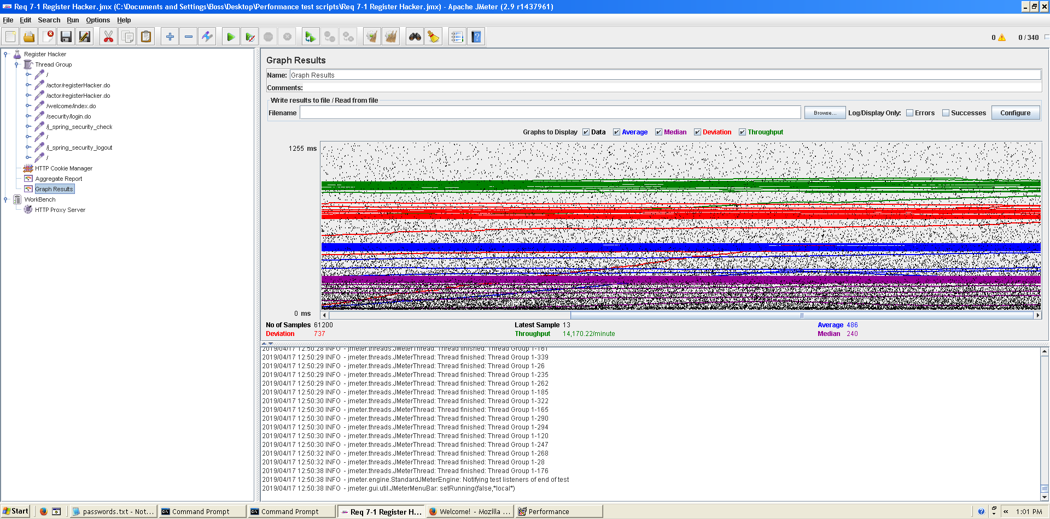

**Overload test case:** 350 concurrent users and 20 of loop count:

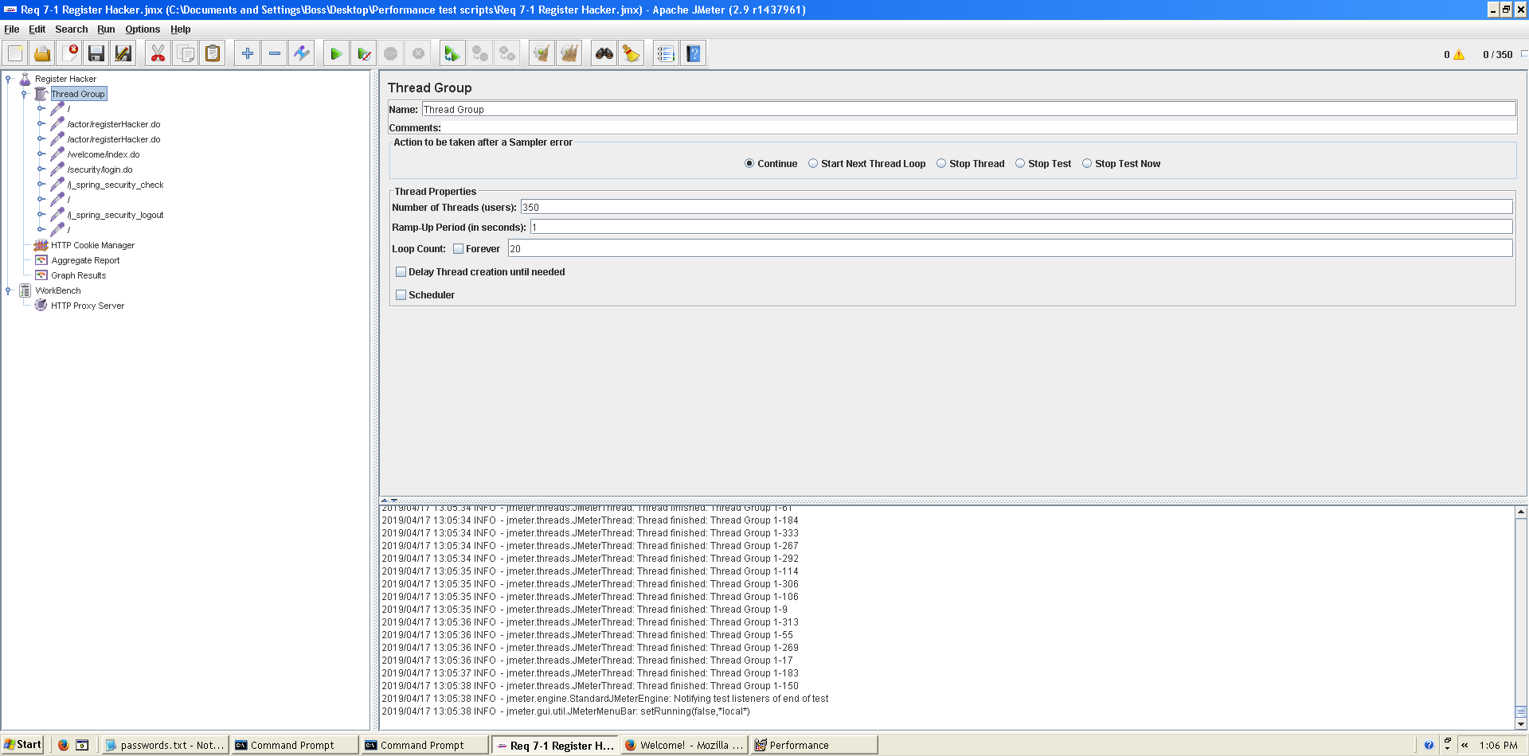

Even though the average time per request is still acceptable, it begins to produce some errors as we can see in the following picture. The errors are always the same: I/O exception (java.net.BindException) caught when connecting to the target host:

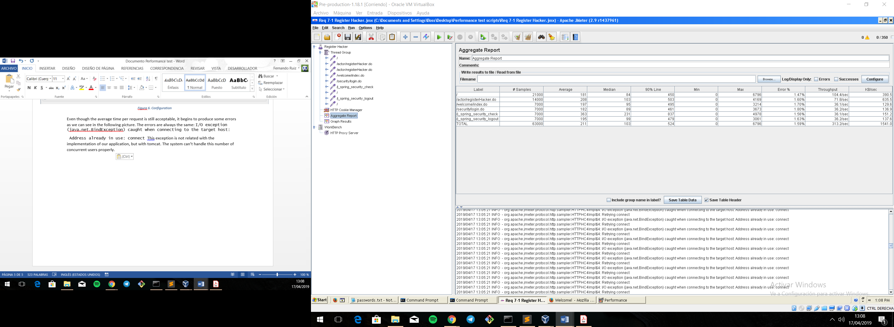 Address already in use: connect This exception is not related with the implementation of our application, but with tomcat. The system can’t handle this number of concurrent users properly.

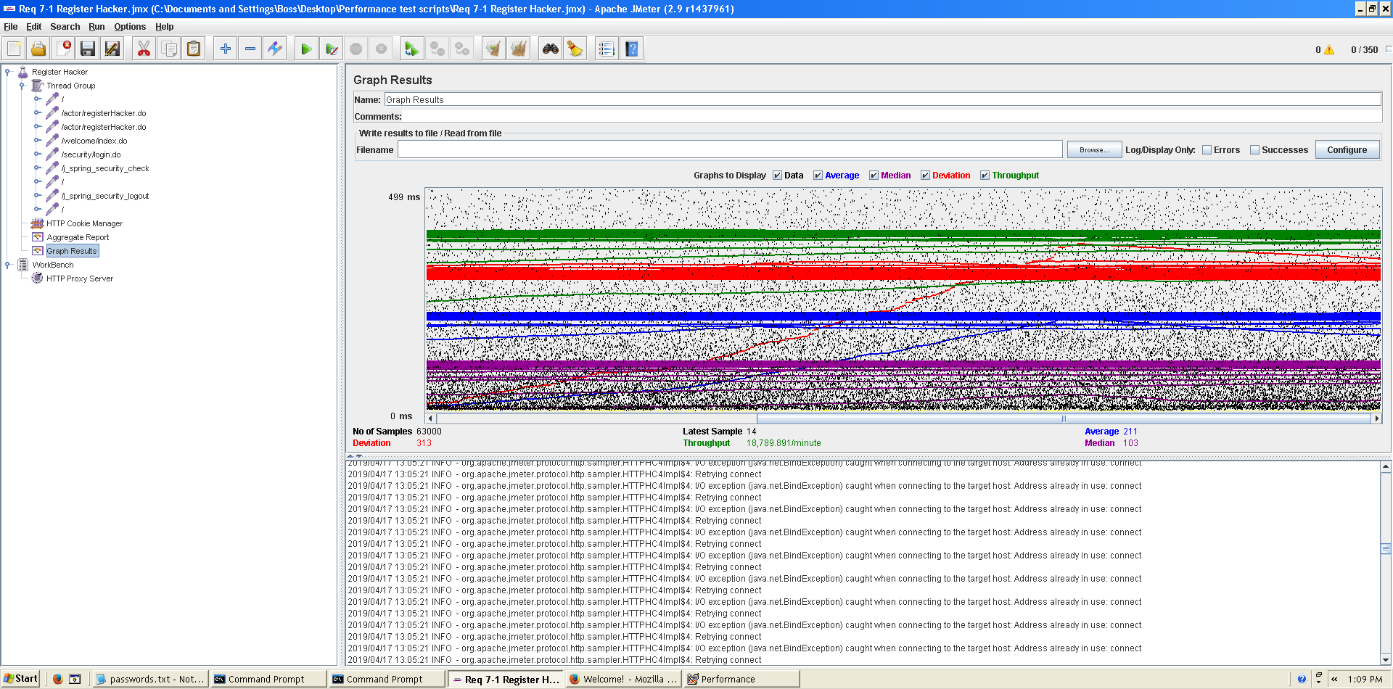  
  
As we can see in the graph below, there is a bottleneck with the CPU. We could improve CPU’s resources because, as we can see it almost works at 100%.

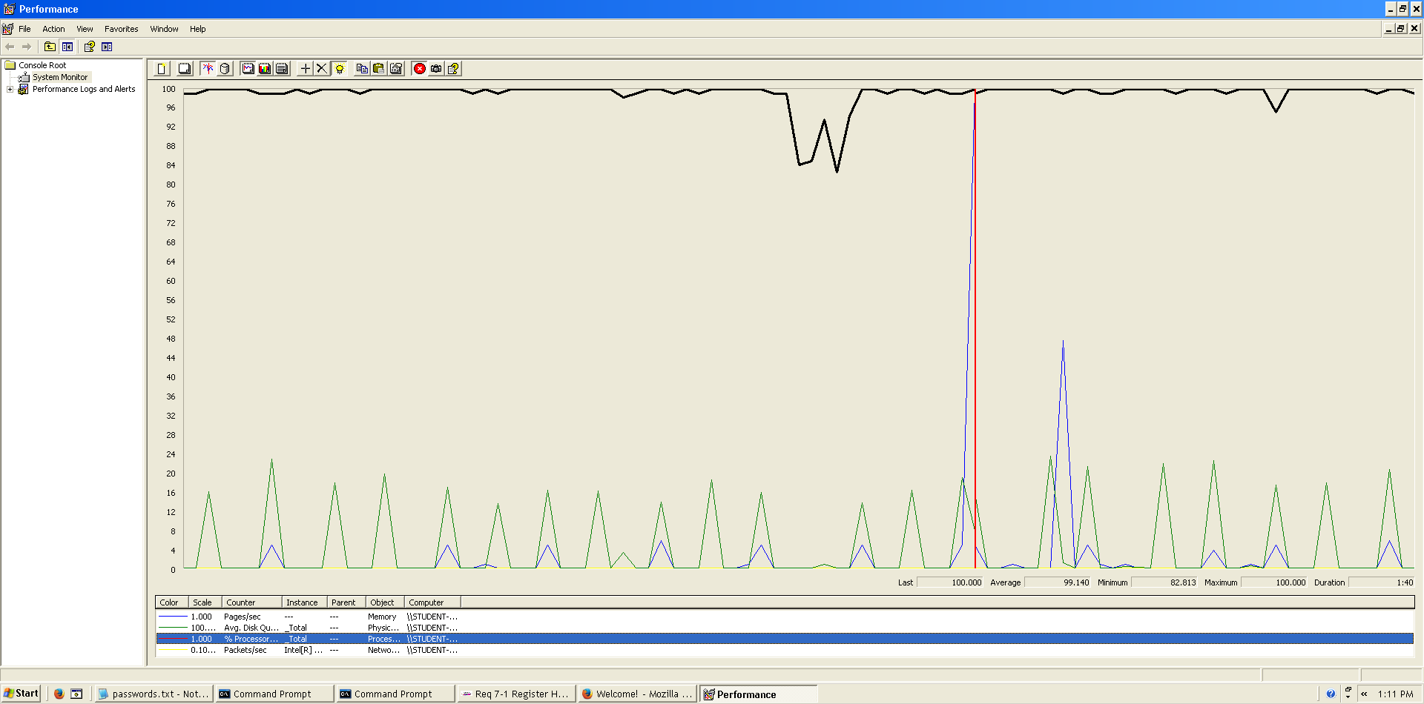

**Conclusion:** The maximum number of concurrent users supported by this test case is 340 and we could improve it by assigning more CPU’s resources to our system.

**Req. 7.1** – An actor who is not authenticated must be able to listing available positions.

Technical details of the computer on which the test has been executed:

* Ram: 8 GB
* CPU: Intel core i7-8550U 1,8GHz
* Hard disk: 1TB
* Network card: Intel(R) Dual Band Wireless-AC 3165

**Test case description**:

* The user goes to available list in the menu.
* The user display the position.
* Return to homepage.

**Maximum workload test case.**  200 concurrent users and 20 of loop count:

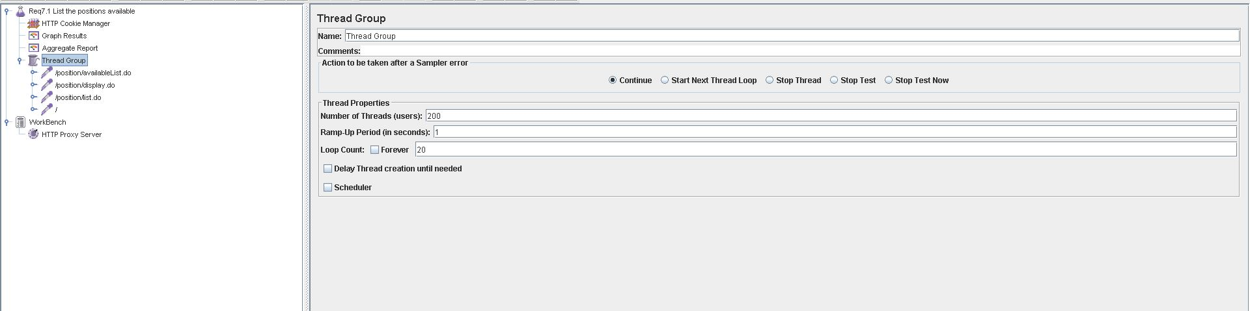

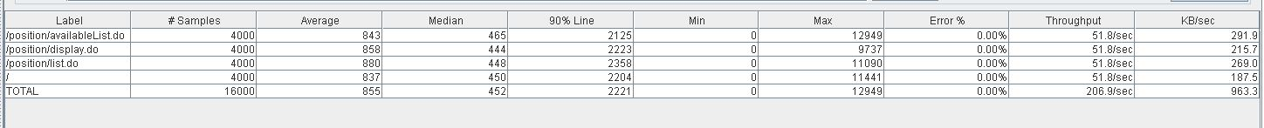

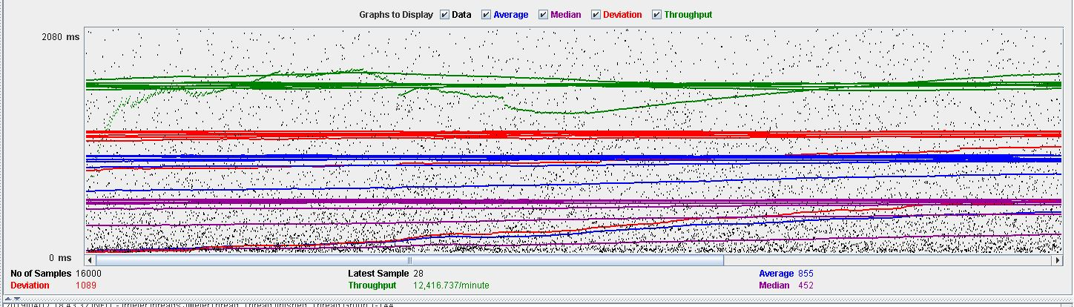

**Overload test case:**215 concurrent users and 20 of loop count:

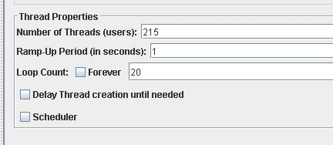

As we can see in the report if we increase the number of threads the 90% line gets a value too high.



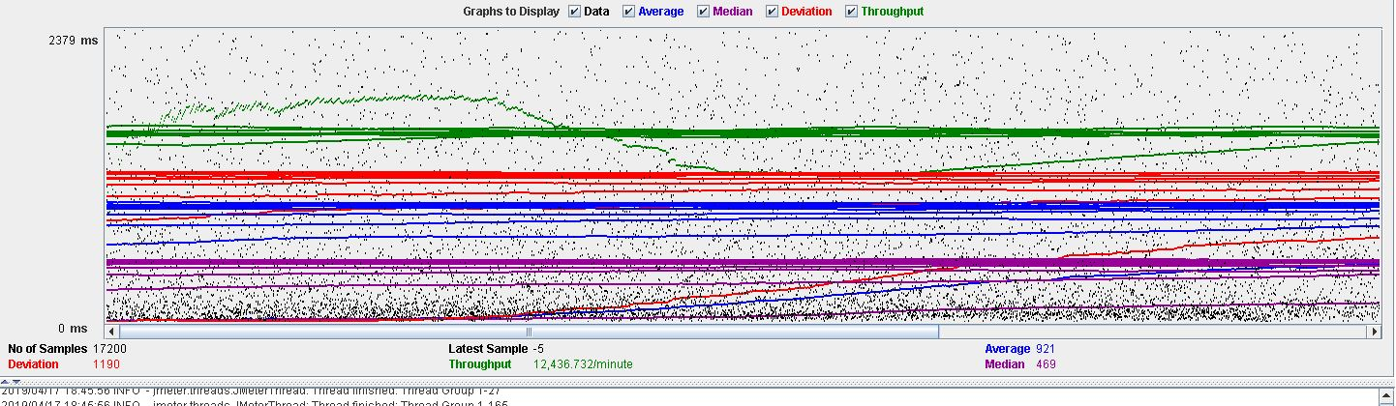

As we can see in the graph below, there is a bottleneck with the CPU. Probably we could improve the maximum workload of the application if we assign more processors to the virtual machine.

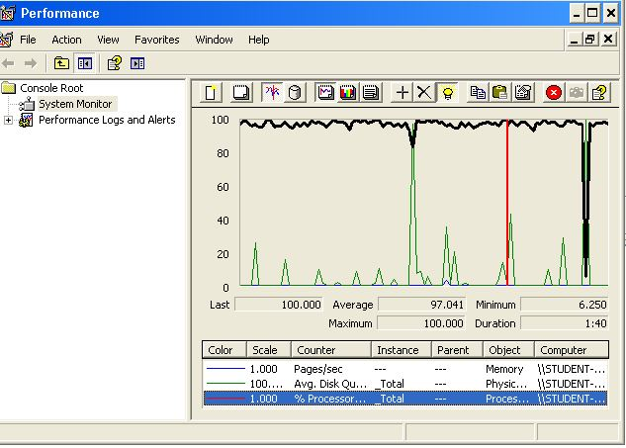

**Conclusion:** The maximum number of concurrent users supported by this test case is 200 and we could improve it by assigning more CPU’s resources to our system.

**Req. 7.3** – An actor who is not authenticated must be able to: List the companies available and navigate to the corresponding positions.

Technical details of the computer on which the test has been executed:

* Ram: 8,00 GB
* CPU: Intel Core i7-7700HQ
* Hard disk: 256 GB SSD + 921 GB HDD
* Network card: Intel(R) Dual Band Wireless-AC 3168

**Test case description**:

* The user goes to company list view.
* The user display a company from the list.
* The user display de positions of the company.

**Maximum workload test case.** 485 concurrent users and 20 of loop count:

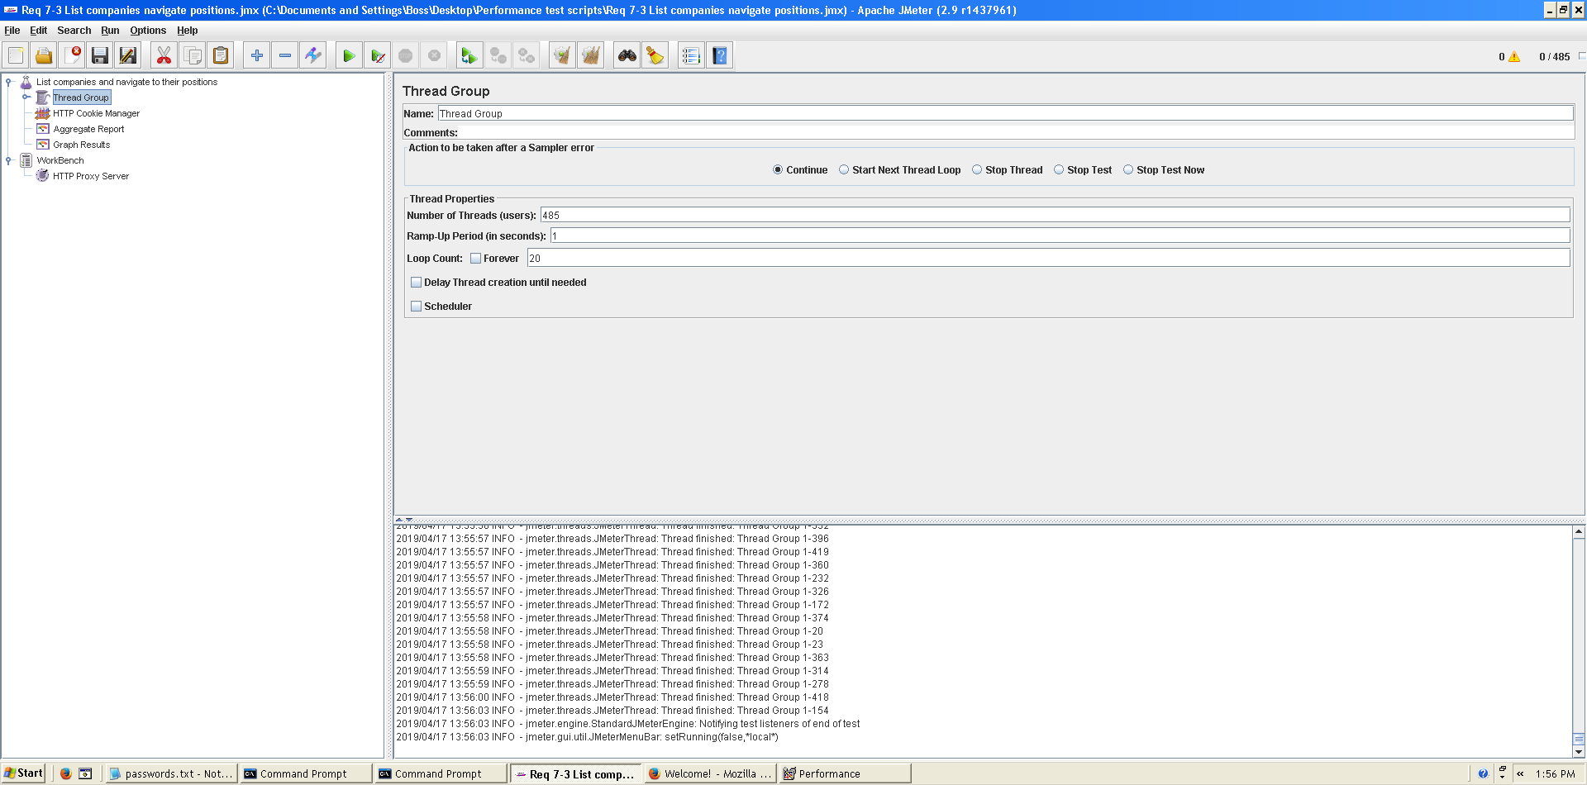

This is the maximum workload of the test case without any crash or excesive delay. As we can see in the picture below, we don’t have any errors and the average time per request is pretty acceptable.

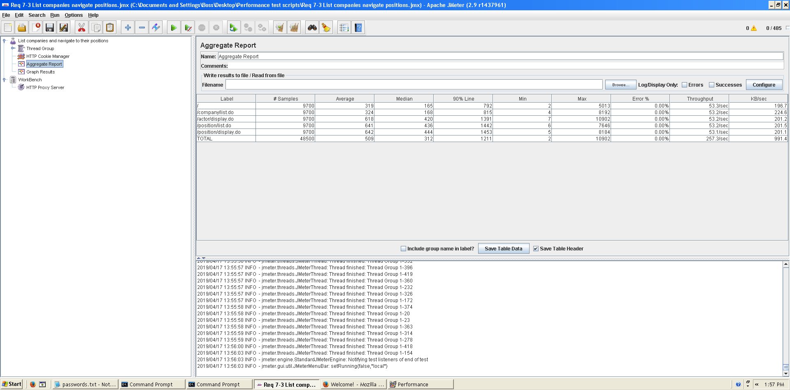

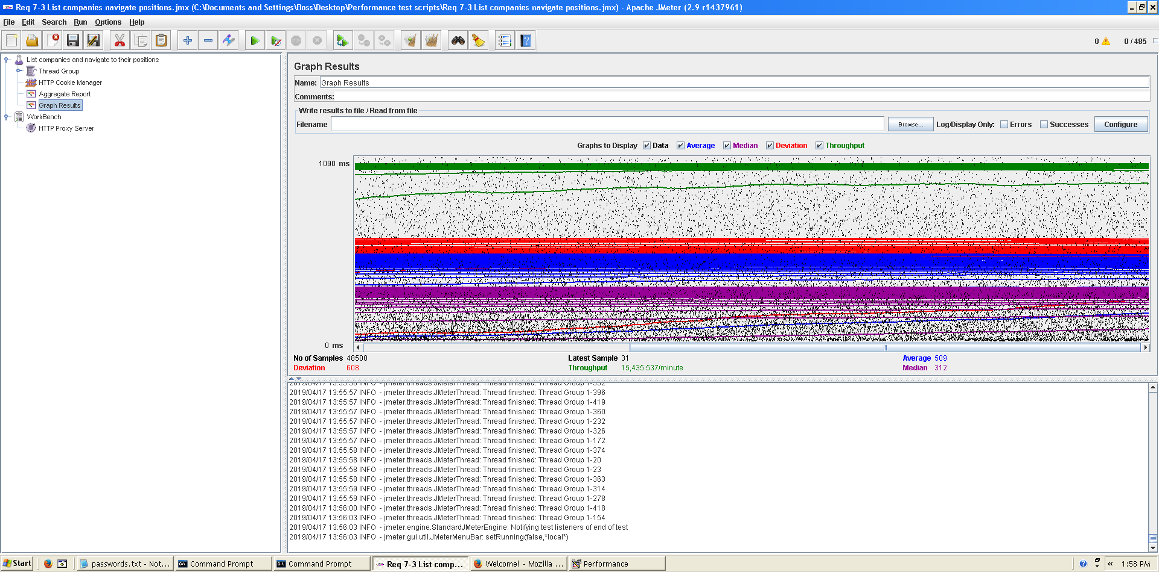

**Overload test case:** 495 concurrent users and 20 of loop count:

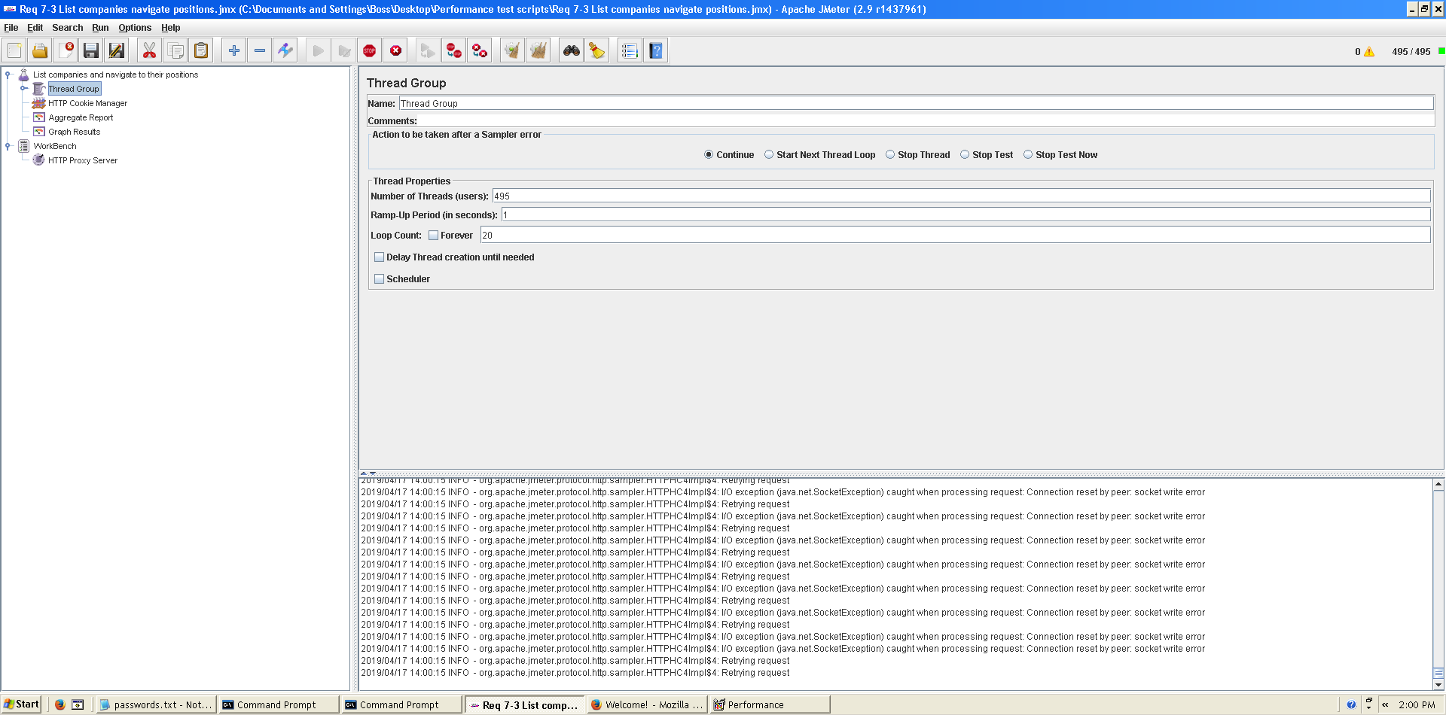

Even though the average time per request is still acceptable, it begins to produce some errors as we can see in the following picture. The errors are always the same: I/O exception (java.net.SocketException) caught when processing request: Connection reset by peer: socket write error This exception is not related with the implementation of our application, but with tomcat. The system can’t handle this number of concurrent users properly.

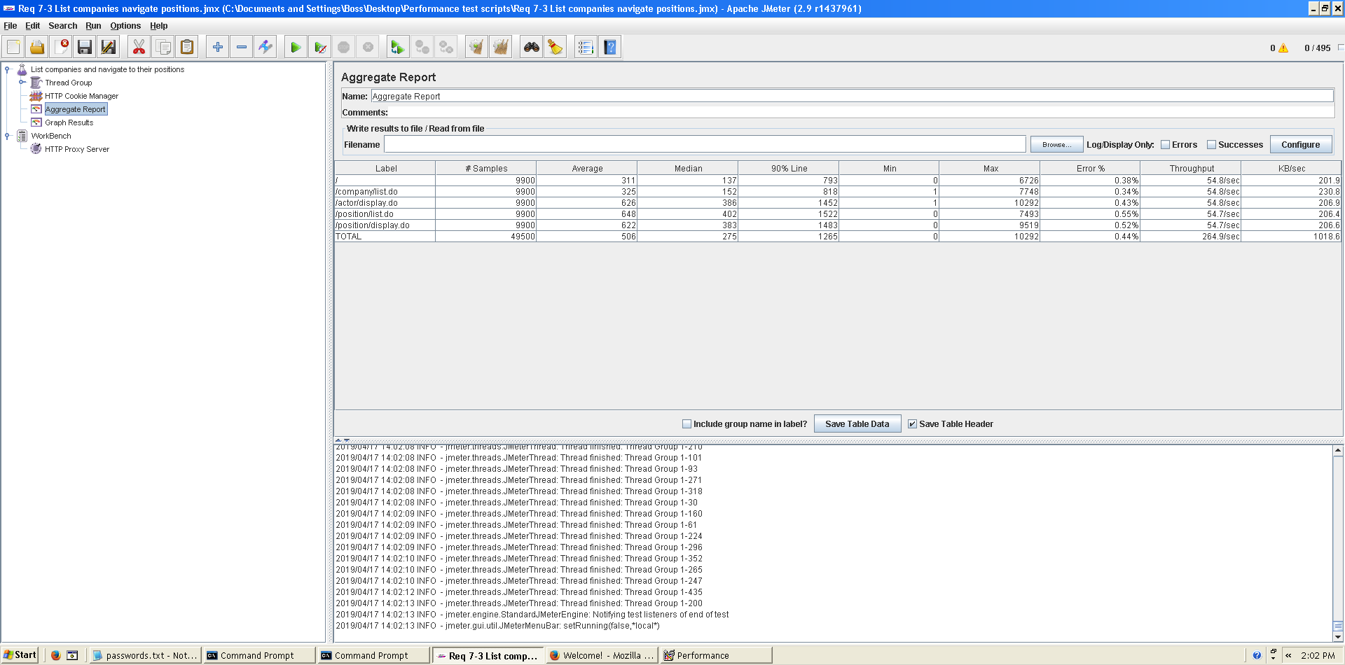

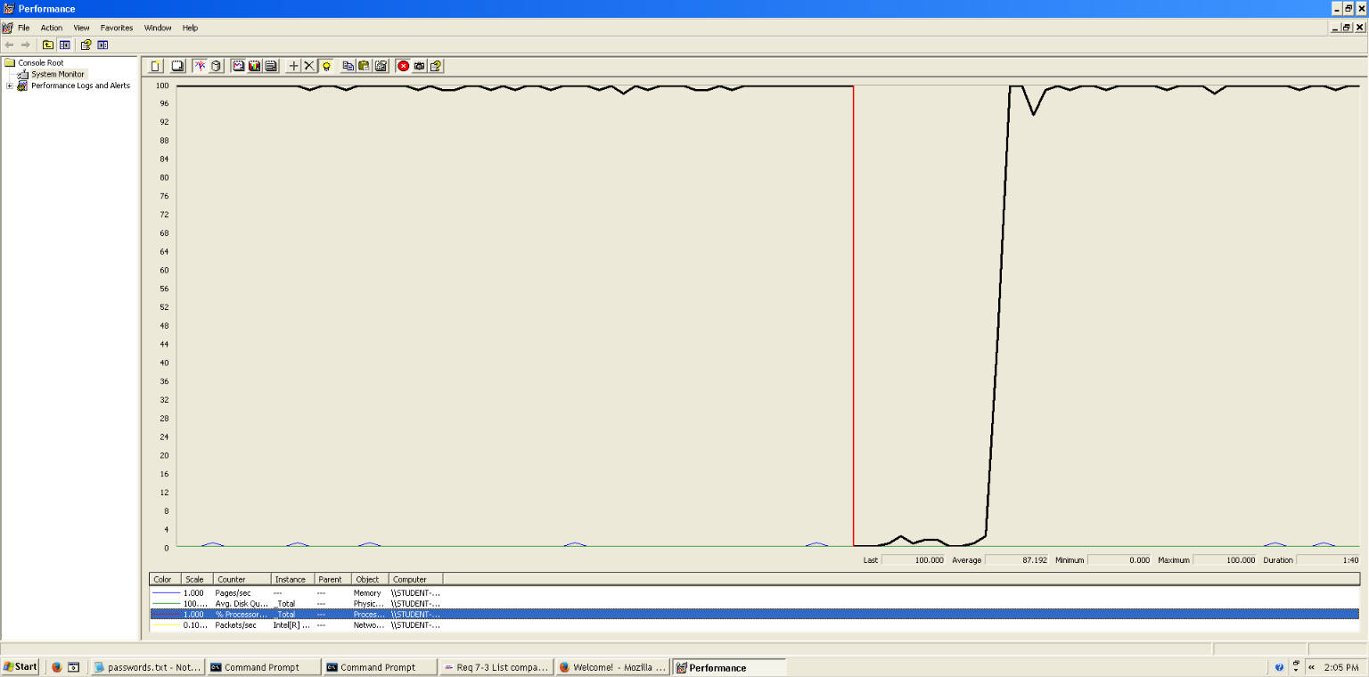As we can see in the graph below, there is a bottleneck with the CPU. Probably we could improve the maximum workload of the application if we assign more processors to the virtual machine but not improve it so much because we can see it doesn’t work at 100% always.  
  
  
  
  
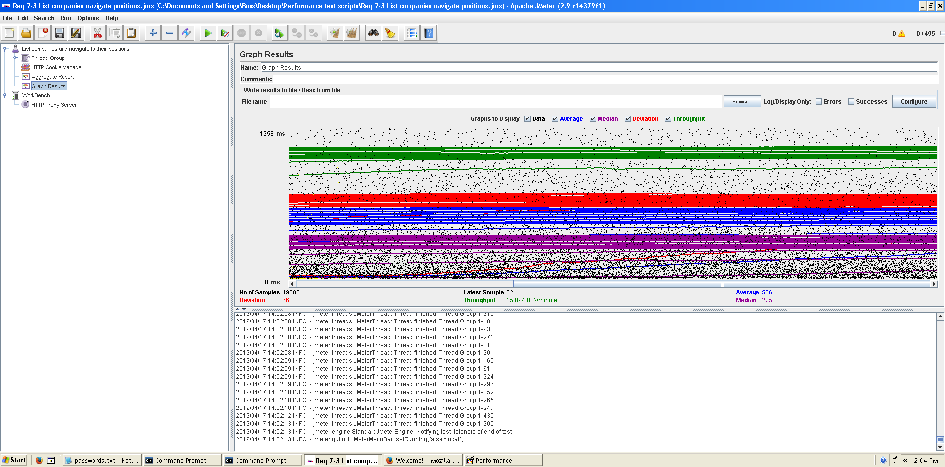 **Conclusion:** The maximum number of concurrent users supported by this test case is 485 and we could improve it by assigning more CPU’s resources to our system.

**Req. 7.4** – An actor who is not authenticated must be able to search for a position using a single key word that must be contained in its title, its description, its profile, its skills its technologies or the name of the corresponding company.

Technical details of the computer on which the test has been executed:

* Ram: 8,192 (1x) MB, DDR3L RAM (1,600 MHz)
* CPU: Intel Core i7-5500U
* Hard disk: 1 TB HDD - 5,400 rpm
* Interface network: Gigabit Ethernet LAN - 10BASE-T/100BASE-TX/1000BASE-T

**Test case description**:

* The user goes to search view.
* Searches for positions using the key word ‘r’.

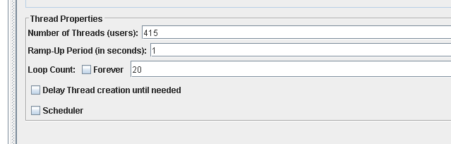**Maximum workload test case.** 415 concurrent users and 20 of loop count:

This is the maximum workload of the test case without any crash or excessive delay. As we can see in the picture below, we don’t have any errors and the average time per request is pretty acceptable.



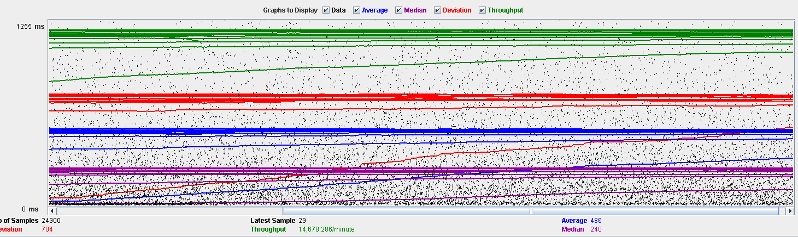

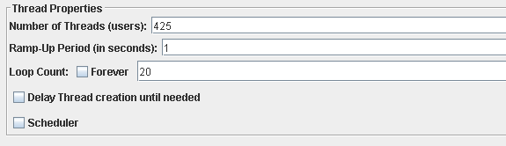 **Overload test case:** 425 concurrent users and 20 of loop count:

Even though the average time per request is still acceptable, it begins to produce some errors as we can see in the following picture. The errors are always the same: I/O exception (java.net.SocketException) caught when processing request: Connection reset by peer: socket write error

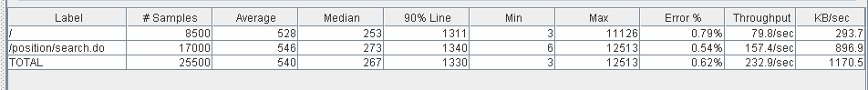This exception is not related with the implementation of our application, but with tomcat. The system can’t handle this number of concurrent users properly.

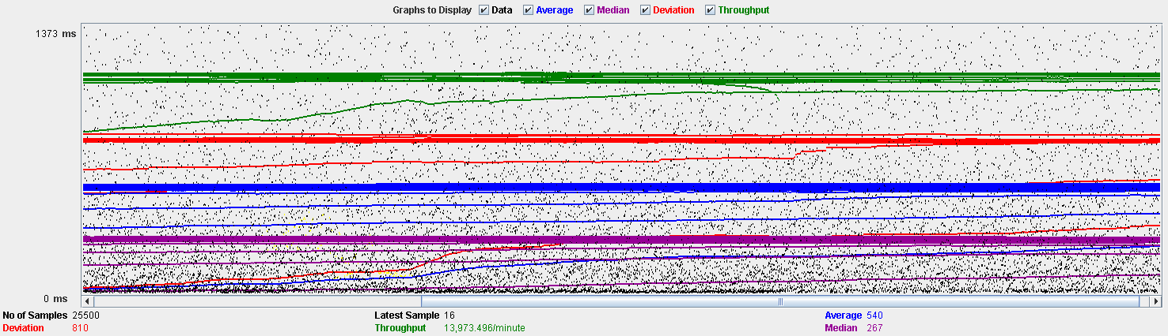

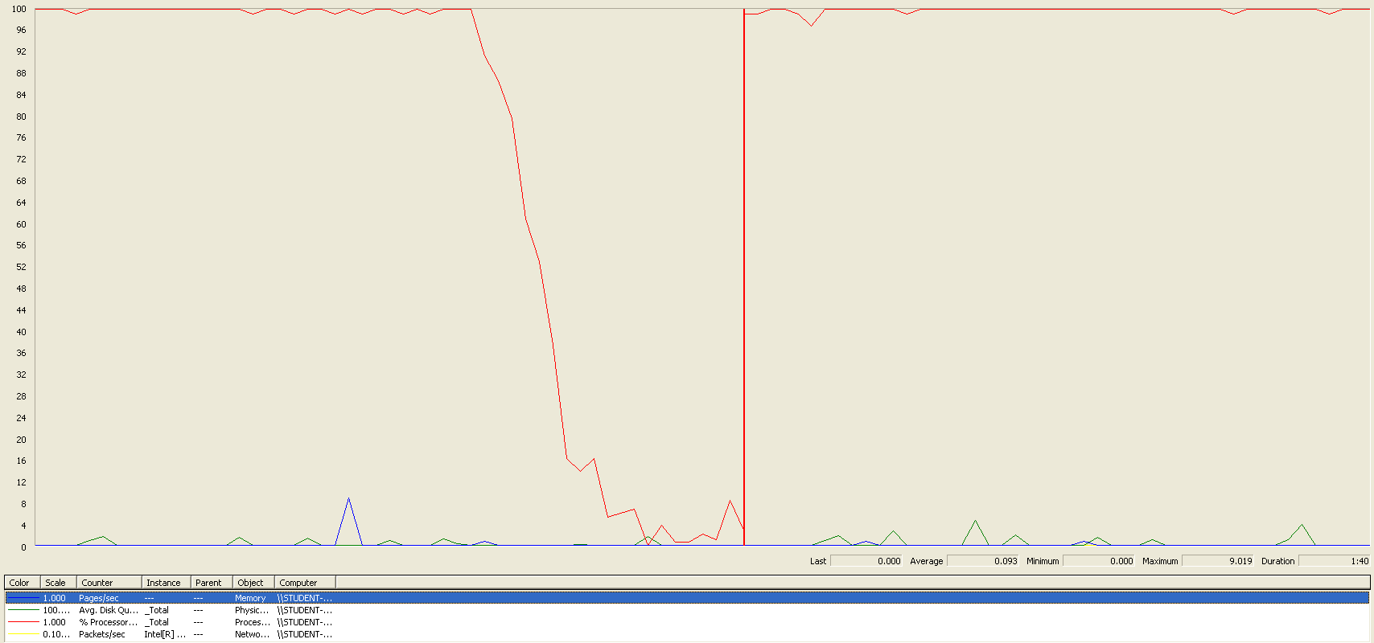As we can see in the graph below, there is a bottleneck with the CPU. Probably we could improve the maximum workload of the application if we assign more processors to the virtual machine.

**Conclusion:** The maximum number of concurrent users supported by this test case is 425 and we could improve it by assigning more CPU’s resources to our system.

**Req. 8.2** – An actor who is authenticated must be able to: Edit his or her personal data (administrator).

Technical details of the computer on which the test has been executed:

* Ram: 8,00 GB
* CPU: Intel Core i7-7700HQ
* Hard disk: 256 GB SSD + 921 GB HDD
* Network card: Intel(R) Dual Band Wireless-AC 3168

**Test case description**:

* The user log in the system.
* The user goes to his/her profile.
* The user goes to personal edit form.
* Change any field.
* Press save button save changes.
* Log out the system.

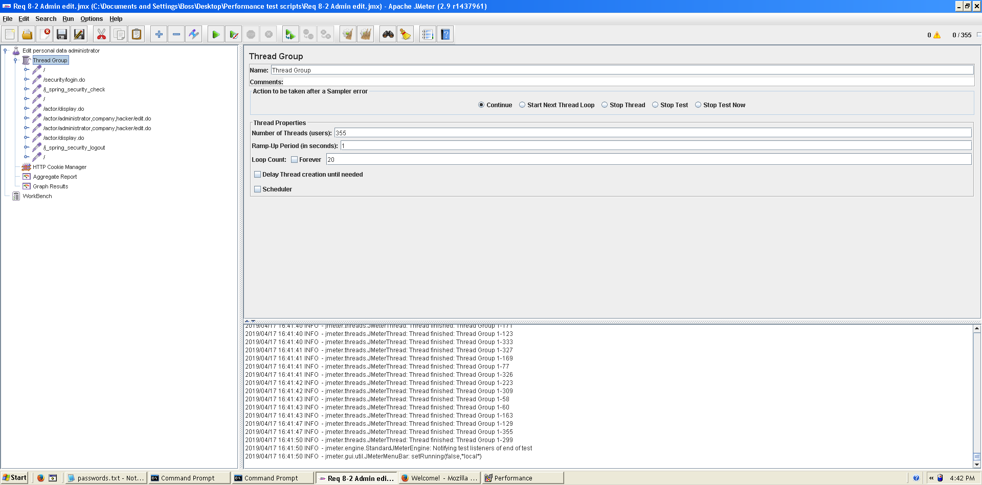**Maximum workload test case.** 355 concurrent users and 20 of loop count:

This is the maximum workload of the test case without any crash or excesive delay. As we can see in the picture below, we don’t have any errors and the average time per request is pretty acceptable.

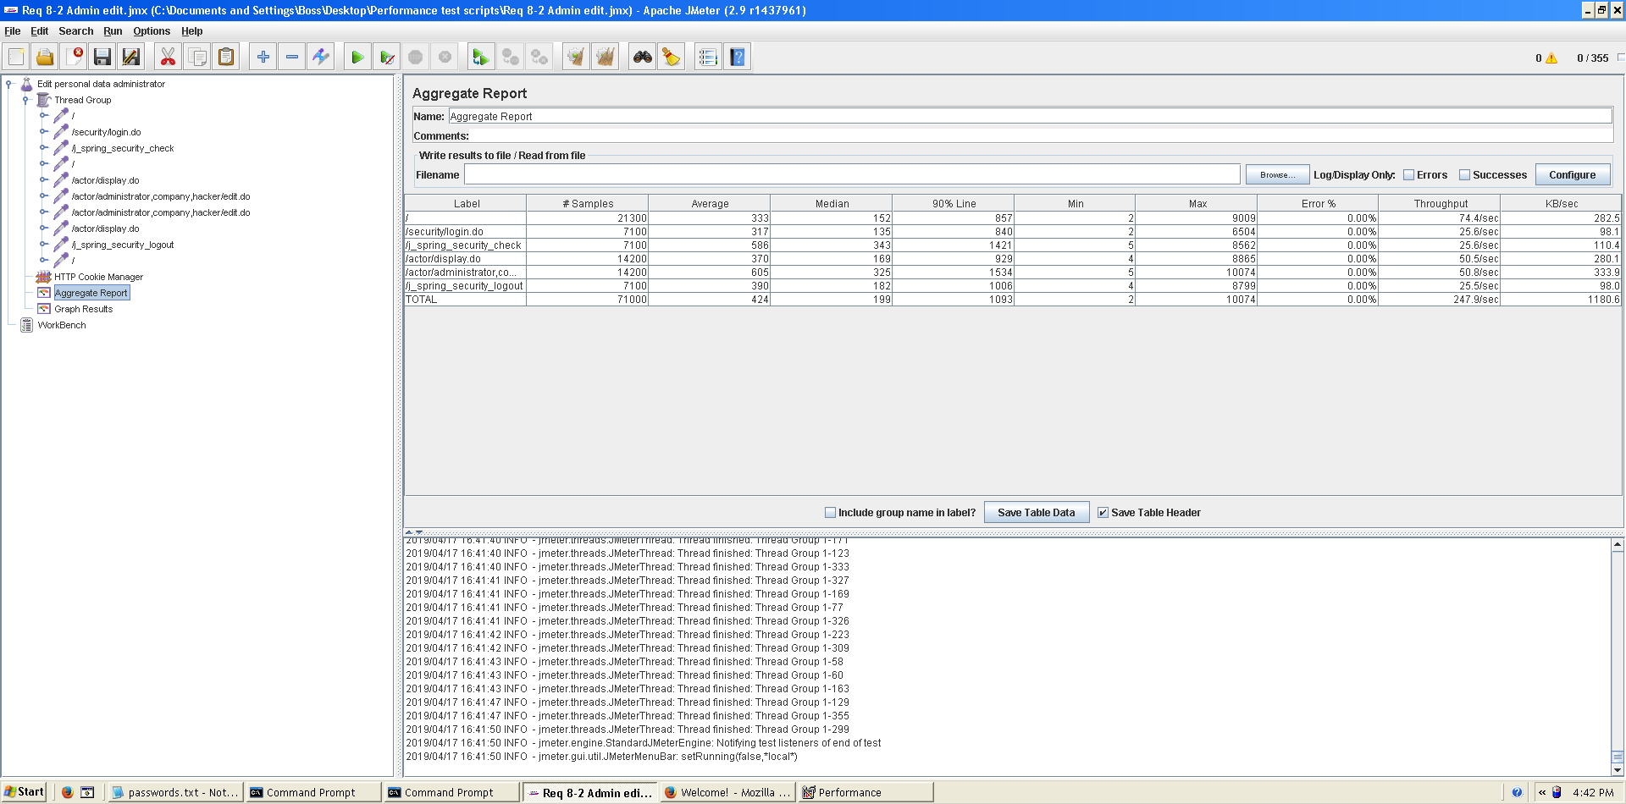

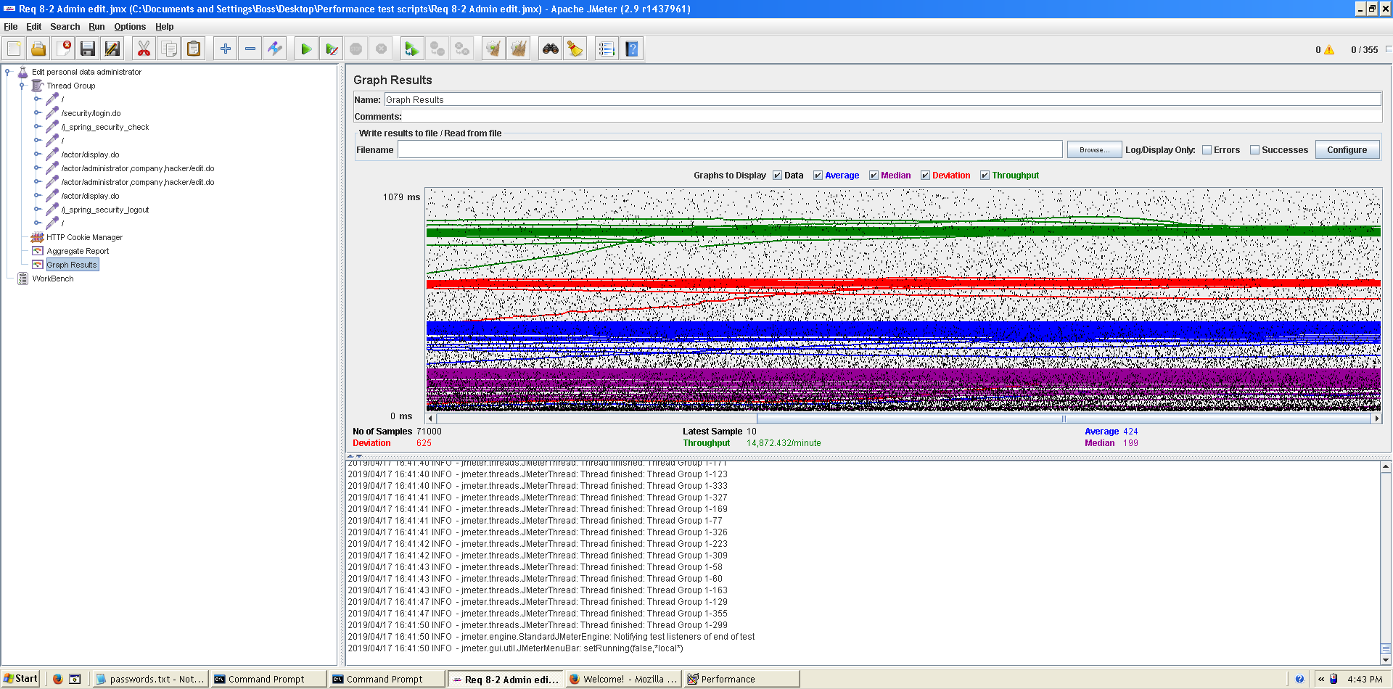

**Overload test case:** 365 concurrent users and 20 of loop count:

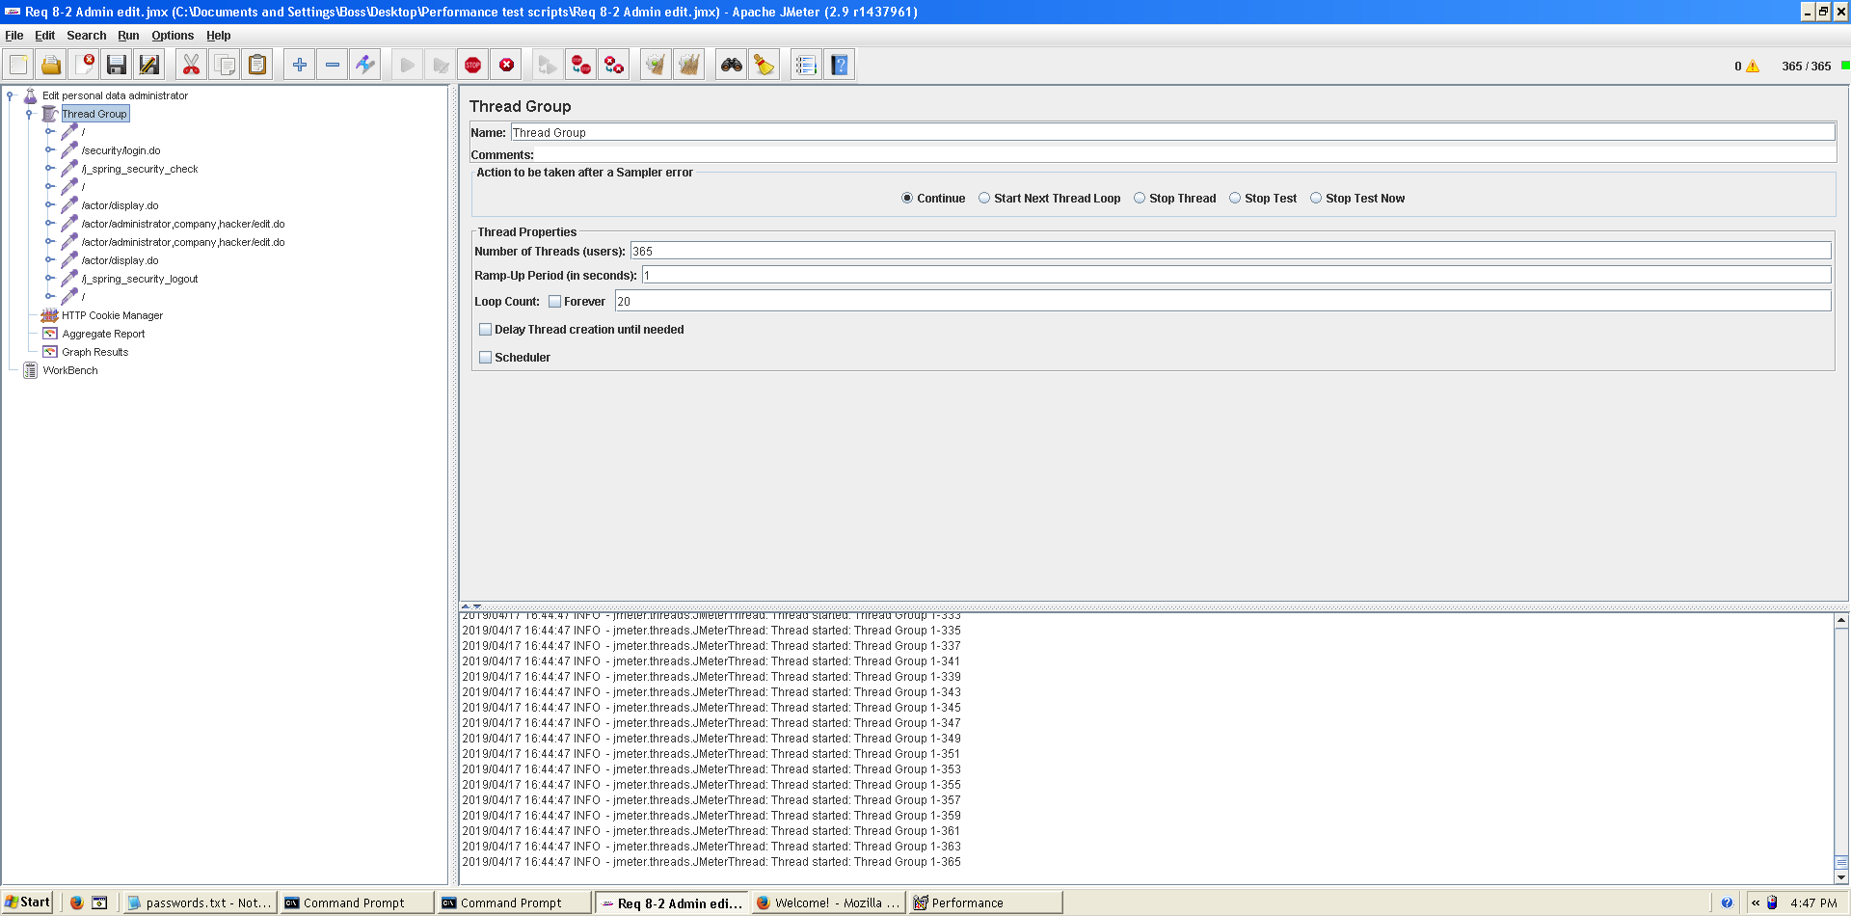

Even though the average time per request is still acceptable, it begins to produce some errors as we can see in the following picture. The errors are always the same: I/O exception (java.net.SocketException) caught when processing request: Connection reset by peer: socket write error This exception is not related with the implementation of our application, but with tomcat. The system can’t handle this number of concurrent users properly.

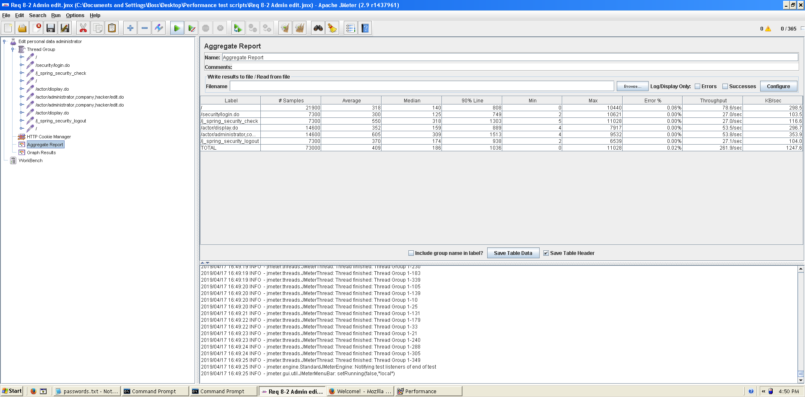

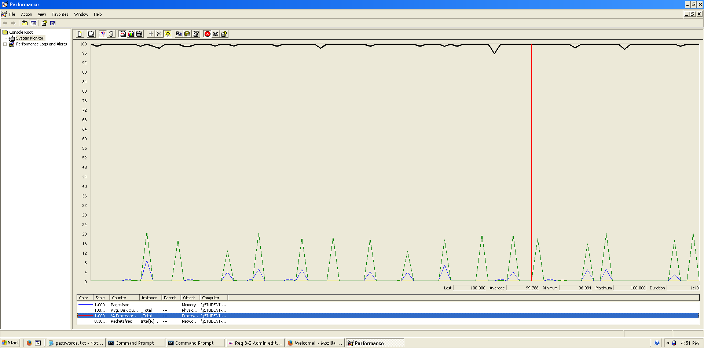As we can see in the aggregate report, there’s not so many errors, the maximum was 0.06% in the welcome view. In the graph below, there is a bottleneck with the CPU. Probably we could improve the maximum workload of the application if we assign more processors to the virtual machine.  
  
  
  
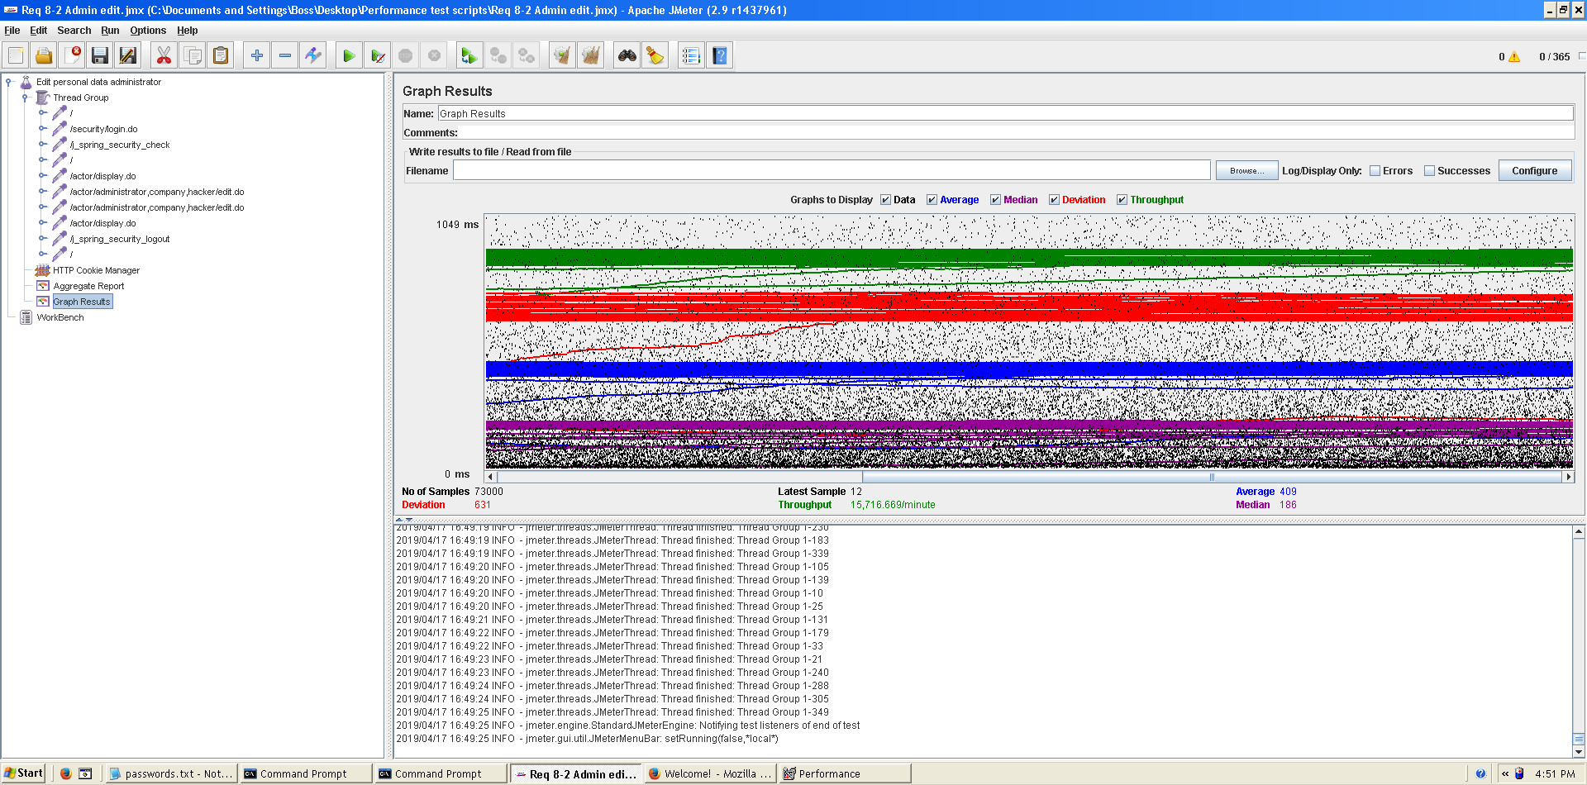**Conclusion:** The maximum number of concurrent users supported by this test case is 355 and we could improve it by assigning more CPU’s resources to our system.

**Req. 8.2** – An actor who is authenticated must be able to: Edit his or her personal data (company).

Technical details of the computer on which the test has been executed:

* Ram: 8,00 GB
* CPU: Intel Core i7-7700HQ
* Hard disk: 256 GB SSD + 921 GB HDD
* Network card: Intel(R) Dual Band Wireless-AC 3168

**Test case description**:

* The user log in the system.
* The user goes to his/her profile.
* The user goes to personal edit form.
* Change any field.
* Press save button save changes.
* Log out the system.

**Maximum workload test case.** 370 concurrent users and 20 of loop count:

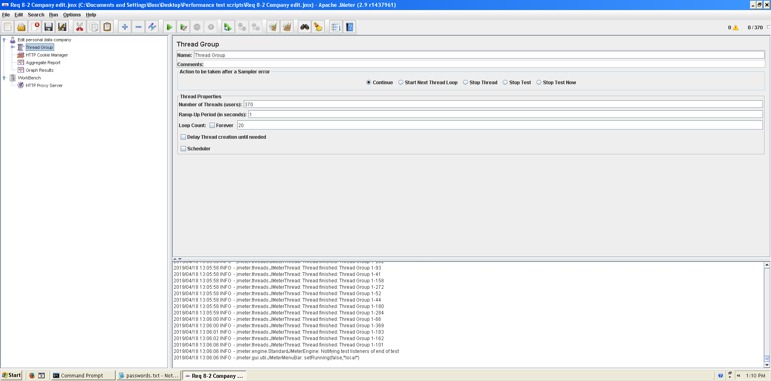

This is the maximum workload of the test case without any crash or excesive delay. As we can see in the picture below, we don’t have any errors and the average time per request is pretty acceptable.

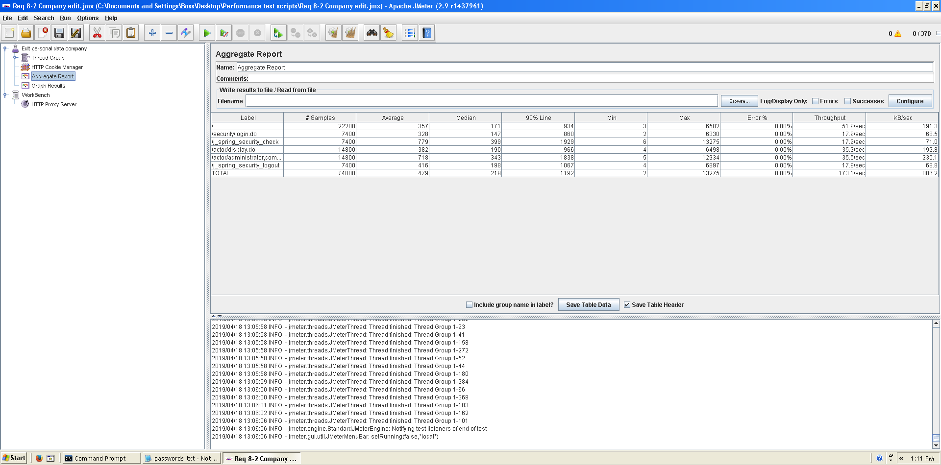

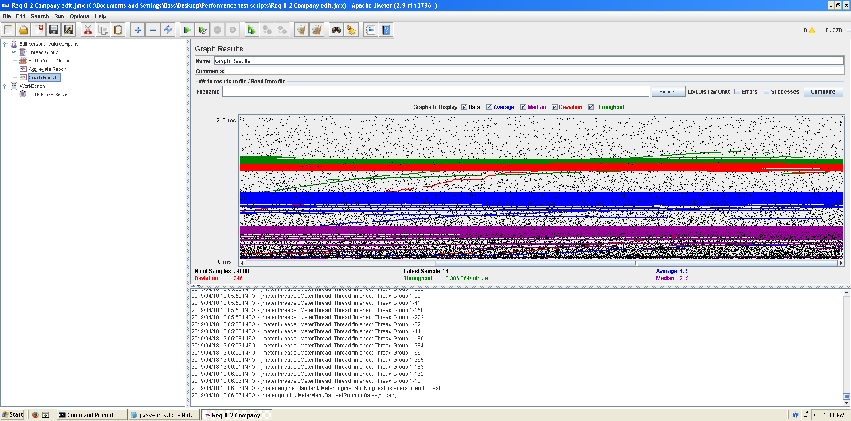

**Overload test case:** 380 concurrent users and 20 of loop count:

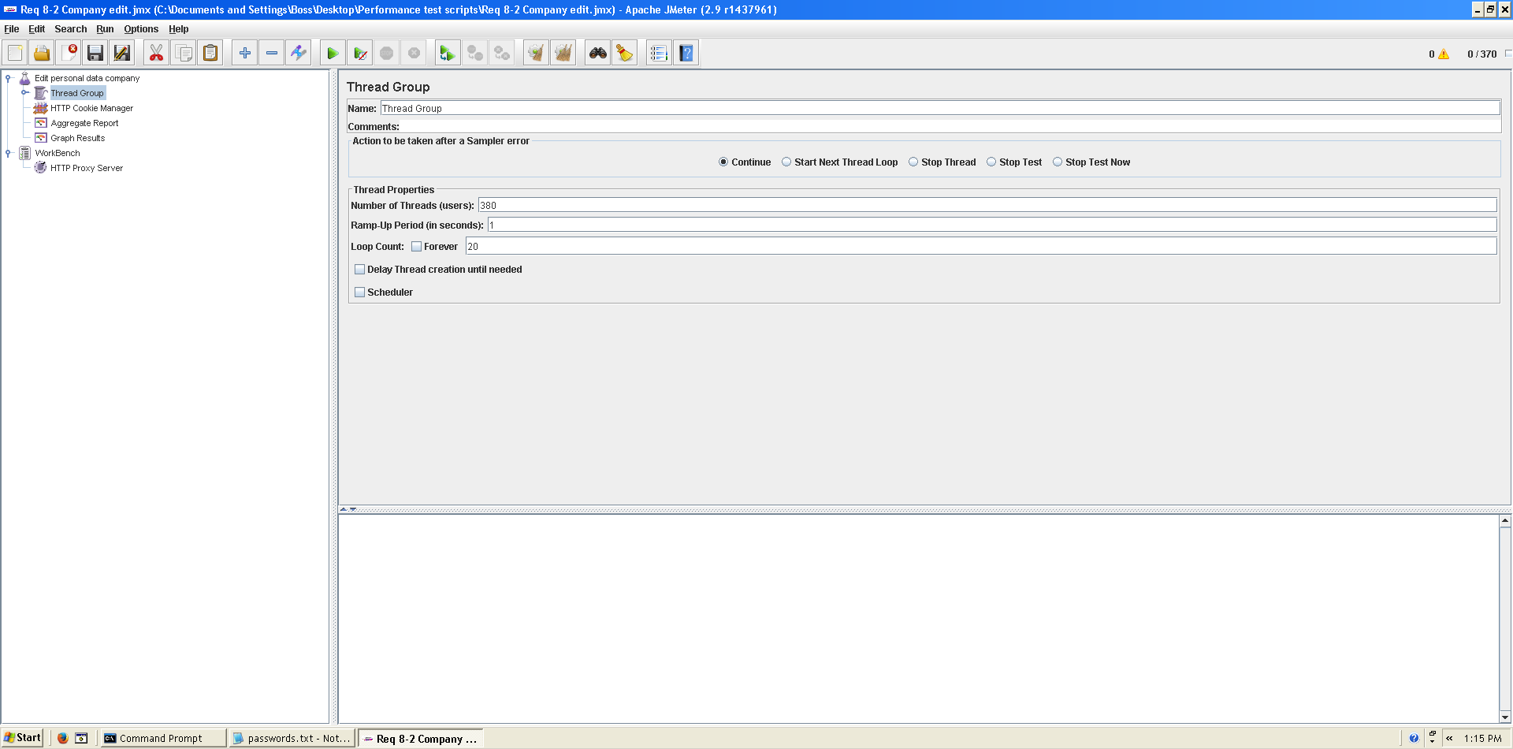

It begins to produce some errors as we can see in the following picture. The errors are always the same: I/O exception (java.net.SocketException) caught when processing request: Connection reset by peer: socket write error This exception is not related with the implementation of our application, but with tomcat. The system can’t handle this number of concurrent users properly.

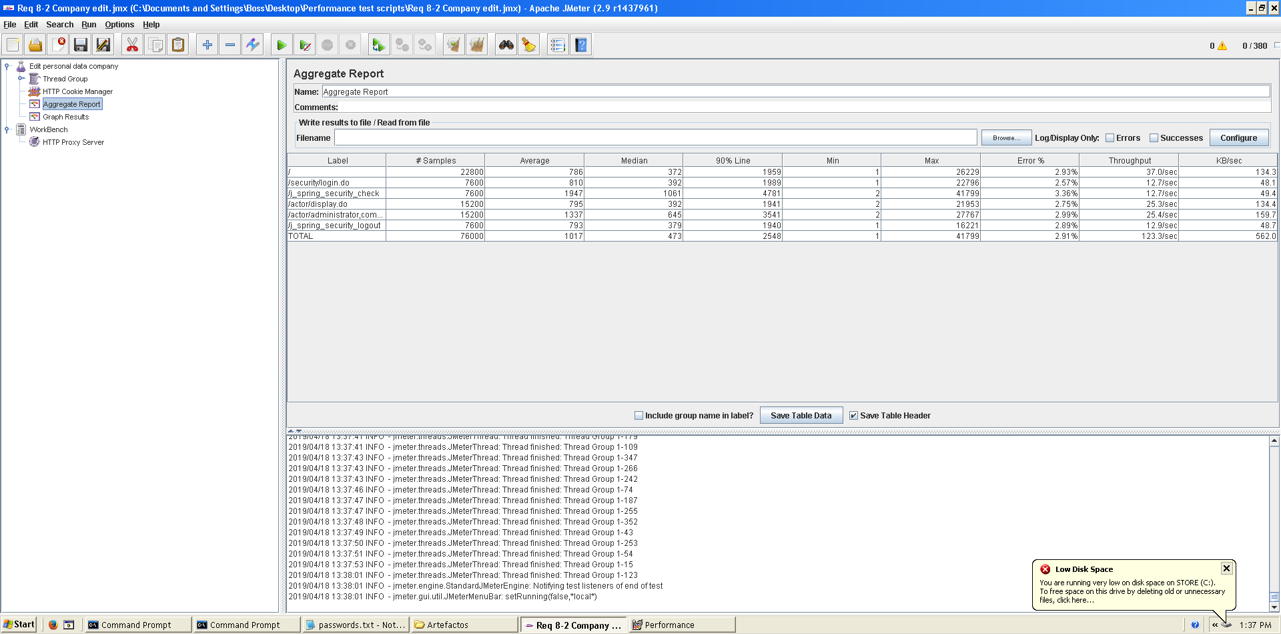

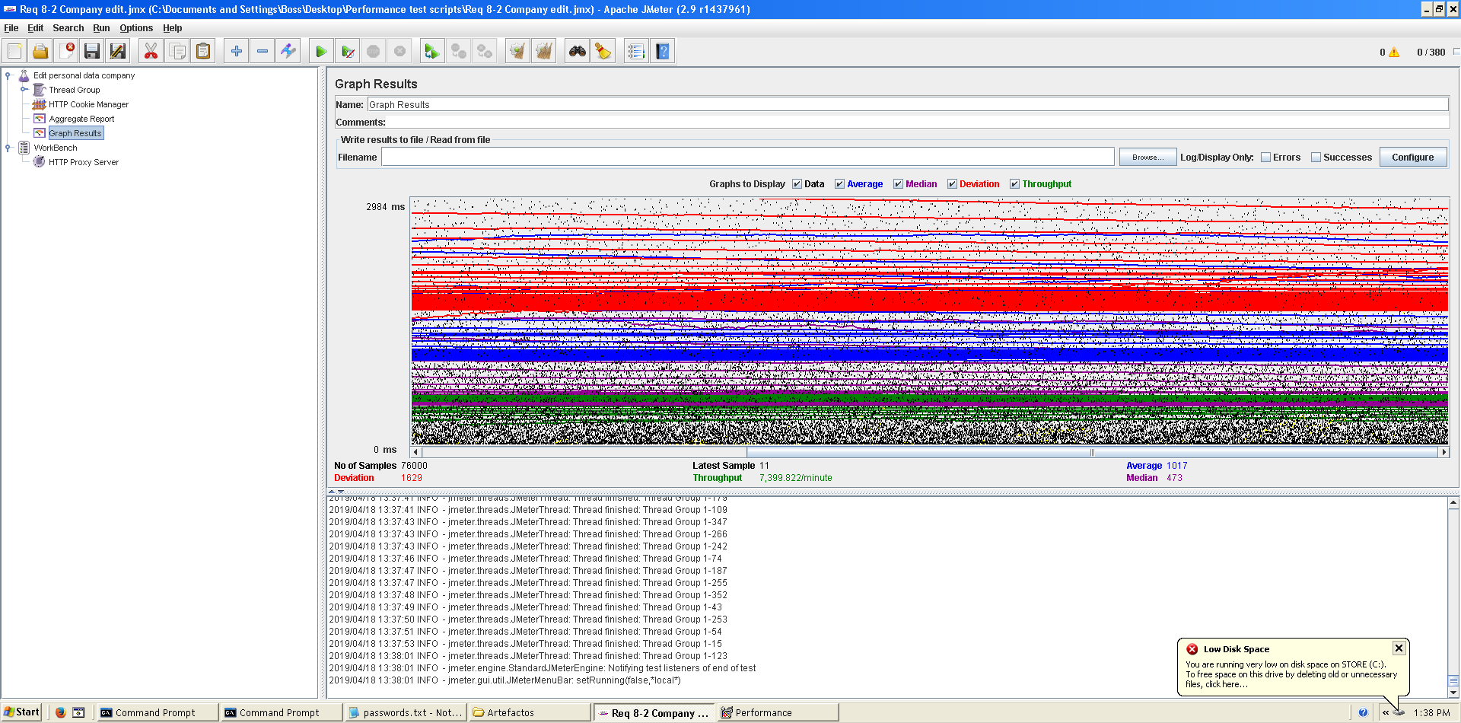

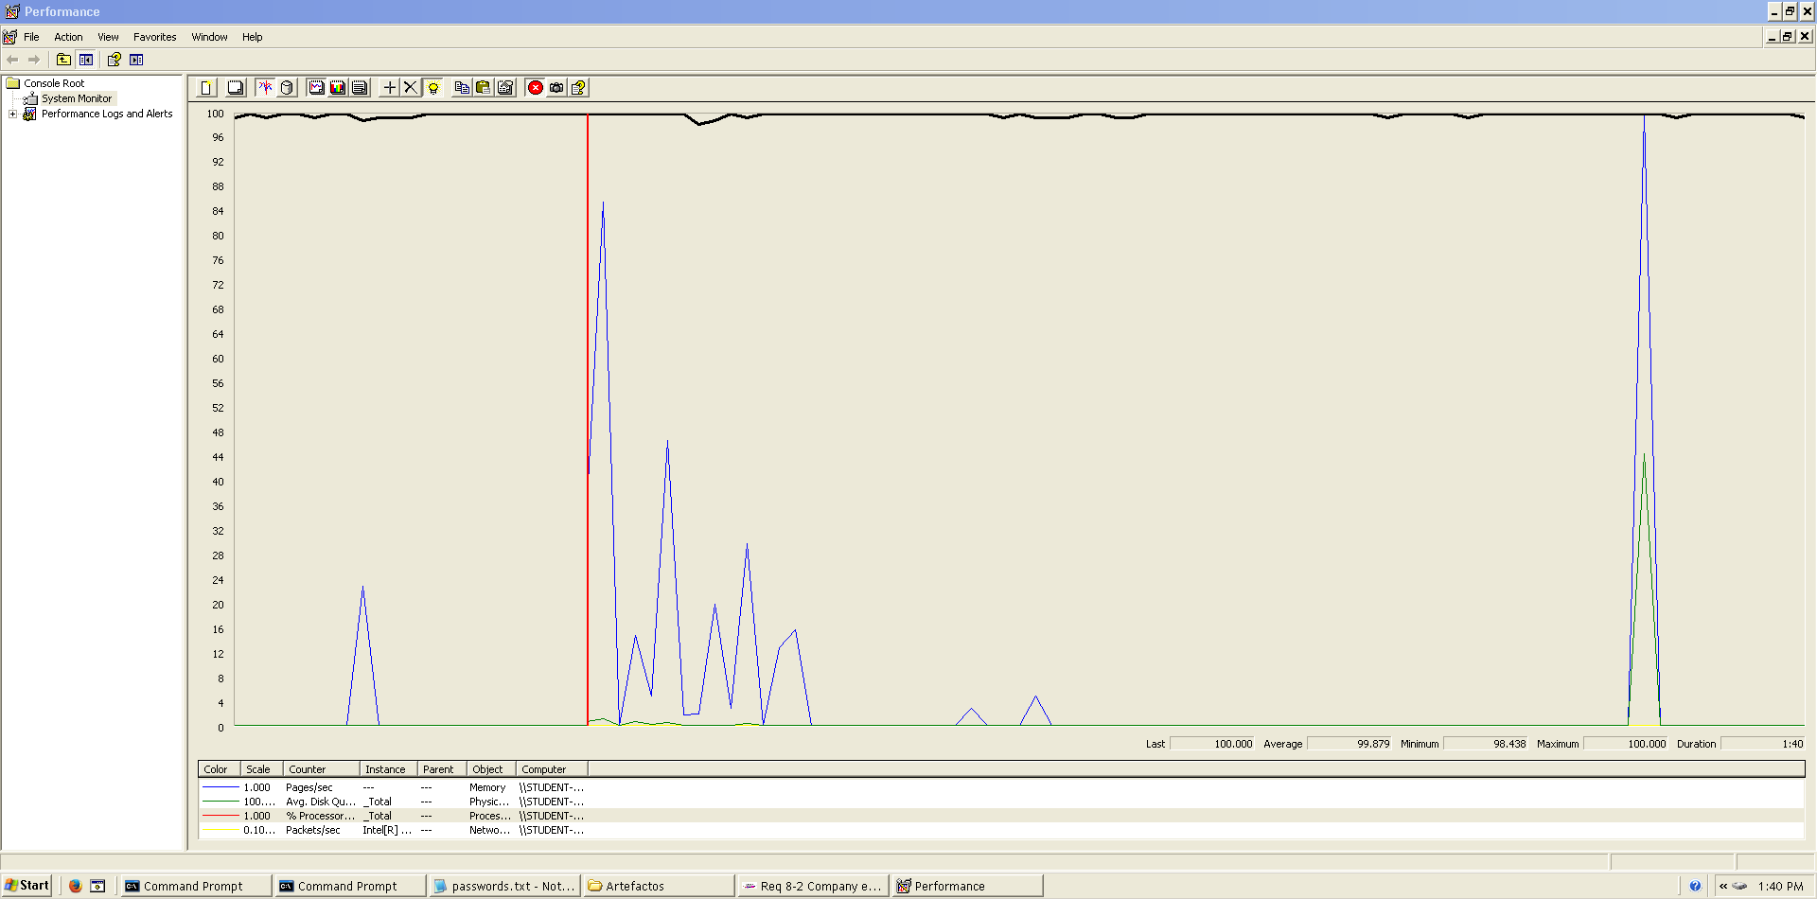As we can see in the graph below, there is a bottleneck with the CPU. Probably we could improve the maximum workload of the application if we assign more processors to the virtual machine.  
  
  
  
  
**Conclusion:** The maximum number of concurrent users supported by this test case is 370 and we could improve it by assigning more CPU’s resources to our system.

**Req. 8.2** – An actor who is authenticated must be able to: Edit his or her personal data (hacker).

Technical details of the computer on which the test has been executed:

* Ram: 8,00 GB
* CPU: Intel Core i7-7700HQ
* Hard disk: 256 GB SSD + 921 GB HDD
* Network card: Intel(R) Dual Band Wireless-AC 3168

**Test case description**:

* The user log in the system.
* The user goes to his/her profile.
* The user goes to personal edit form.
* Change any field.
* Press save button save changes.
* Log out the system.

**Maximum workload test case.** 310 concurrent users and 20 of loop count:

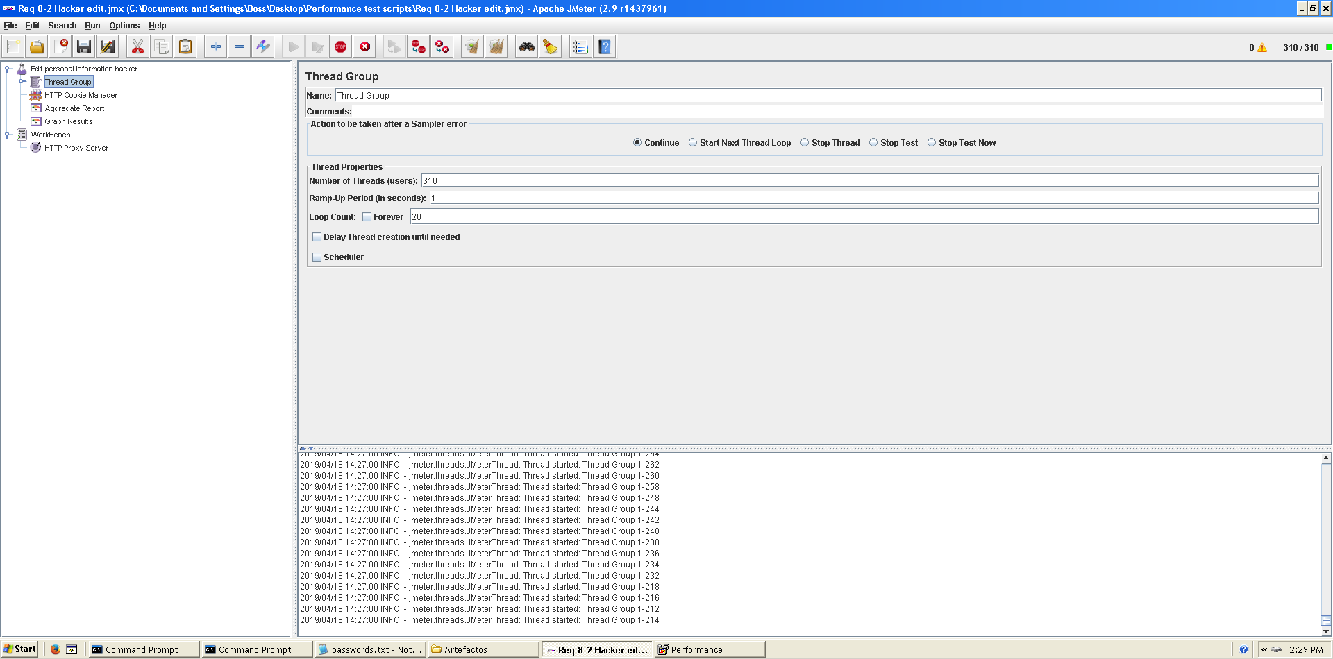

This is the maximum workload of the test case without any crash or excesive delay. As we can see in the picture below, we don’t have any errors and the average time per request is pretty acceptable.

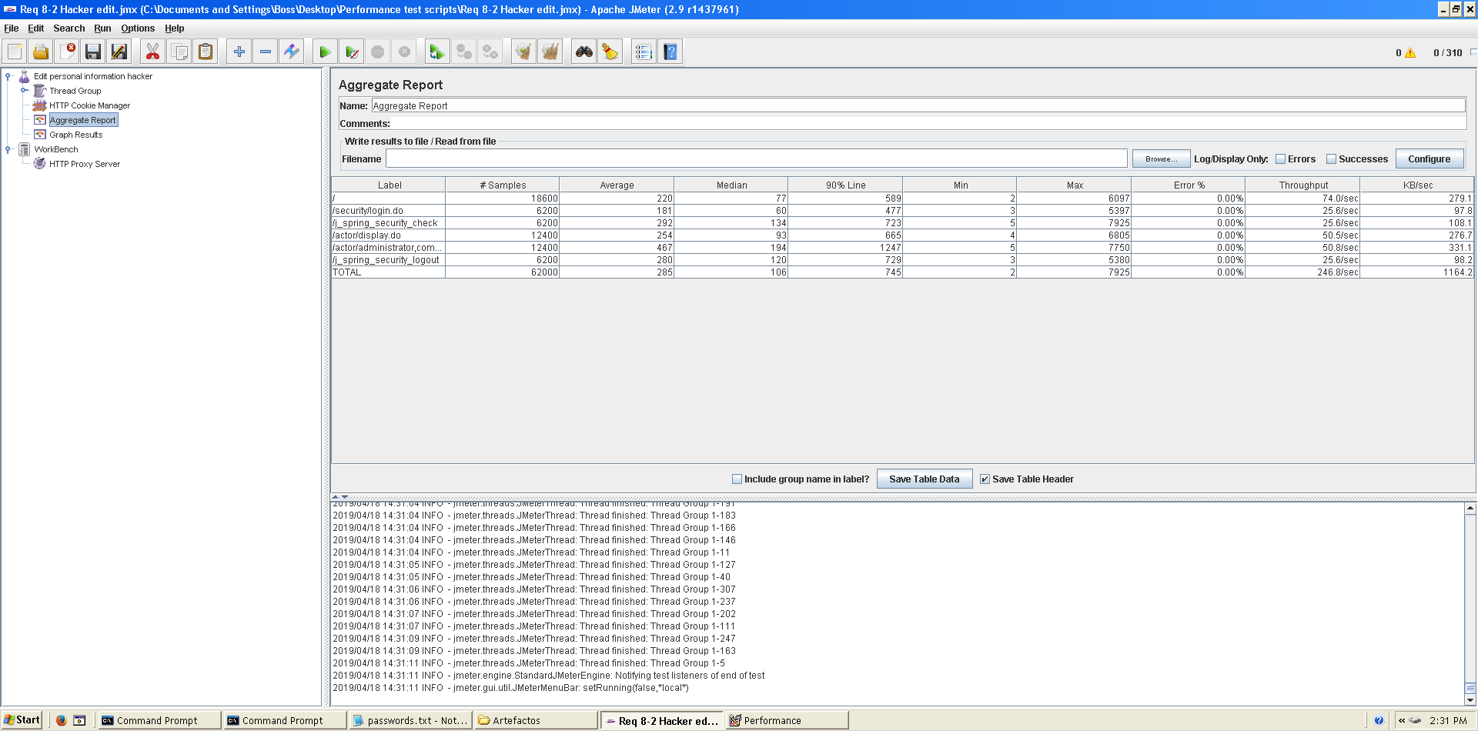

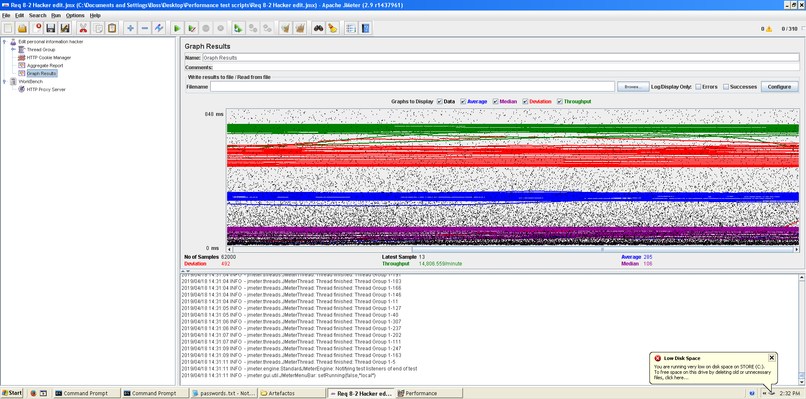

**Overload test case:** 320 concurrent users and 20 of loop count:

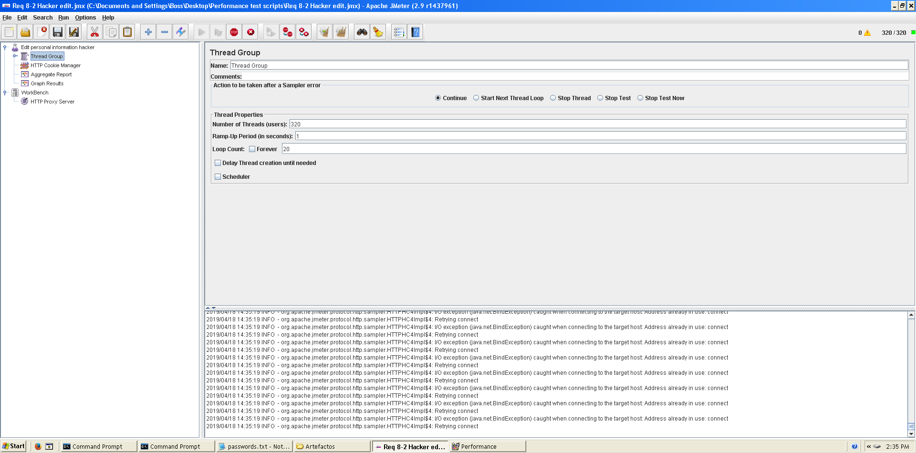

It begins to produce some errors as we can see in the following picture. The errors are always the same: I/O exception (java.net.BindException) caught when connecting to the target host:

Address already in use: connect This exception is not related with the implementation of our application, but with tomcat. The system can’t handle this number of concurrent users properly.

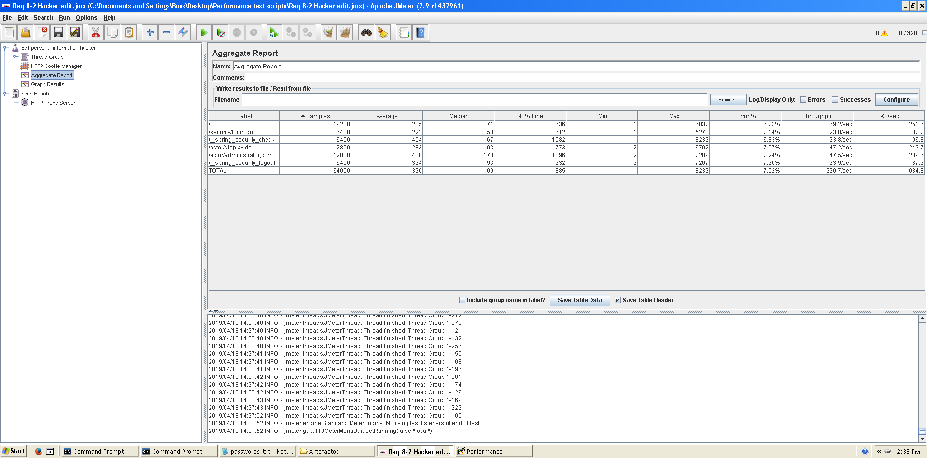

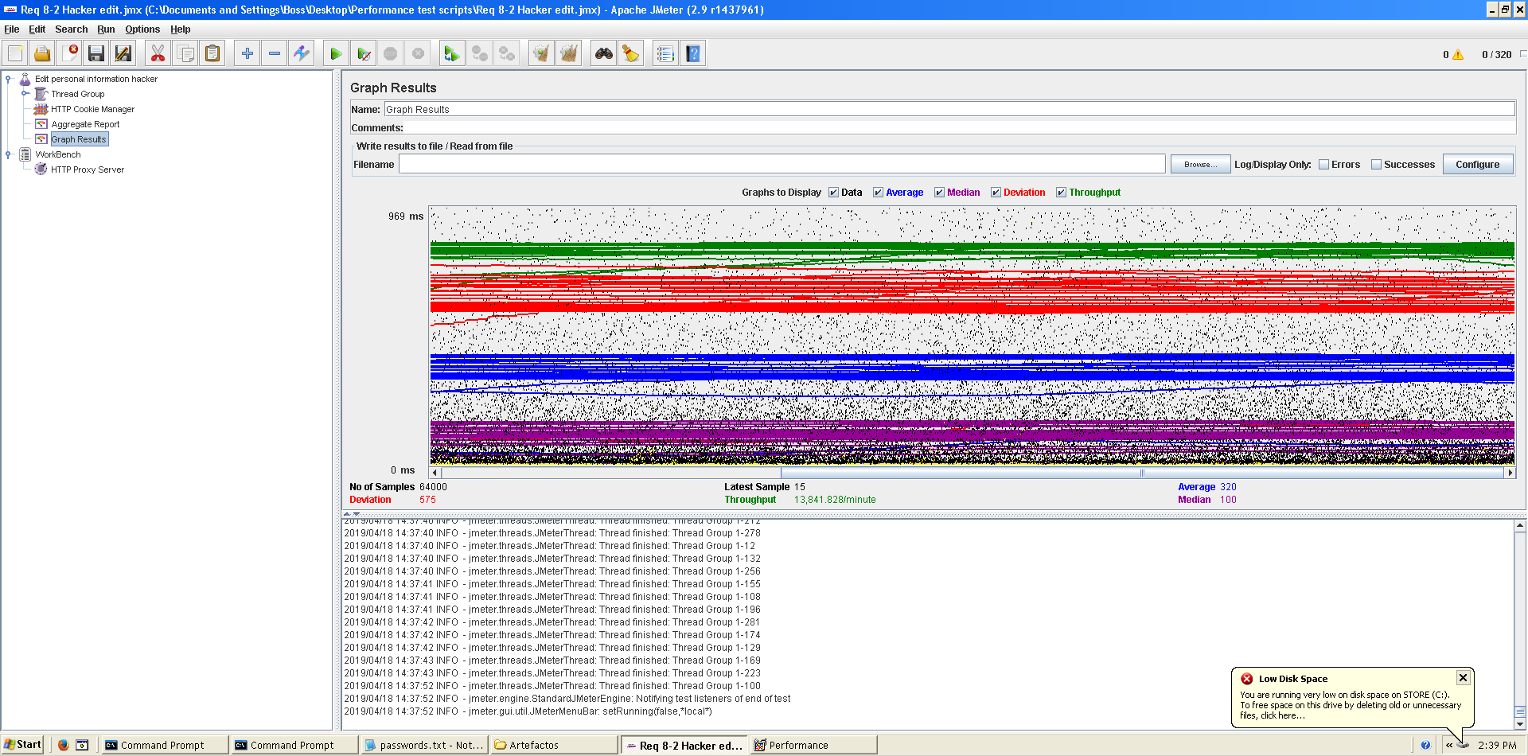

As we can see in the graph below, there is a bottleneck with the CPU. Probably we could improve the maximum workload of the application if we assign more processors to the virtual machine but not improve it so much because we can see it doesn’t work always at 100%.

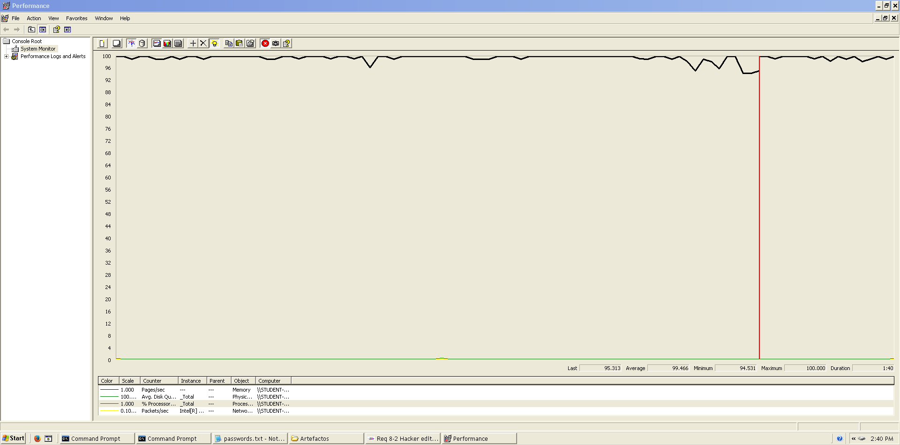

**Conclusion:** The maximum number of concurrent users supported by this test case is 310 and we could improve it by assigning more CPU’s resources to our system.

**Req. 9.1** – An actor who is authenticated as company must be able to creating and deleting their positions.

Technical details of the computer on which the test has been executed:

* Ram: 8 GB
* CPU: Intel core i7-8550U 1,8GHz
* Hard disk: 1TB
* Network card: Intel(R) Dual Band Wireless-AC 3165

**Test case description**:

We initiate session in the system and we go to the page of the data of the actor. We click on position and it takes us to the list of positions, we create a new position. Once created we give it to edit it and we delete it. We relog the system.

**Maximum workload test case.** 150 concurrent users and 20 of loop count:

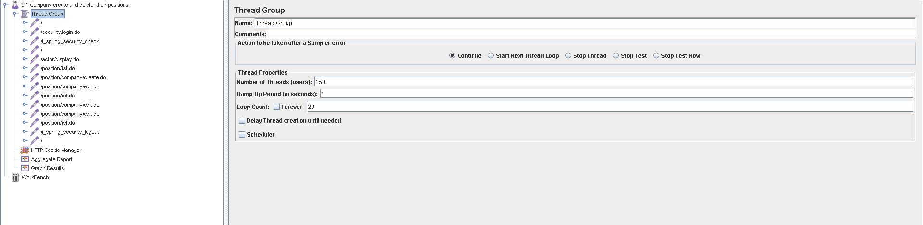

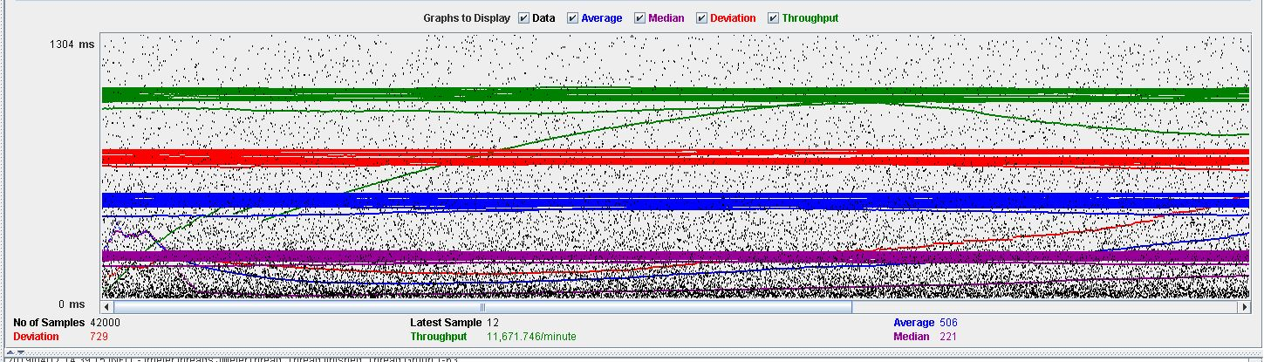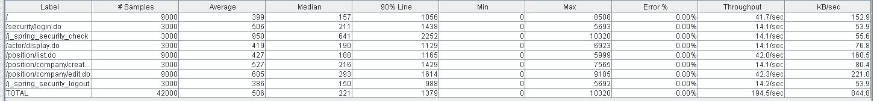

**Overload test case:** 175 concurrent users and 20 of loop count:

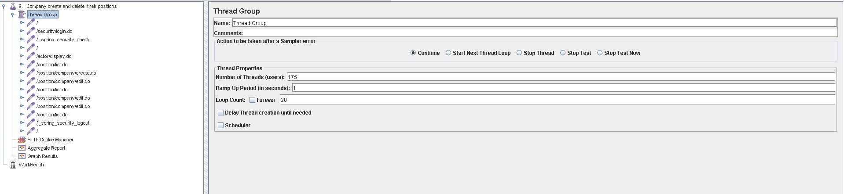

As we can see in the report if we increase the number of threads the 90% line gets a value too high.

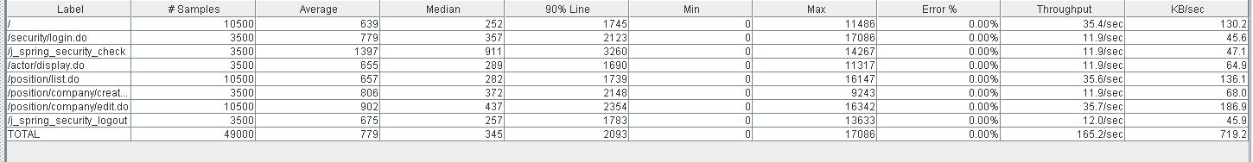

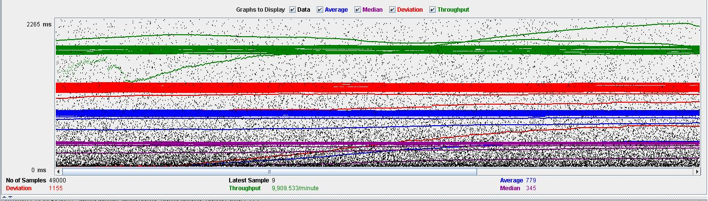

As we can see in the graph below, there is a bottleneck with the CPU. Probably we could improve the maximum workload of the application if we assign more processors to the virtual machine.

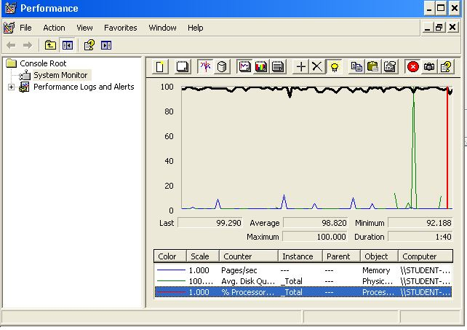

**Conclusion:** The maximum number of concurrent users supported by this test case is 425 and we could improve it by assigning more CPU’s resources to our system.

**Req. 9.1** – An actor who is authenticated as company must be able to displaying their positions.

Technical details of the computer on which the test has been executed:

* Ram: 8 GB
* CPU: Intel core i7-8550U 1,8GHz
* Hard disk: 1TB
* Network card: Intel(R) Dual Band Wireless-AC 3165

**Test case description**:

We initiate session in the system and we go to the page of the data of the actor. Click on position and take us to the list of positions, we show you a position. We relog the system.

**Maximum workload test case.** 150 concurrent users and 20 of loop count:



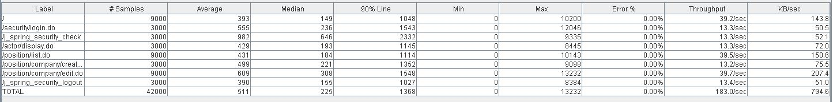

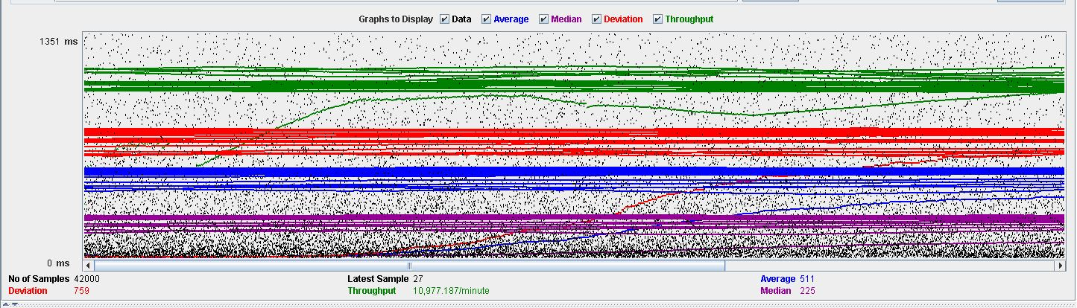

**Overload test case:** 175 concurrent users and 20 of loop count:



As we can see in the report if we increase the number of threads the 90% line gets a value too high.

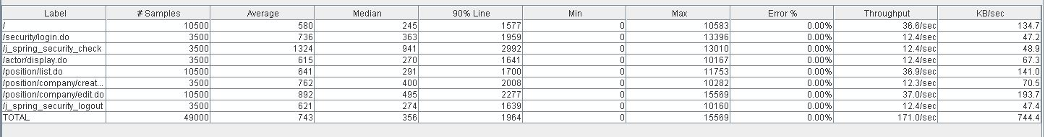

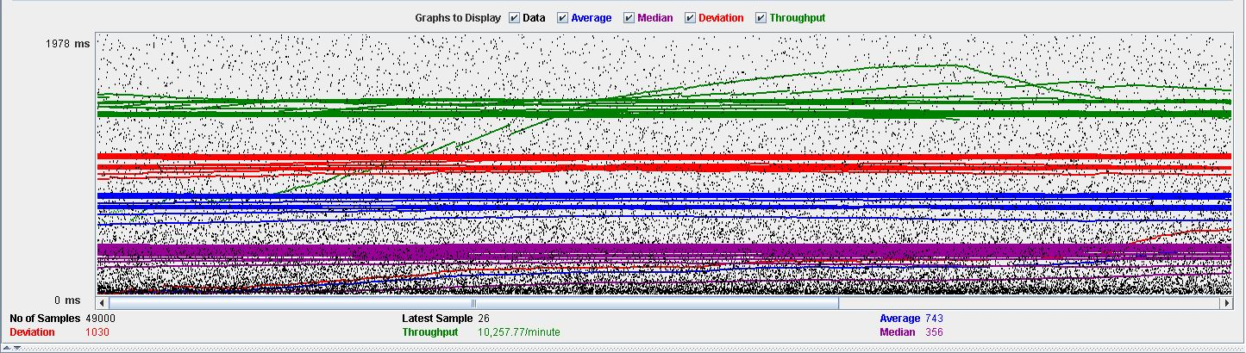

As we can see in the graph below, there is a bottleneck with the CPU. Probably we could improve the maximum workload of the application if we assign more processors to the virtual machine.

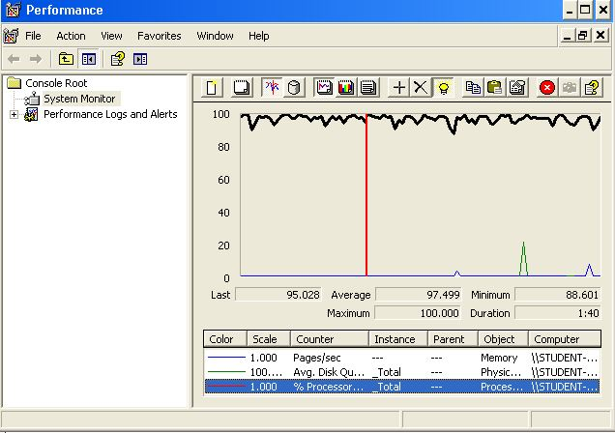

**Conclusion:** The maximum number of concurrent users supported by this test case is 425 and we could improve it by assigning more CPU’s resources to our system.

**Req. 9.1** – An actor who is authenticated as company must be able to editing their positions.

Technical details of the computer on which the test has been executed:

* Ram: 8 GB
* CPU: Intel core i7-8550U 1,8GHz
* Hard disk: 1TB
* Network card: Intel(R) Dual Band Wireless-AC 3165

**Test case description**:

We initiate session in the system and we go to the page of the data of the actor. Click on position and take us to the list of positions, we give you to edit one. We relog the system.

**Maximum workload test case.** 115 concurrent users and 20 of loop count:

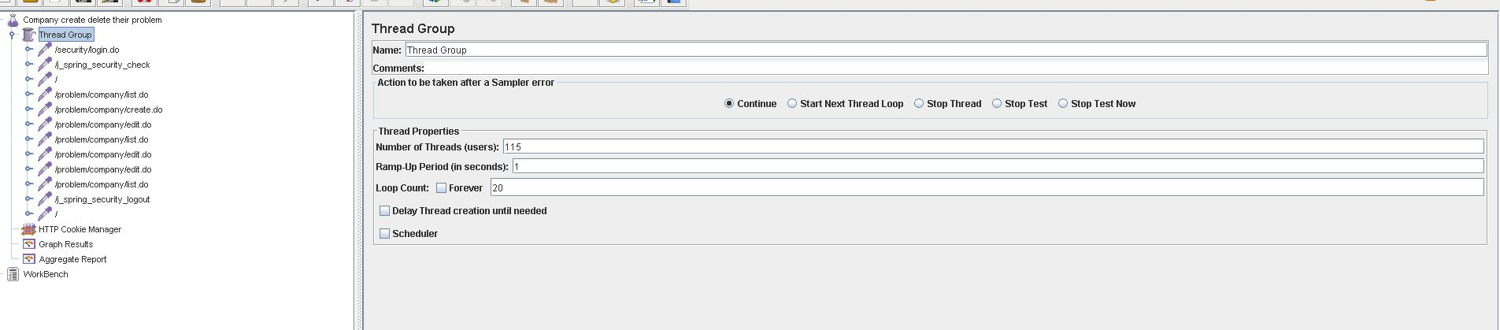

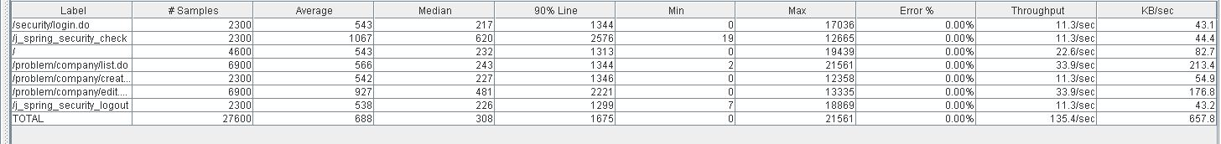

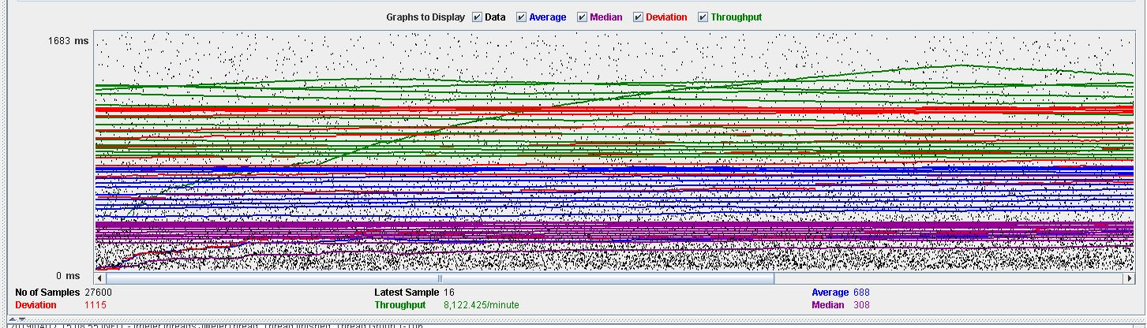

**Overload test case:** 125 concurrent users and 20 of loop count:

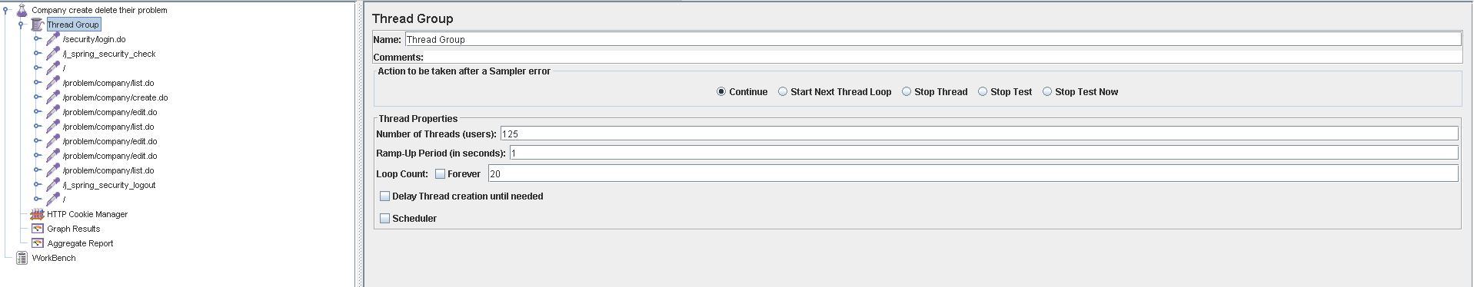

As we can see in the report if we increase the number of threads the 90% line gets a value too high.

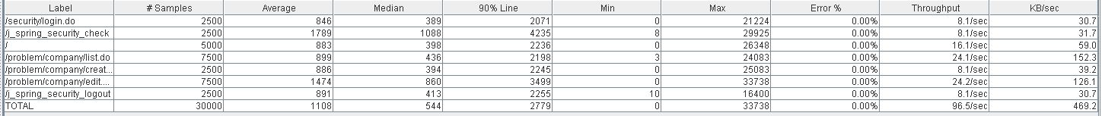

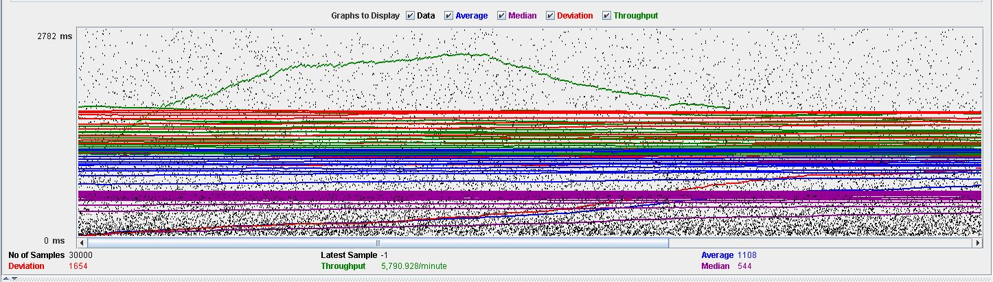

As we can see in the graph below, there is a bottleneck with the CPU. Probably we could improve the maximum workload of the application if we assign more processors to the virtual machine.

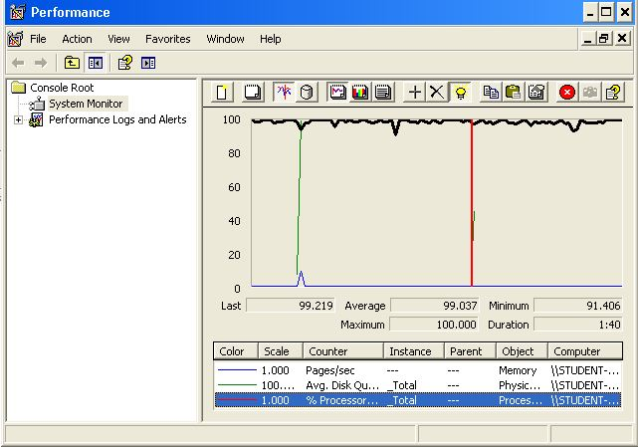

**Conclusion:** The maximum number of concurrent users supported by this test case is 425 and we could improve it by assigning more CPU’s resources to our system.

**Req. 9.1** – An actor who is authenticated as company must be able to make final their positions in draft mode.

Technical details of the computer on which the test has been executed:

* Ram: 8 GB
* CPU: Intel core i7-8550U 1,8GHz
* Hard disk: 1TB
* Network card: Intel(R) Dual Band Wireless-AC 3165

**Test case description**:  
We initiate session in the system and we go to the page of the data of the actor. We click on position and it takes us to the list of positions, we give it to show one and click on make final. We closed session in the system.

**Maximum workload test case.** concurrent users and 20 of loop count:

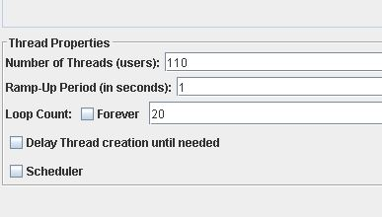

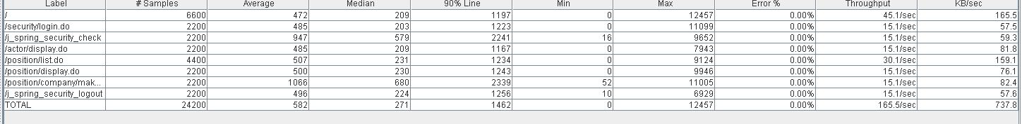

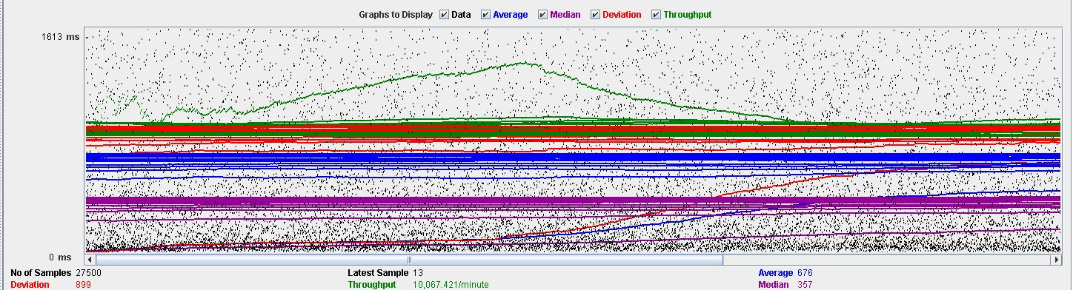

**Overload test case:** 125 concurrent users and 20 of loop count:

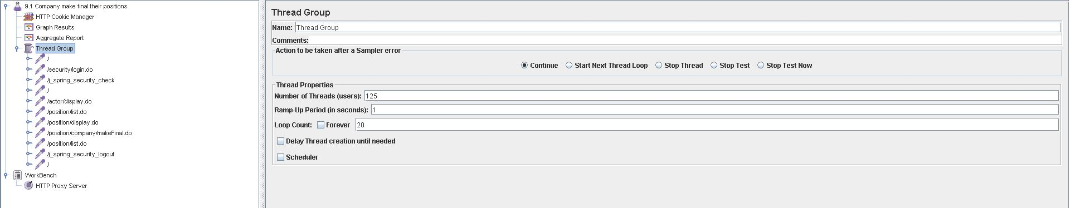

As we can see in the report if we increase the number of threads the 90% line gets a value too high.

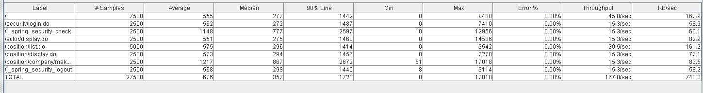



As we can see in the graph below, there is a bottleneck with the CPU. Probably we could improve the maximum workload of the application if we assign more processors to the virtual machine.

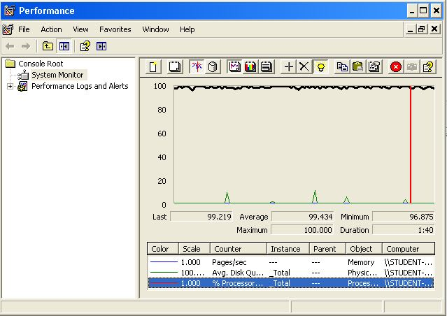

**Conclusion:** The maximum number of concurrent users supported by this test case is 425 and we could improve it by assigning more CPU’s resources to our system.

**Req. 9.1** – An actor who is authenticated as company must be able to listing their positions.

Technical details of the computer on which the test has been executed:

* Ram: 8 GB
* CPU: Intel core i7-8550U 1,8GHz
* Hard disk: 1TB
* Network card: Intel(R) Dual Band Wireless-AC 3165

**Test case description**:  
We initiate session in the system and we go to the page of the data of the actor. Click on position and take us to the list of positions. We closed session in the system.

**Maximum workload test case.**  175 concurrent users and 20 of loop count:

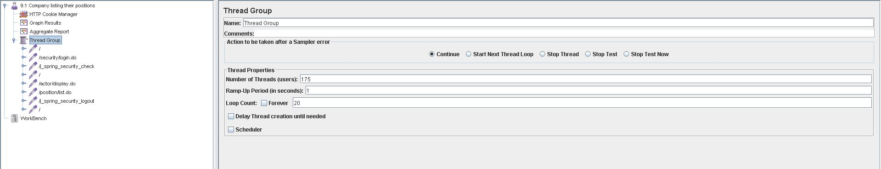



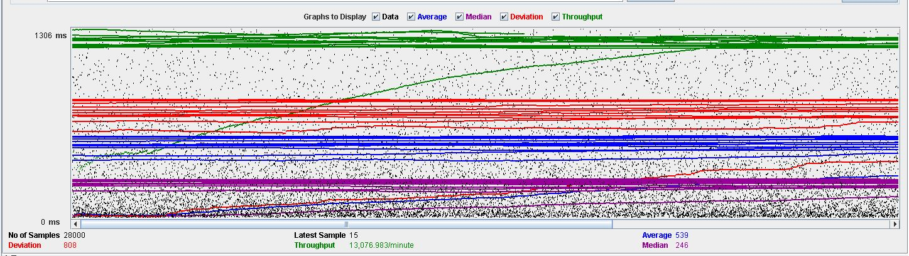

**Overload test case:** 190 concurrent users and 20 of loop count:

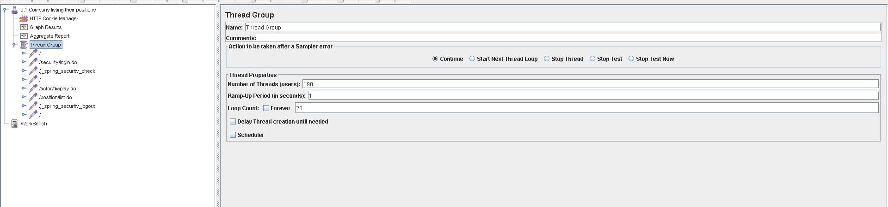

As we can see in the report if we increase the number of threads the 90% line gets a value too high.

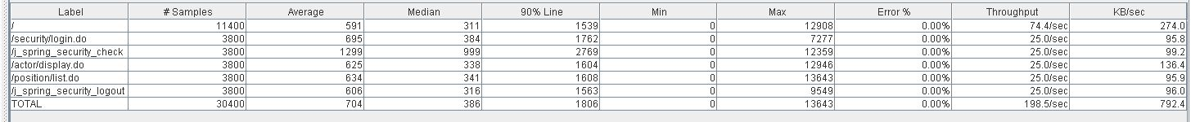

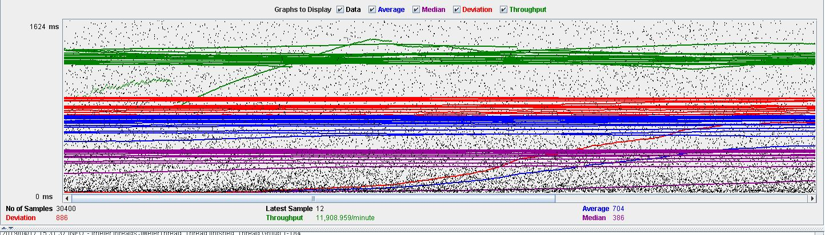

As we can see in the graph below, there is a bottleneck with the CPU. Probably we could improve the maximum workload of the application if we assign more processors to the virtual machine.

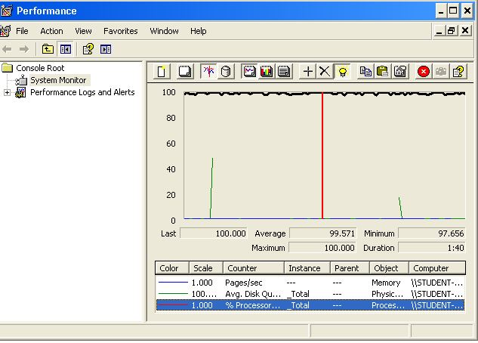

**Conclusion:** The maximum number of concurrent users supported by this test case is 425 and we could improve it by assigning more CPU’s resources to our system.

**Req. 9.2** – An actor who is authenticated as a company must be able to creating and deleting their problems.

Technical details of the computer on which the test has been executed:

* Ram: 8 GB
* CPU: Intel core i7-8550U 1,8GHz
* Hard disk: 1TB
* Network card: Intel(R) Dual Band Wireless-AC 3165

**Test case description**:

We initiate session in the system and we go to the page of the data of the actor. We click on position and it takes us to the list of problems, we create a new problem. Once created we give it to edit it and we delete it. We relog the system.

**Maximum workload test case.**  100 concurrent users and 20 of loop count:

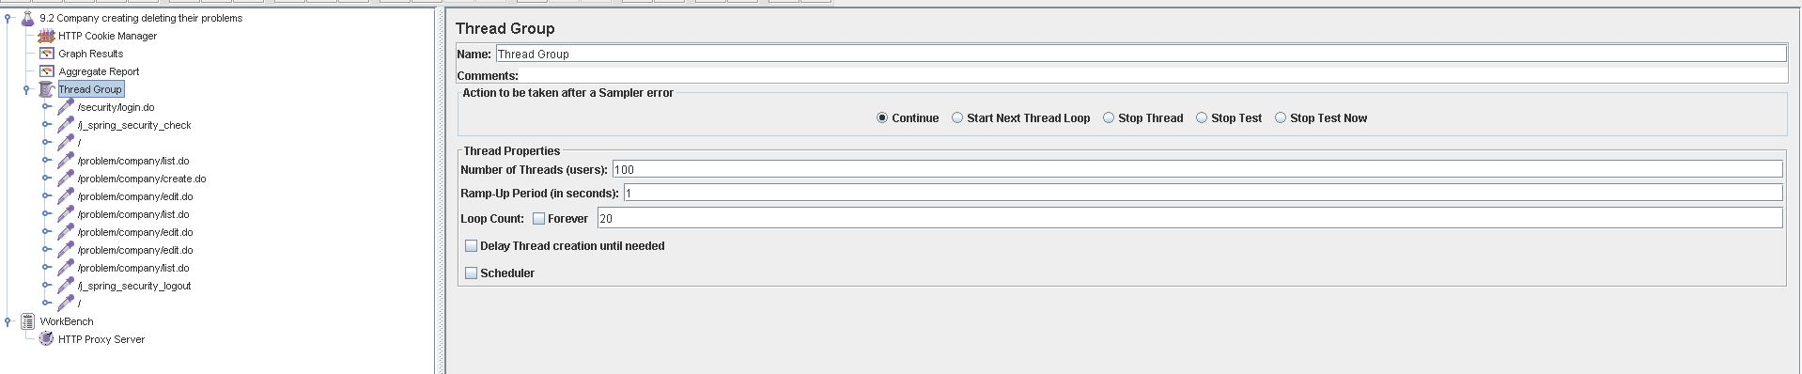

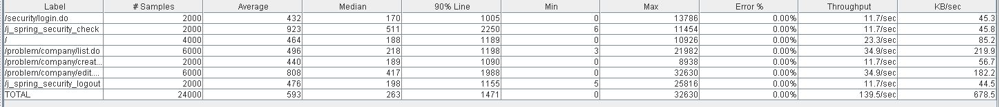

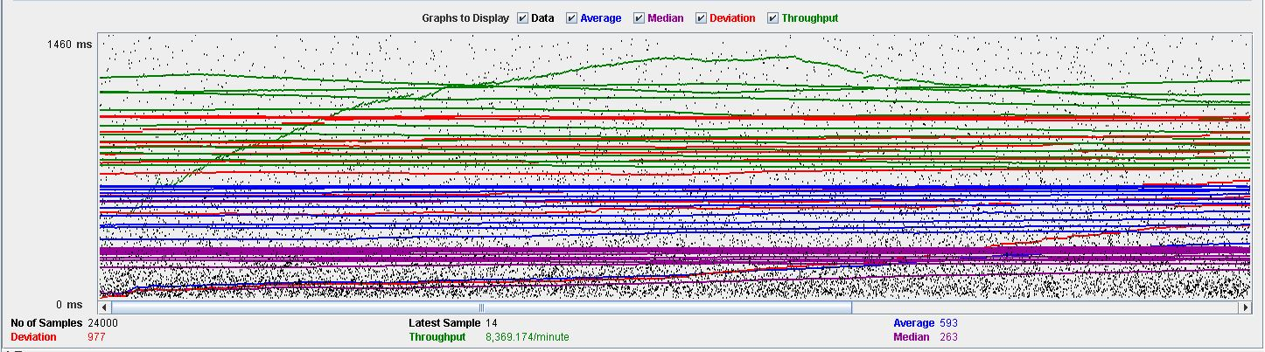

**Overload test case:** 125 concurrent users and 20 of loop count:

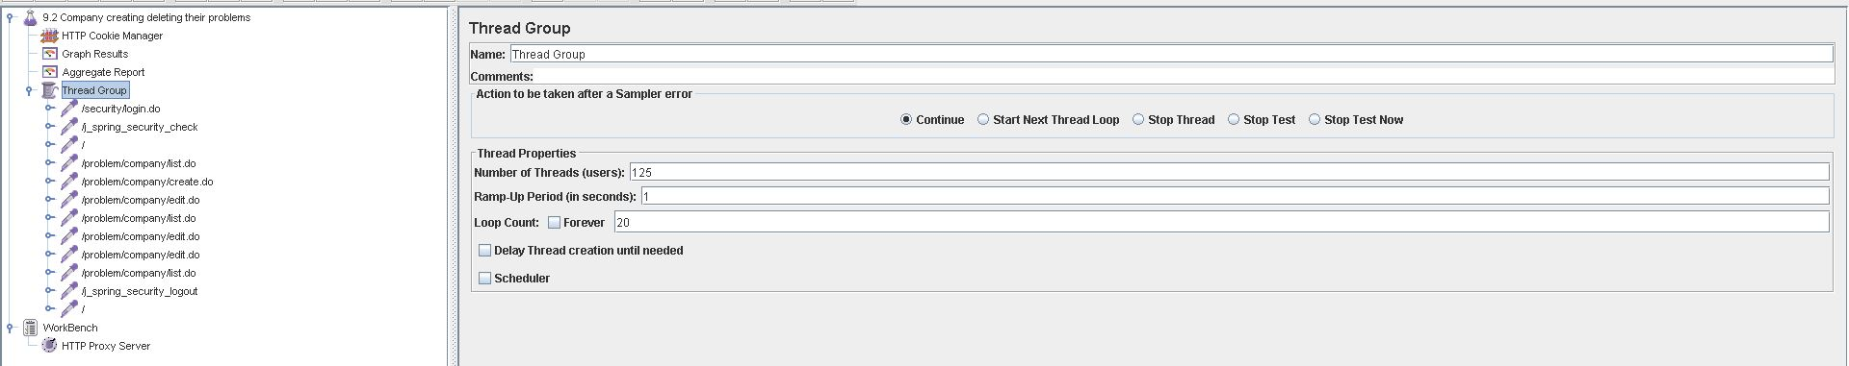

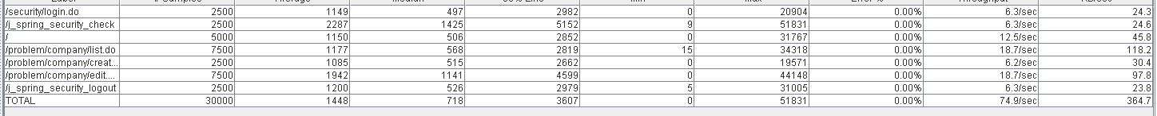

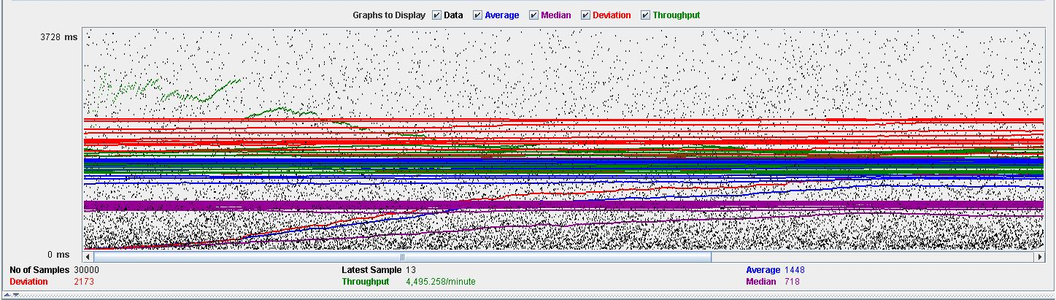

As we can see in the graph below, there is a bottleneck with the CPU. Probably we could improve the maximum workload of the application if we assign more processors to the virtual machine.

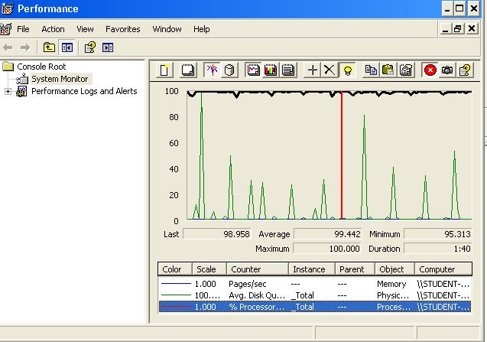

**Conclusion:** The maximum number of concurrent users supported by this test case is 425 and we could improve it by assigning more CPU’s resources to our system.**Req. 9.2** – An actor who is authenticated as a company must be able to listing and displaying their problems.

Technical details of the computer on which the test has been executed:

* Ram: 8 GB
* CPU: Intel core i7-8550U 1,8GHz
* Hard disk: 1TB
* Network card: Intel(R) Dual Band Wireless-AC 3165

**Test case description**:

**Maximum workload test case.**  175 concurrent users and 20 of loop count:

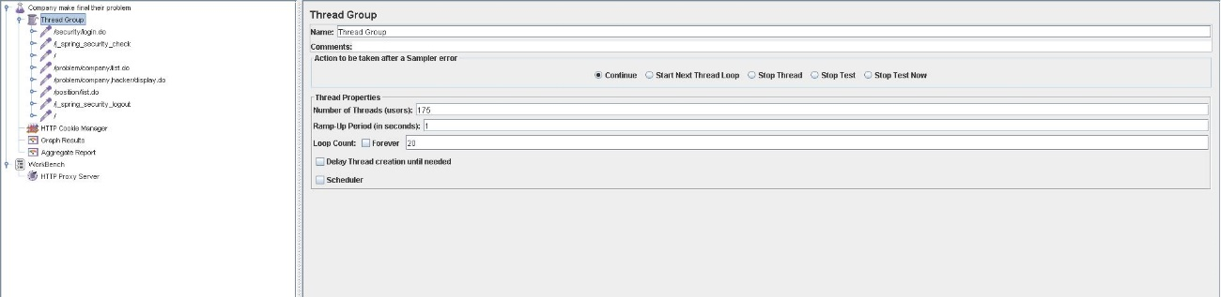

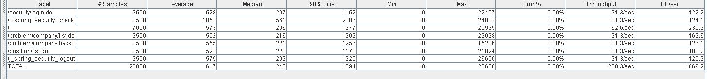

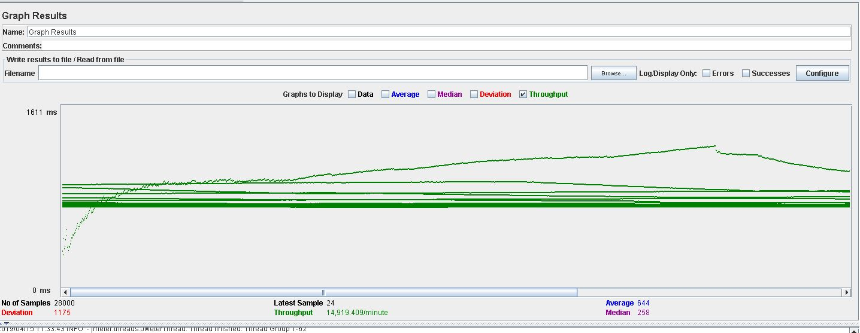

**Overload test case:**200 concurrent users and 20 of loop count:

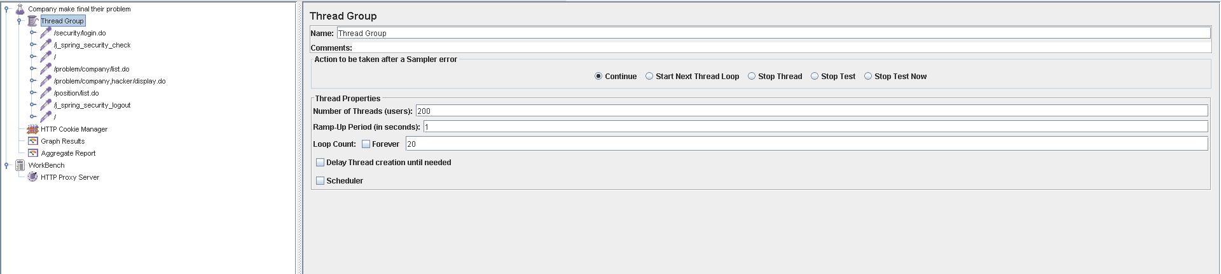

As we can see in the report if we increase the number of threads the 90% line gets a value too high.

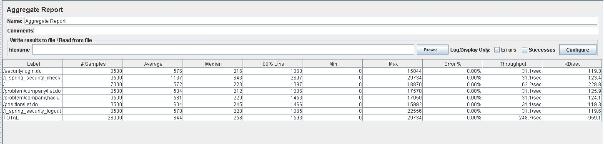

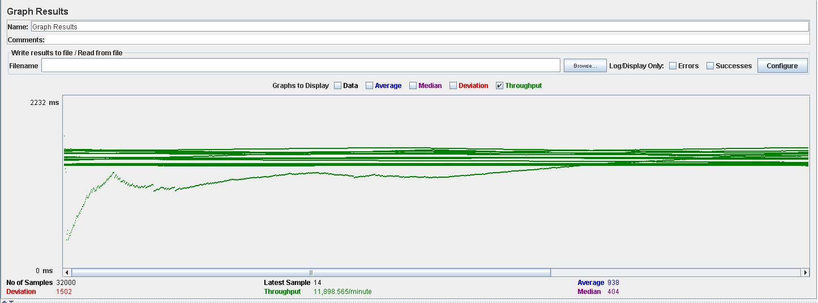

As we can see in the graph below, there is a bottleneck with the CPU. Probably we could improve the maximum workload of the application if we assign more processors to the virtual machine.

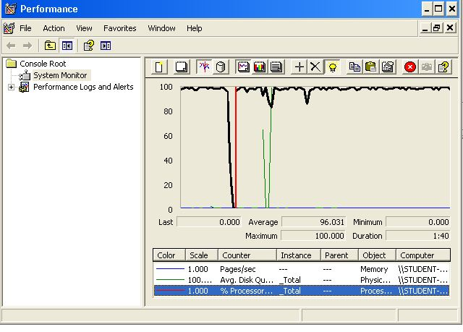

**Conclusion:** The maximum number of concurrent users supported by this test case is 425 and we could improve it by assigning more CPU’s resources to our system.

**Req. 9.2** – An actor who is authenticated as a company must be able to make final their problems.

Technical details of the computer on which the test has been executed:

* Ram: 8 GB
* CPU: Intel core i7-8550U 1,8GHz
* Hard disk: 1TB
* Network card: Intel(R) Dual Band Wireless-AC 3165

**Test case description**:

We initiate session in the system. We click on problems and it takes us to the list of problems, we give it to show one and click on make final. We closed session in the system.

**Maximum workload test case.**  175 concurrent users and 20 of loop count:

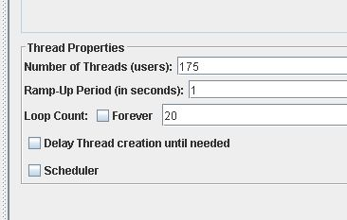



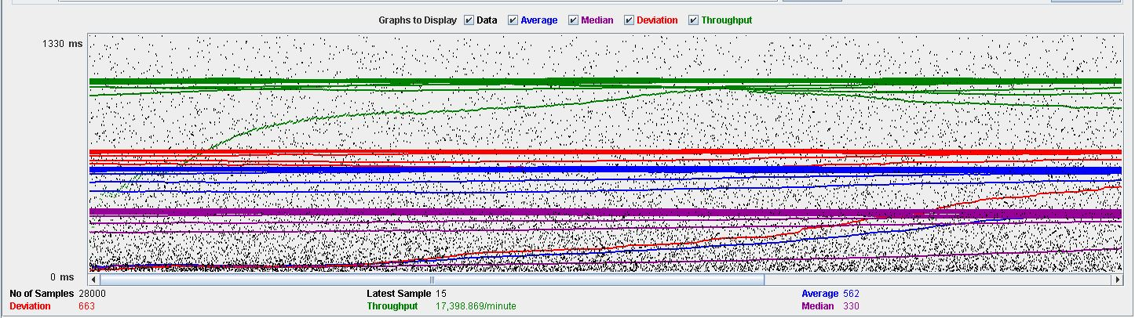

**Overload test case:**200 concurrent users and 20 of loop count:

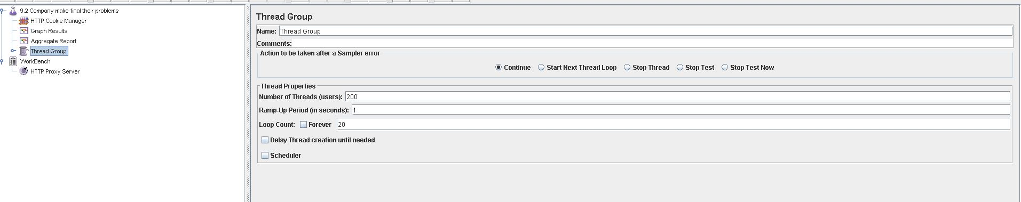

As we can see in the report if we increase the number of threads the 90% line gets a value too high.

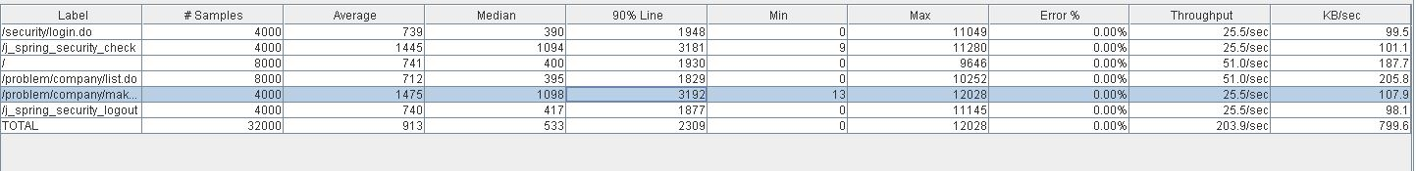

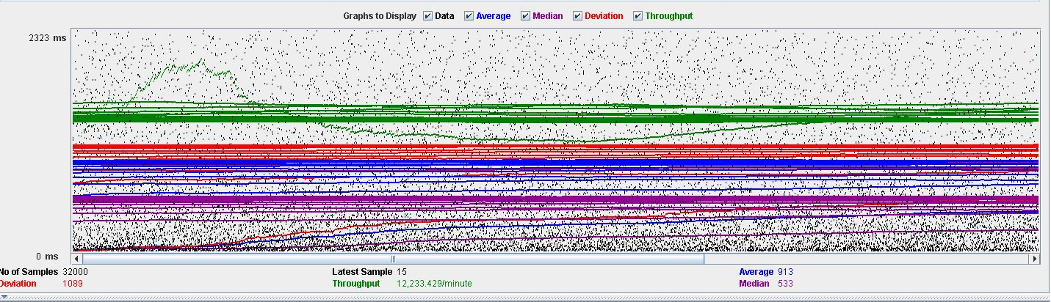

As we can see in the graph below, there is a bottleneck with the CPU. Probably we could improve the maximum workload of the application if we assign more processors to the virtual machine.

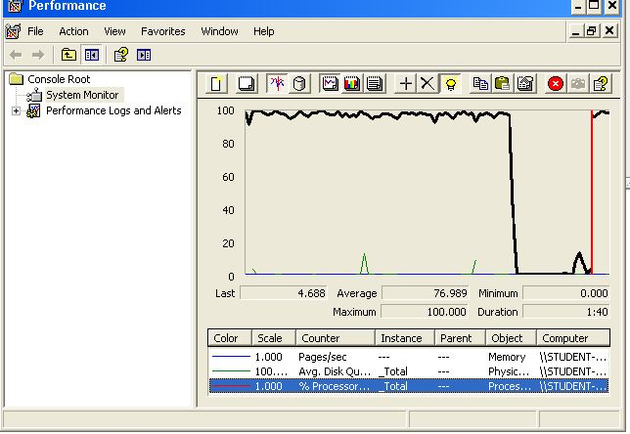

**Conclusion:** The maximum number of concurrent users supported by this test case is 425 and we could improve it by assigning more CPU’s resources to our system.

**Req. 9.1** – An actor who is authenticated as a company must be able to editing their problems.

Technical details of the computer on which the test has been executed:

* Ram: 8 GB
* CPU: Intel core i7-8550U 1,8GHz
* Hard disk: 1TB
* Network card: Intel(R) Dual Band Wireless-AC 3165

**Test case description**:

We initiate session in the system and we go to problems. Click on position and take us to the list of problems, we give you to edit one. We relog the system.

**Maximum workload test case.**  250 concurrent users and 20 of loop count: 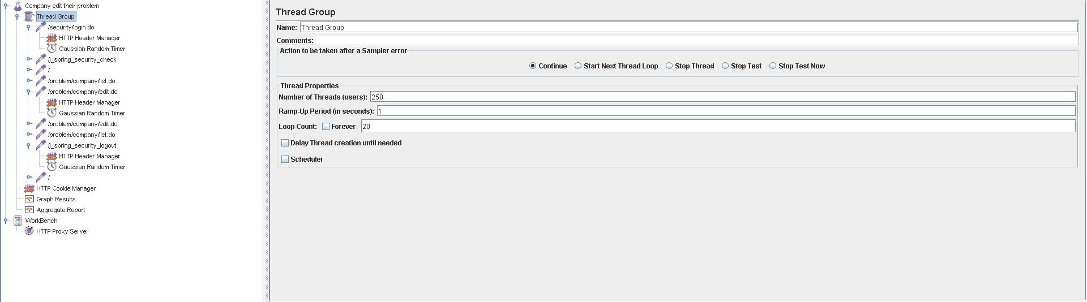

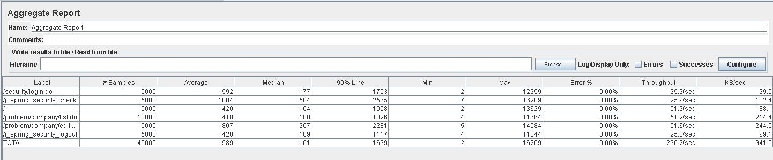

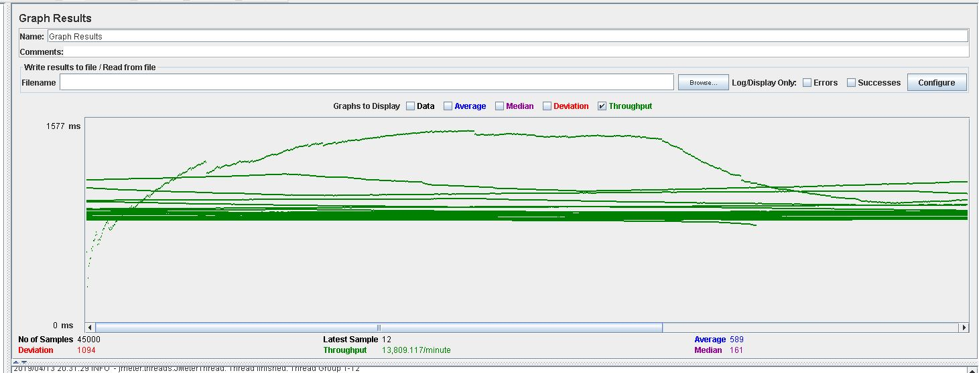

**Overload test case:**275 concurrent users and 20 of loop count:

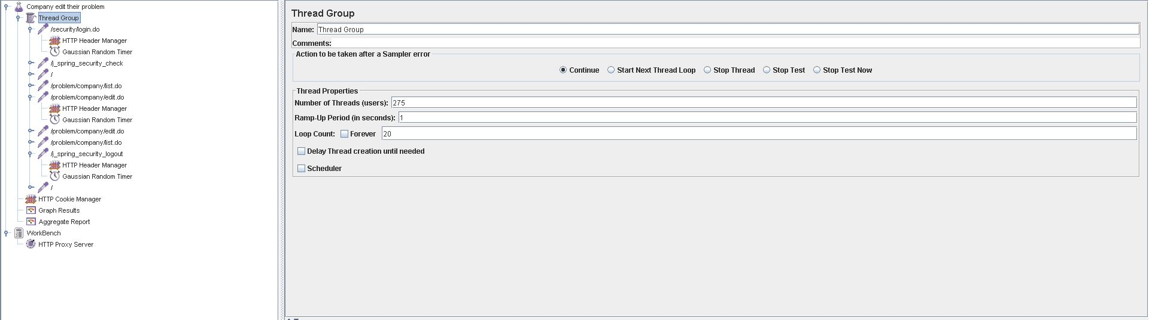

As we can see in the report if we increase the number of threads the 90% line gets a value too high.

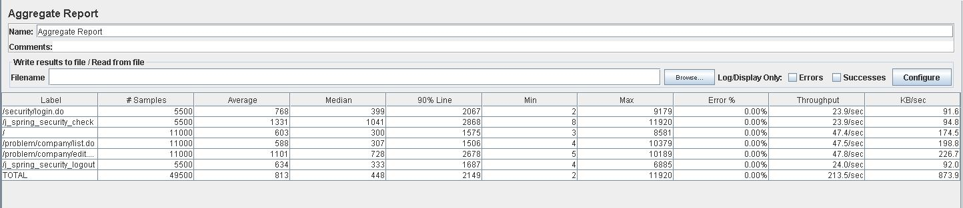

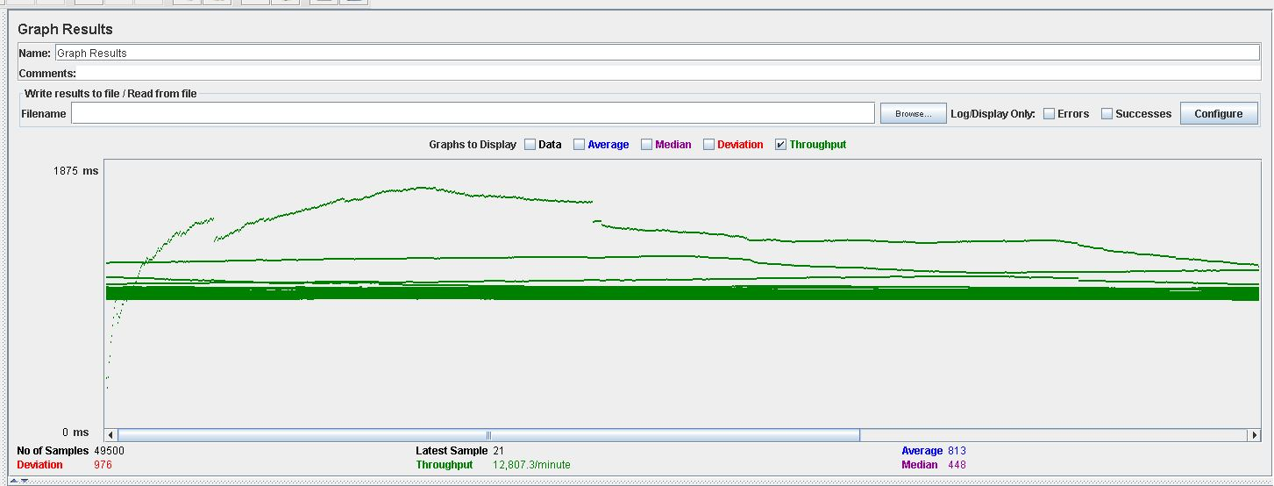

As we can see in the graph below, there is a bottleneck with the CPU. Probably we could improve the maximum workload of the application if we assign more processors to the virtual machine.

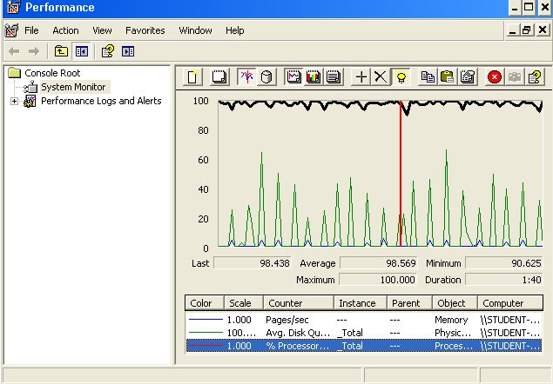

**Conclusion:** The maximum number of concurrent users supported by this test case is 425 and we could improve it by assigning more CPU’s resources to our system.

**Req. 9.3** – Manage the applications to their positions, which includes listing them grouped by status, showing them, and updating them. Updating an application amounts to making a decision on it: an application whose status is SUBMITTED may change to status ACCEPTED or REJECTED.

Technical details of the computer on which the test has been executed:

* Ram: 8,0 (1x) GB, DDR3 RAM (1,600 MHz)
* CPU: Intel Core i5-4200U
* Disco duro: 240 GB SSD

**Test case description**:

* The user logs in as a company.
* Display her/his profile.
* List positions.
* Display position.
* List applications.
* Rejected application.
* The company closes session.

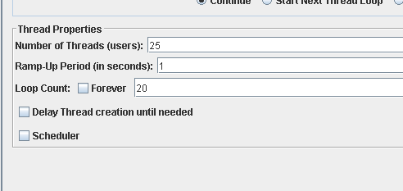**Maximum workload test case.** 25 concurrent users and 20 of loop count:

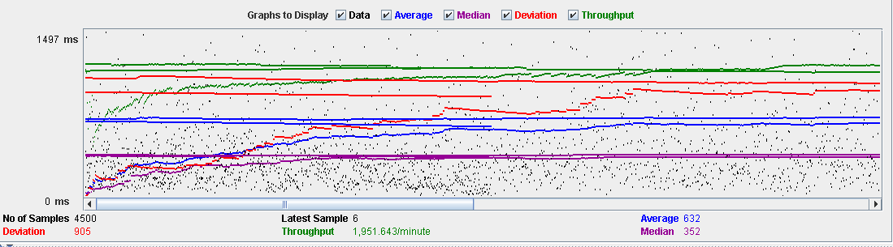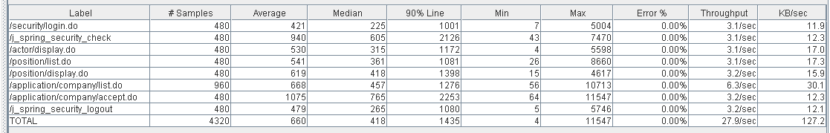

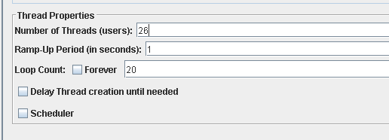**Overload test case:** 26 concurrent users and 20 of loop count:

As we can see in the report if we increase the number of threads the 90% line gets a value too high.

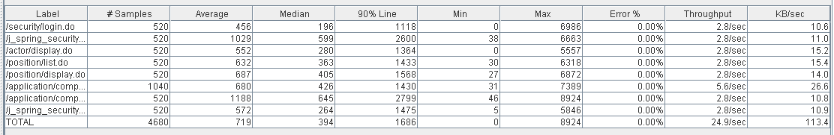

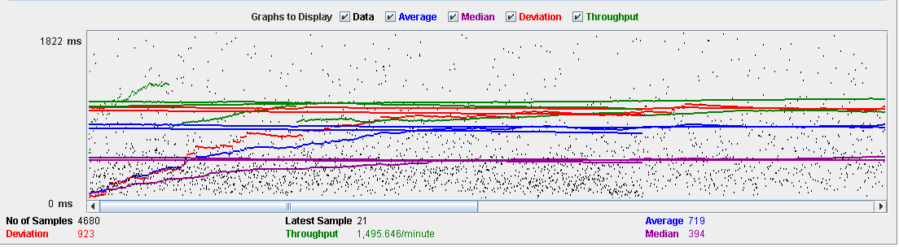

As we can see in the graph below, there is a bottleneck with the CPU. Probably we could improve the maximum workload of the application if we assign more processors to the virtual machine.

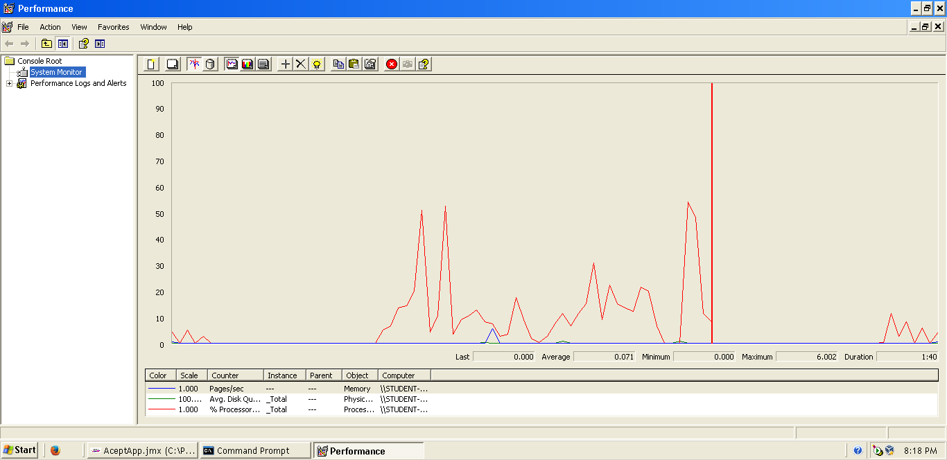

**Conclusion:** The maximum number of concurrent users supported by this test case is 25 and we could improve it by assigning more CPU’s resources to our system.

**Req. 9.3** – Manage the applications to their positions, which includes listing them grouped by status, showing them, and updating them. Updating an application amounts to making a decision on it: an application whose status is SUBMITTED may change to status ACCEPTED or REJECTED.

Technical details of the computer on which the test has been executed:

* Ram: 8,0 (1x) GB, DDR3 RAM (1,600 MHz)
* CPU: Intel Core i5-4200U
* Disco duro: 240 GB SSD

**Test case description**:

* The user logs in as a company.
* Display her/his profile.
* List positions.
* Display position.
* List applications.
* Accepted application.
* The company closes session.

**Maximum workload test case.** 25 concurrent users and 20 of loop count:



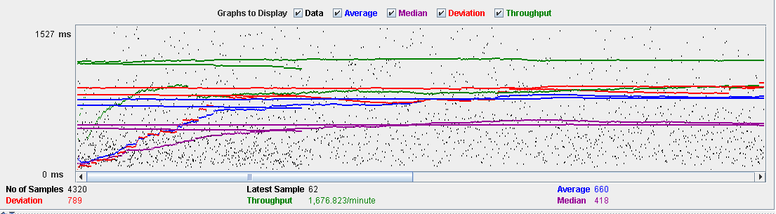

**Overload test case:** 26 concurrent users and 20 of loop count:

As we can see in the report if we increase the number of threads the 90% line gets a value too high.





As we can see in the graph below, there is a bottleneck with the CPU. Probably we could improve the maximum workload of the application if we assign more processors to the virtual machine.

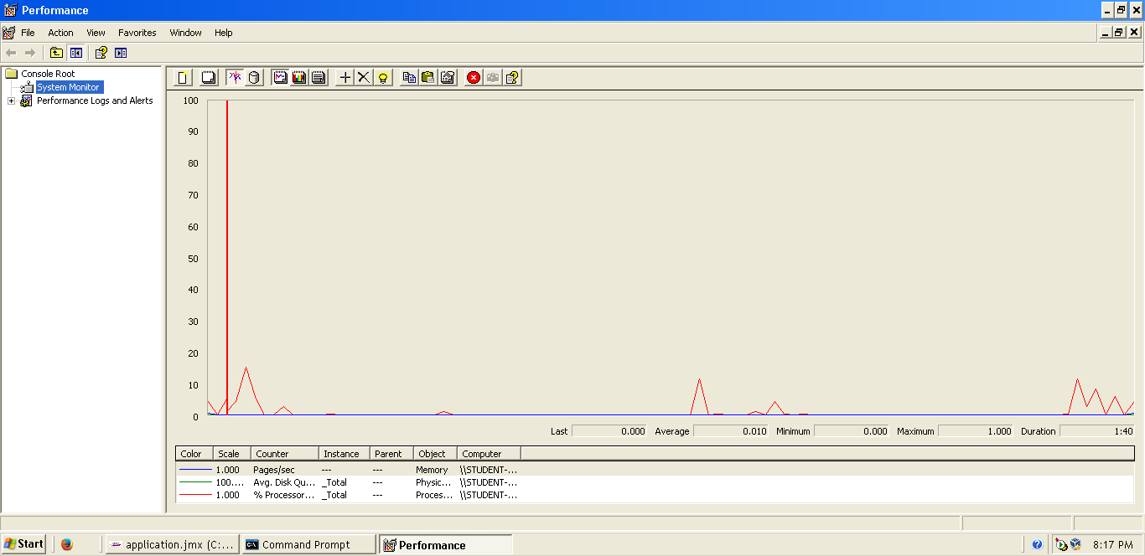

**Conclusion:** The maximum number of concurrent users supported by this test case is 25 and we could improve it by assigning more CPU’s resources to our system.

**Req. 10.1** – Manage his or her applications, which includes listing them grouped by status, showing them, creating them, and updating them. When an application is created, the system assigns an arbitrary problem to it (from the set of problems that have been registered for the corresponding position). Updating an application consists in submitting a solution to the corresponding problem (a piece of text with explanations and a link to the code), registering the submission moment, and changing the status to SUBMITTED.

Technical details of the computer on which the test has been executed:

* Ram: 8,0 (1x) GB, DDR3 RAM (1,600 MHz)
* CPU: Intel Core i5-4200U
* Hard disk: 240 GB SSD

**Test case description**:

* The user logs in as a hacker.
* The hacker accesses the list of own applications.
* The hacker clicks on a pending application.
* The hacker displays the application's display.
* The hacker creates an answer.
* The hacker sends that answer.
* The hacker closes session.

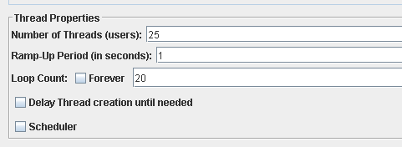**Maximum workload test case.** 25 concurrent users and 20 of loop count:

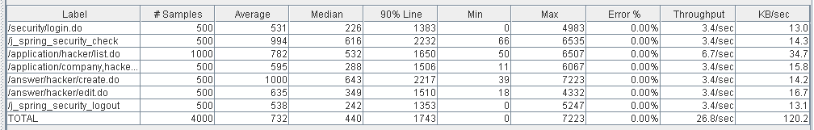

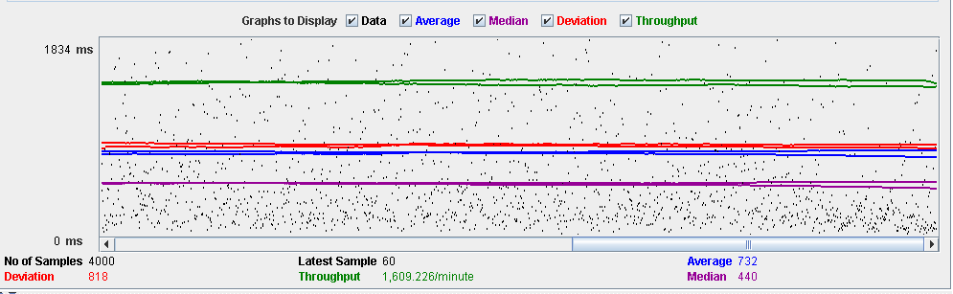

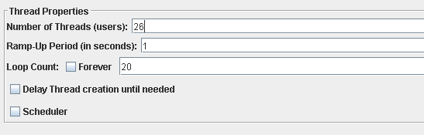**Overload test case:** 26 concurrent users and 20 of loop count:

As we can see in the report if we increase the number of threads the 90% line gets a value too high.

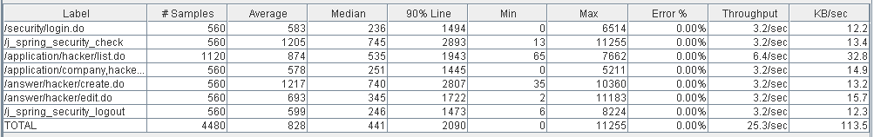

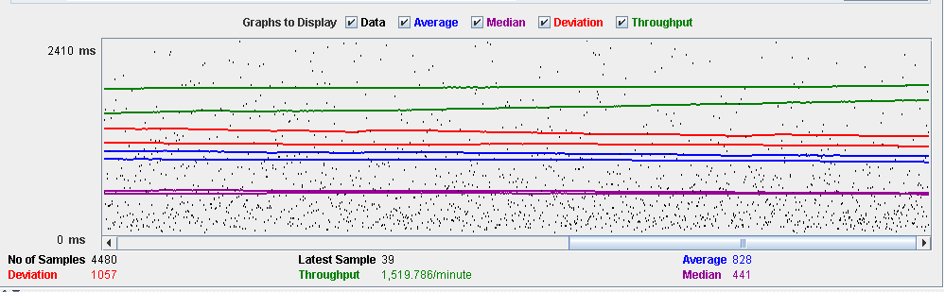

As we can see in the graph below, there is a bottleneck with the CPU. Probably we could improve the maximum workload of the application if we assign more processors to the virtual machine.

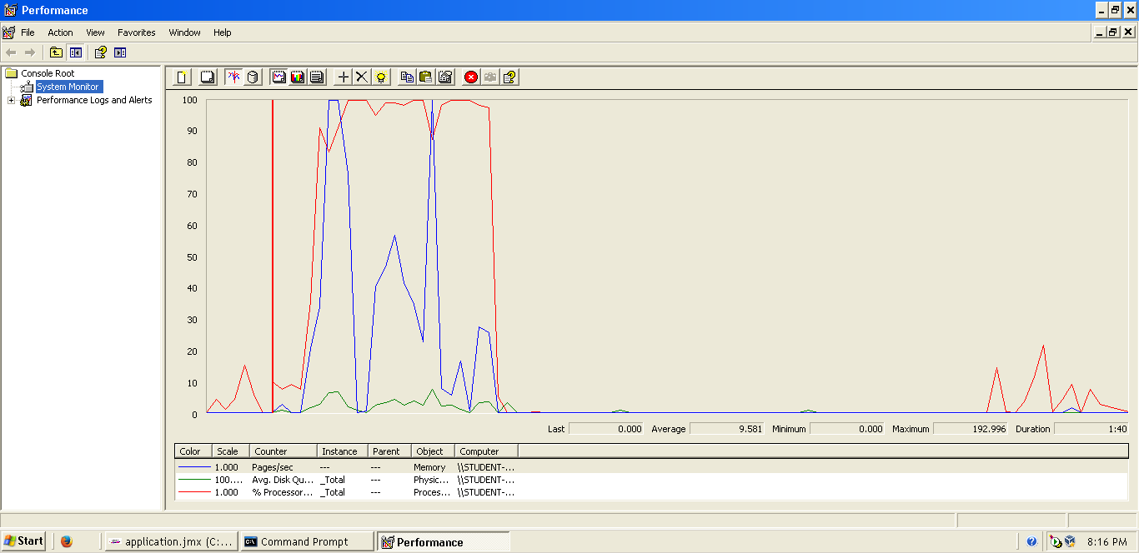

**Conclusion:** The maximum number of concurrent users supported by this test case is 25 and we could improve it by assigning more CPU’s resources to our system.

**Req. 10.1** – Manage his or her applications, which includes listing them grouped by status, showing them, creating them, and updating them. When an application is created, the system assigns an arbitrary problem to it (from the set of problems that have been registered for the corresponding position). Updating an application consists in submitting a solution to the corresponding problem (a piece of text with explanations and a link to the code), registering the submission moment, and changing the status to SUBMITTED.

Technical details of the computer on which the test has been executed:

* Ram: 8,0 (1x) GB, DDR3 RAM (1,600 MHz)
* CPU: Intel Core i5-4200U
* Hard disk: 240 GB SSD

**Test case description**:

* The user logs in as a hacker.
* The hacker accesses the list of available positions.
* The hacker accesses the display of the chosen position.
* The hacker clicks to request the position.
* The hacker chooses the curriculum and saves.
* The hacker closes session.

**Maximum workload test case.** 25 concurrent users and 20 of loop count:

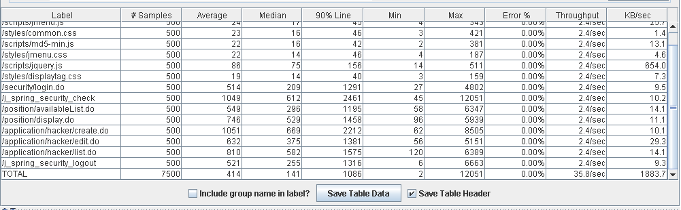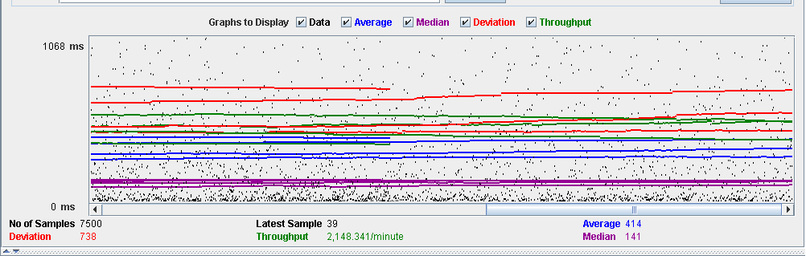

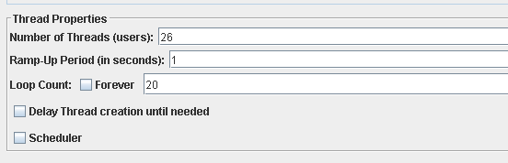**Overload test case:** 26 concurrent users and 20 of loop count:

As we can see in the report if we increase the number of threads the 90% line gets a value too high.

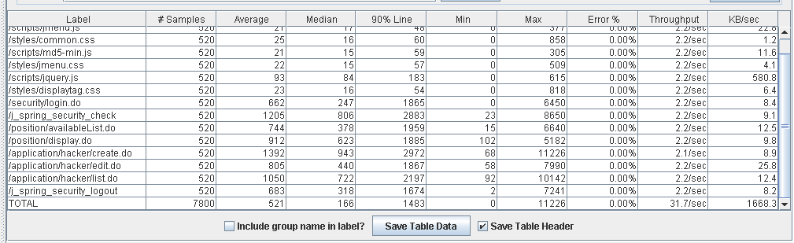

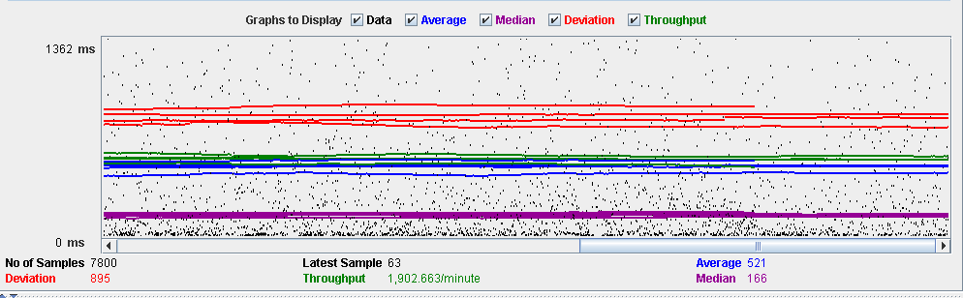

As we can see in the graph below, there is a bottleneck with the CPU. Probably we could improve the maximum workload of the application if we assign more processors to the virtual machine.

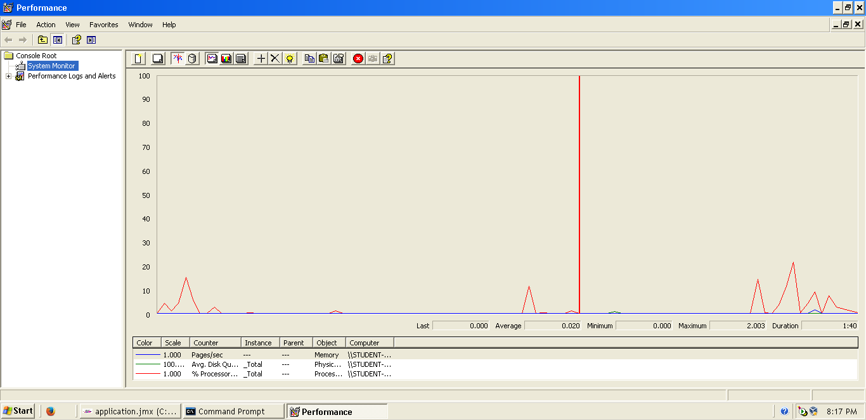

**Conclusion:** The maximum number of concurrent users supported by this test case is 25 and we could improve it by assigning more CPU’s resources to our system.

**Req. 11.1** – An actor who is authenticated as an administrator must be able to: Create user accounts for new administrators.

Technical details of the computer on which the test has been executed:

* Ram: 8,00 GB
* CPU: Intel Core i7-7700HQ
* Hard disk: 256 GB SSD + 921 GB HDD
* Network card: Intel(R) Dual Band Wireless-AC 3168

**Test case description**:

* The user logs in as an administrator.
* The user goes to register administrator view.
* The user completes register administrator form.
* The user logs out the system.
* The user logs in the system with the new admin account.
* The user logs out the system.

**Maximum workload test case.** 355 concurrent users and 20 of loop count:

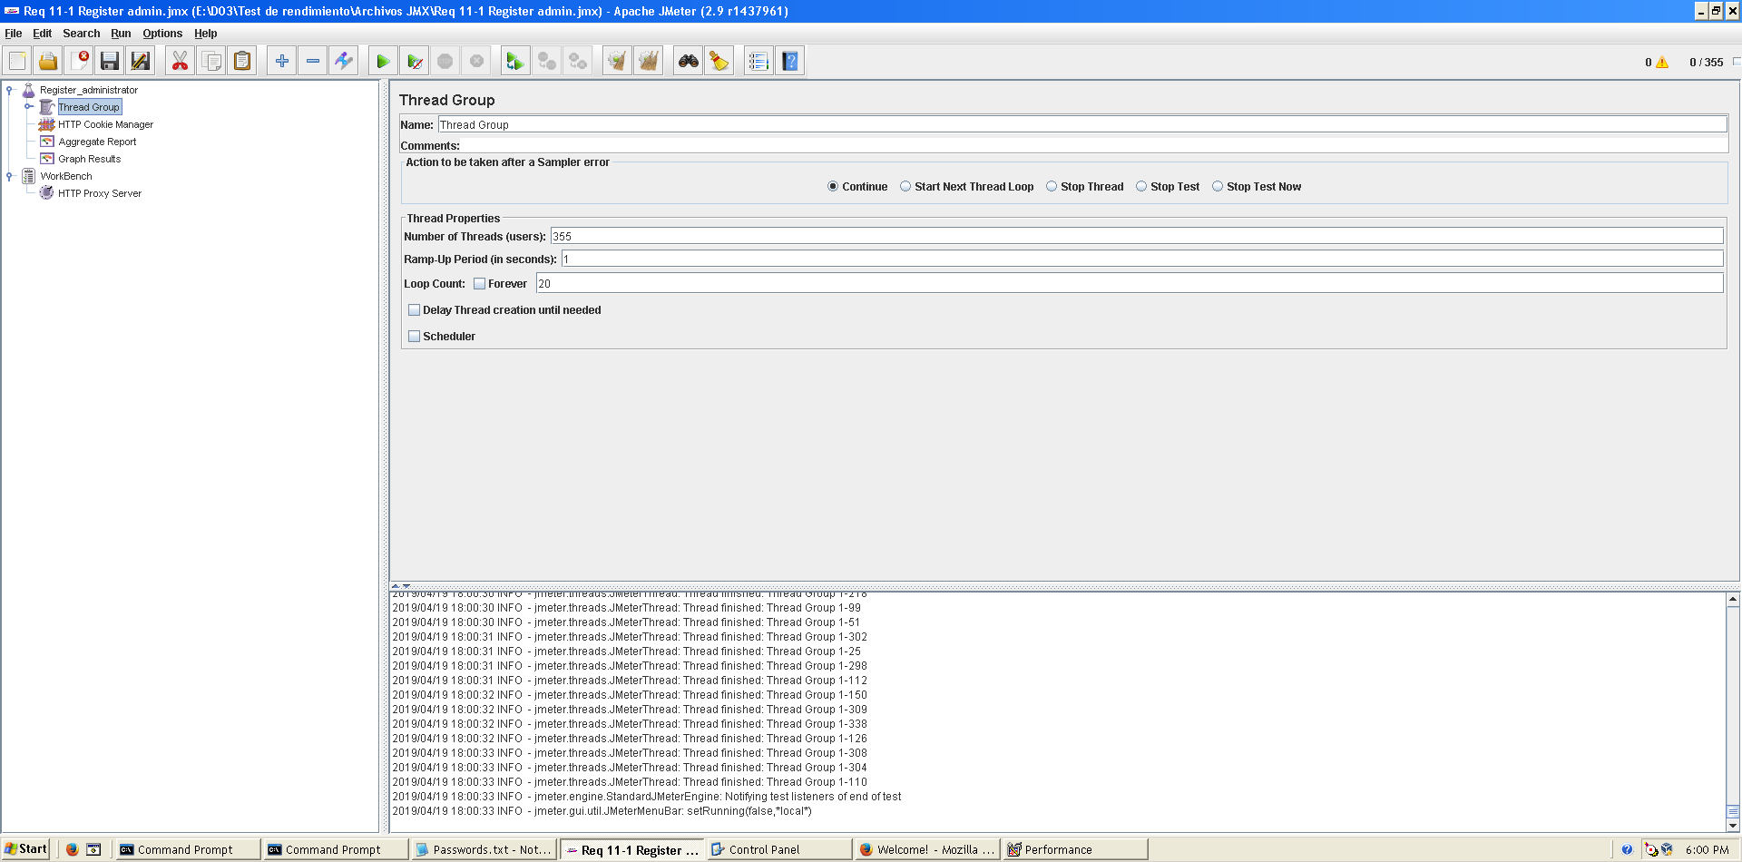

This is the maximum workload of the test case without any crash or excesive delay. As we can see in the picture below, we don’t have any errors and the average time per request is pretty acceptable.

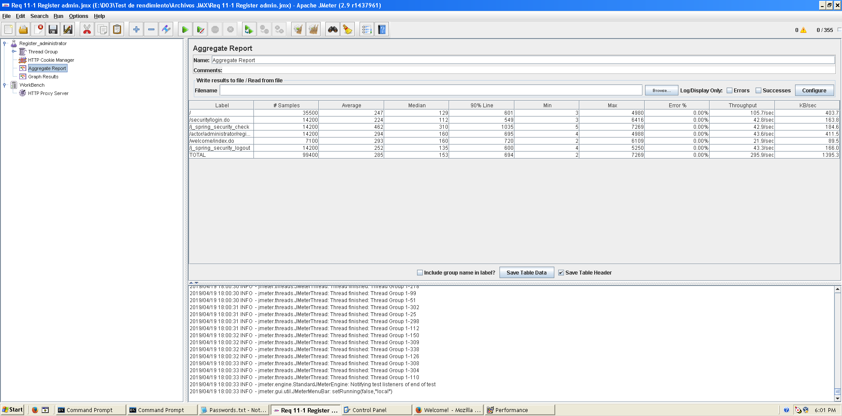

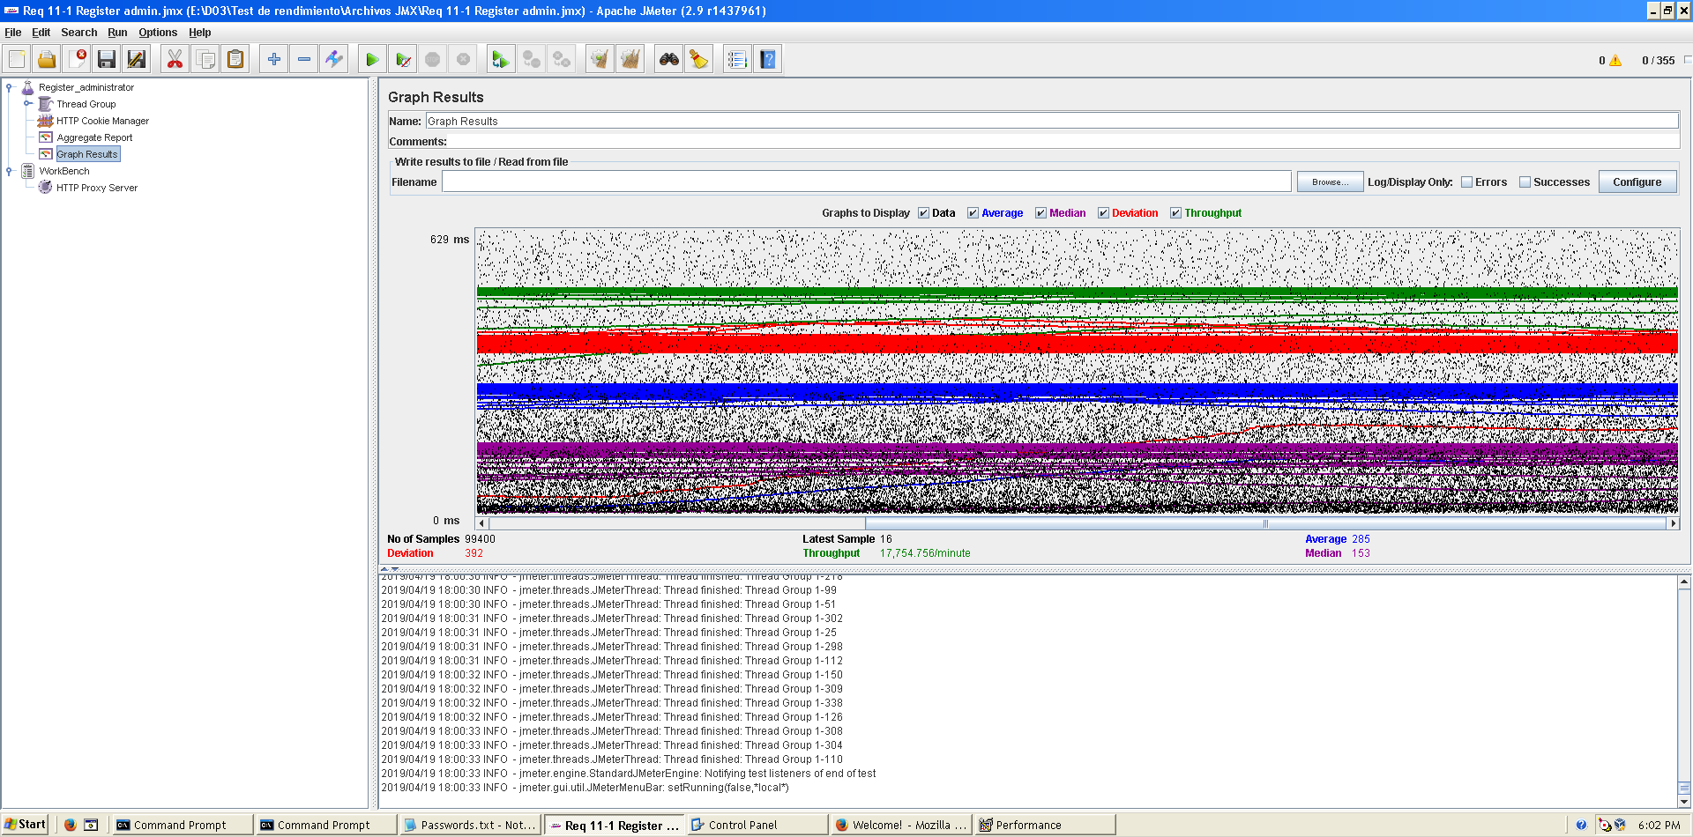**Overload test case:** 365 concurrent users and 20 of loop count:

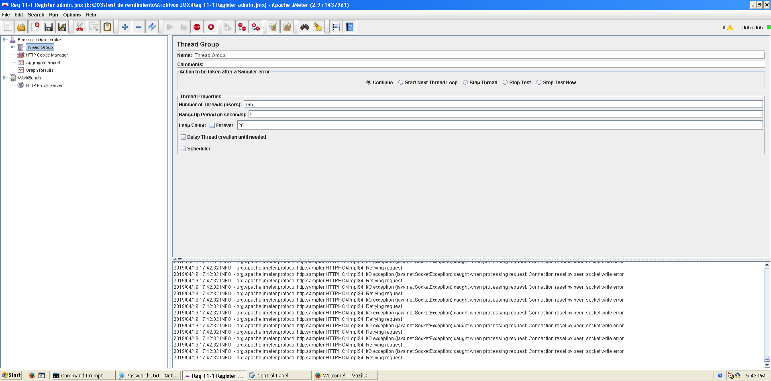

Even though the average time per request is still acceptable, it begins to produce some errors as we can see in the following picture. The errors are always the same: I/O exception (java.net.SocketException) caught when processing request: Connection reset by peer: socket write error This exception is not related with the implementation of our application, but with tomcat. The system can’t handle this number of concurrent users properly.

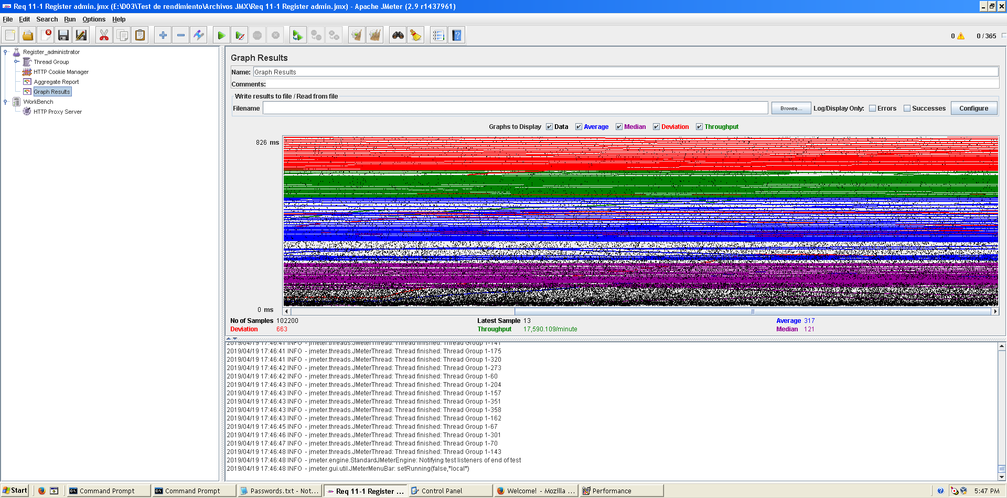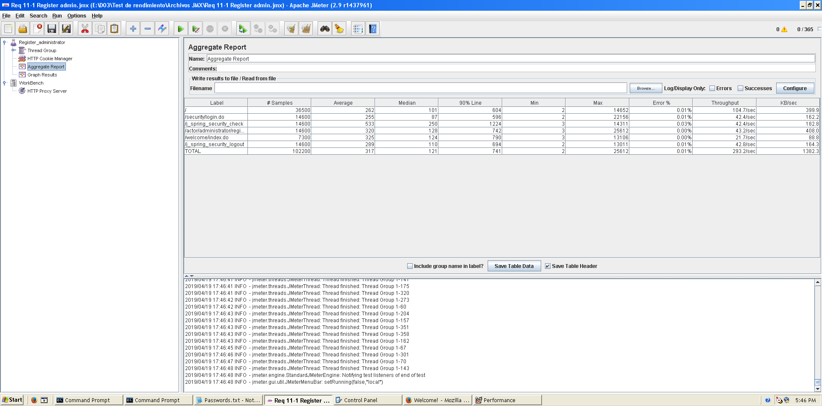

As we can see in the graph below, there is a bottleneck with the CPU. Probably we could improve the maximum workload of the application if we assign more processors to the virtual machine.

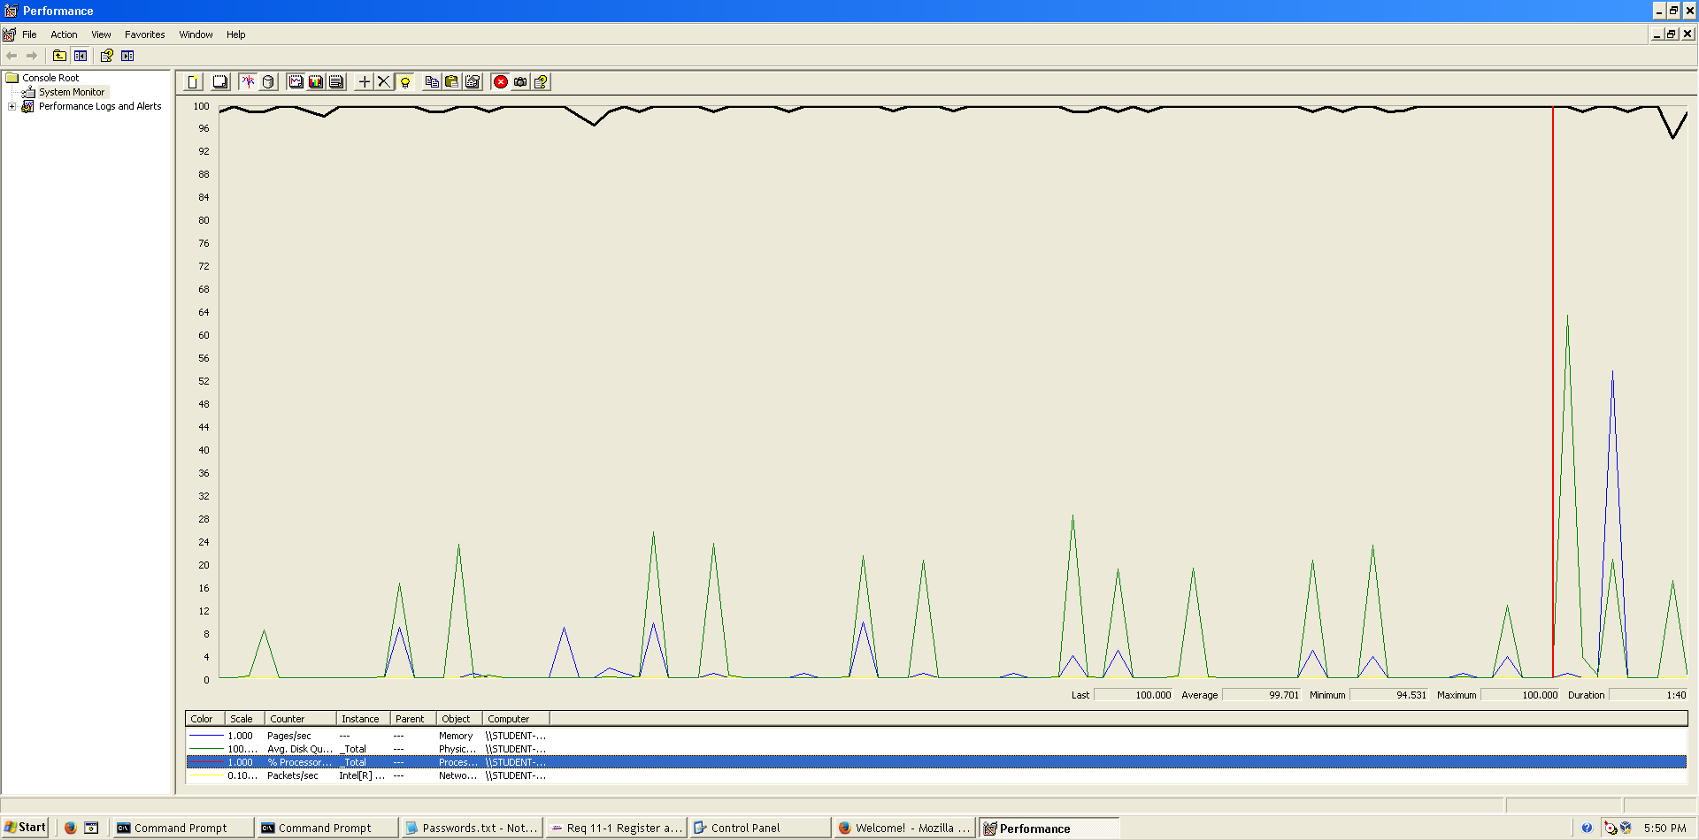

**Conclusion:** The maximum number of concurrent users supported by this test case is 355 and we could improve it by assigning more CPU’s resources to our system.

**Req. 11.2** – An actor who is authenticated as an administrator must be able to: Display a dashboard.

Technical details of the computer on which the test has been executed:

* Ram: 8,00 GB
* CPU: Intel Core i7-7700HQ
* Hard disk: 256 GB SSD + 921 GB HDD
* Network card: Intel(R) Dual Band Wireless-AC 3168

**Test case description**:

* The user logs in as an administrator.
* The user goes to dashboard view.
* The user logs out the system.

**Maximum workload test case.** 390 concurrent users and 20 of loop count:

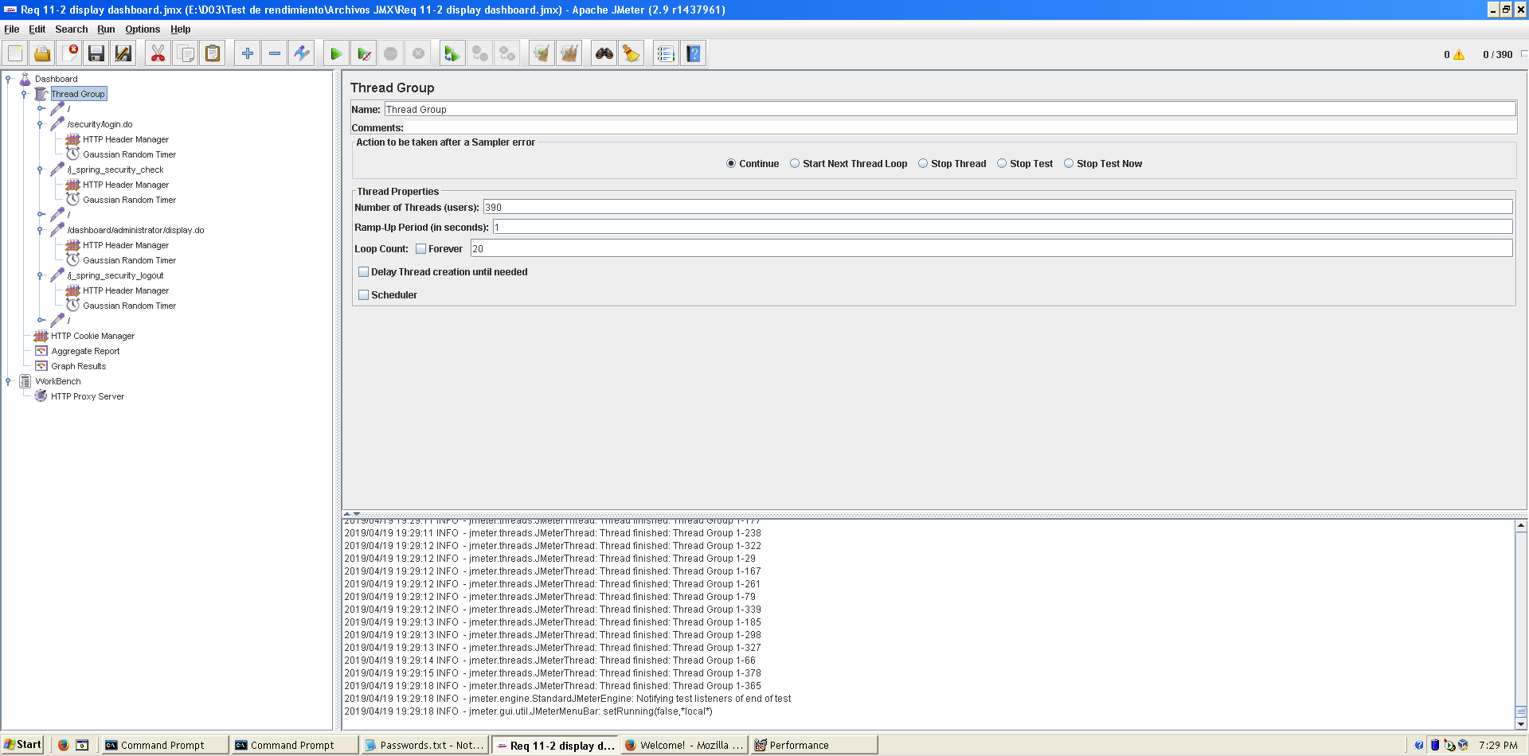

This is the maximum workload of the test case without any crash or excesive delay. As we can see in the picture below, we don’t have any errors and the average time per request is pretty acceptable.

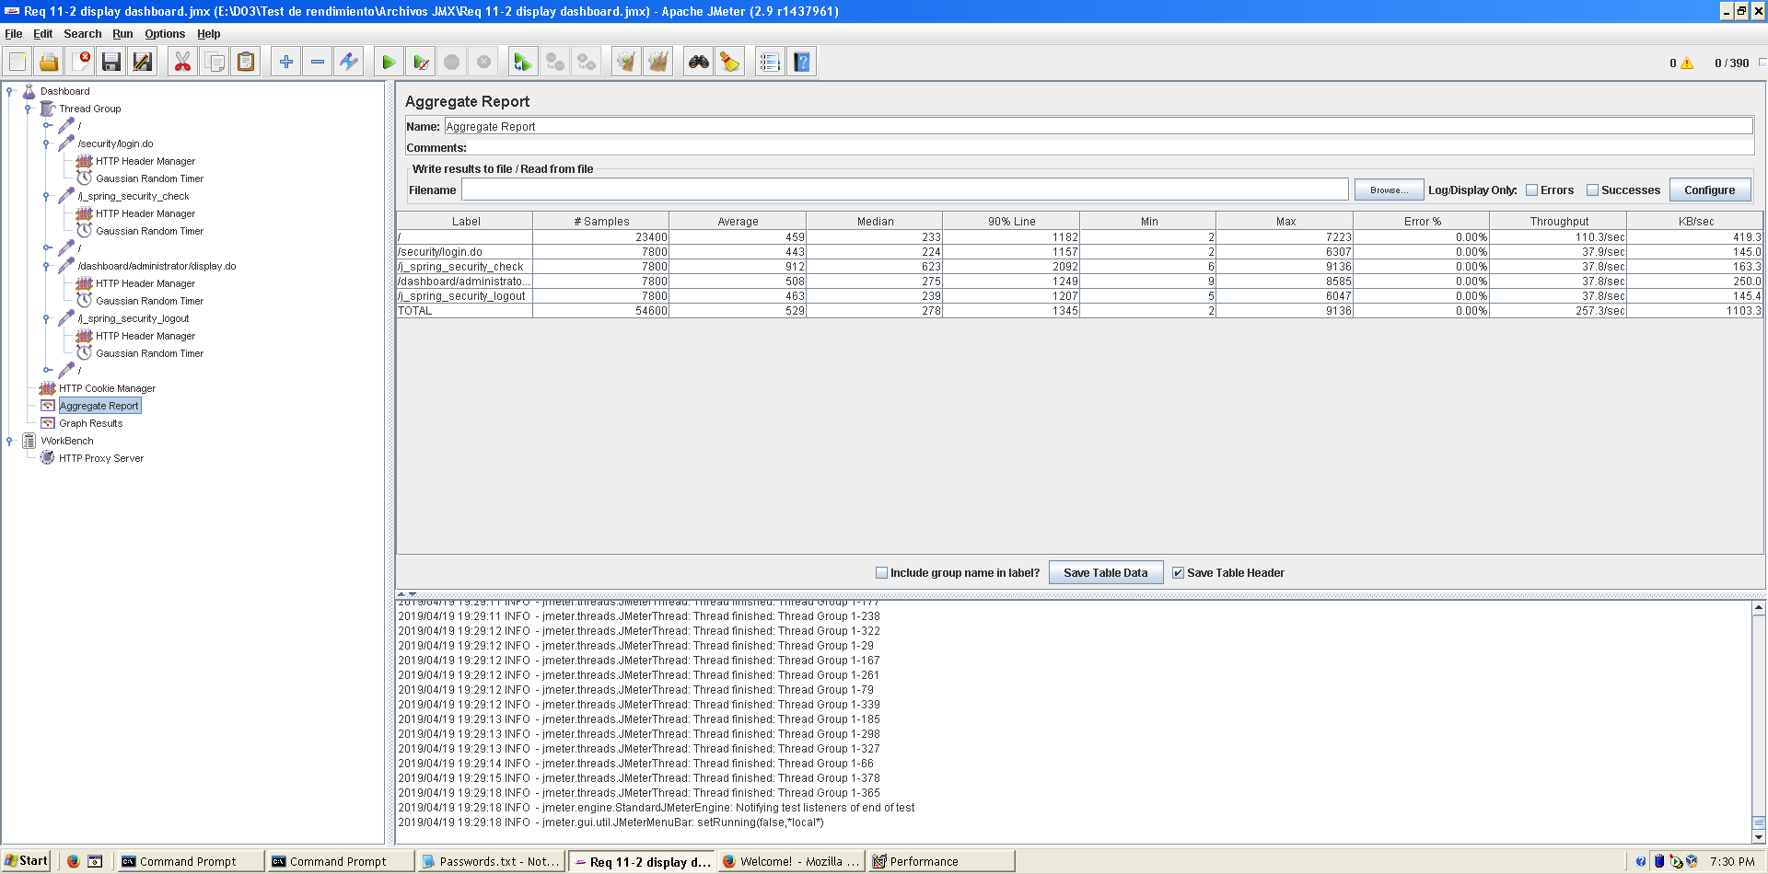

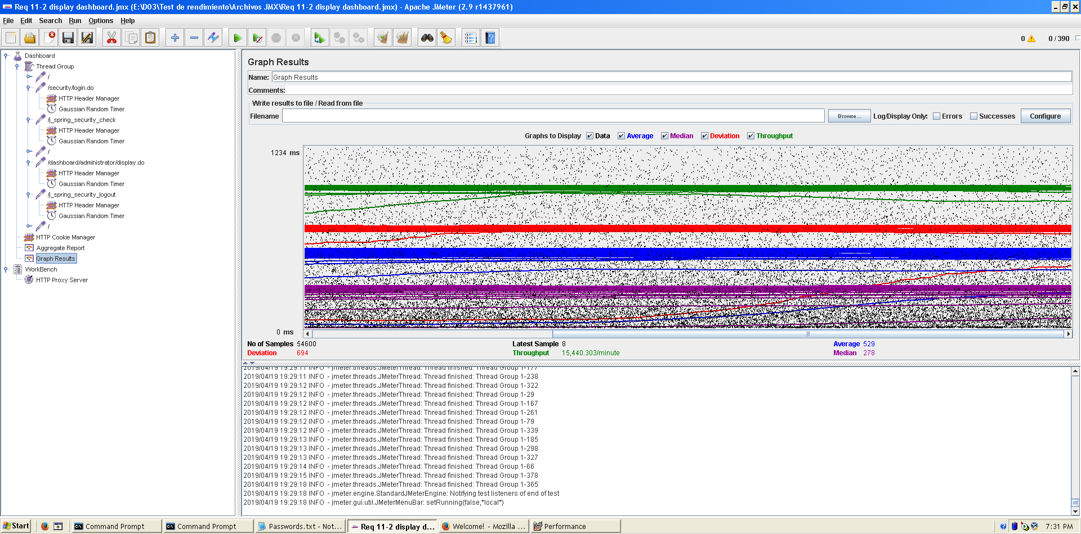  
  
**Overload test case:** 400 concurrent users and 20 of loop count:

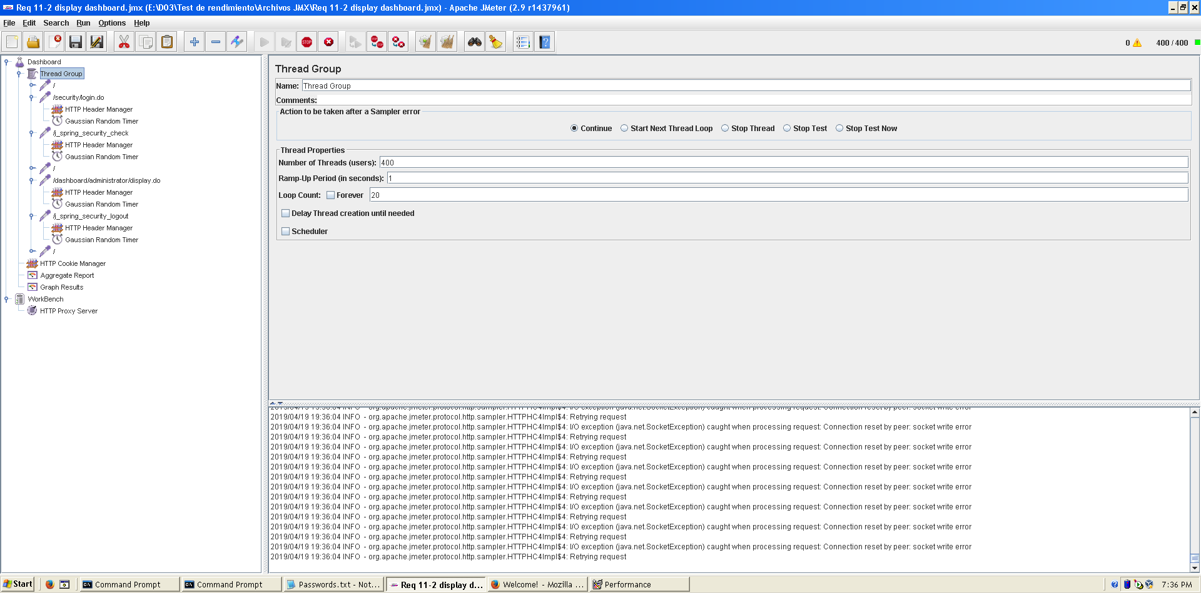

Even though the average time per request is still acceptable, it begins to produce some errors as we can see in the following picture. The errors are always the same: I/O exception (java.net.SocketException) caught when processing request: Connection reset by peer: socket write error This exception is not related with the implementation of our application, but with tomcat. The system can’t handle this number of concurrent users properly.

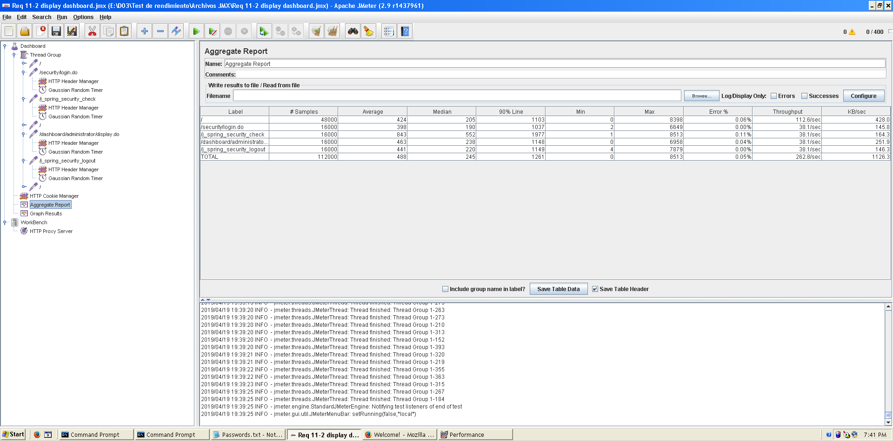

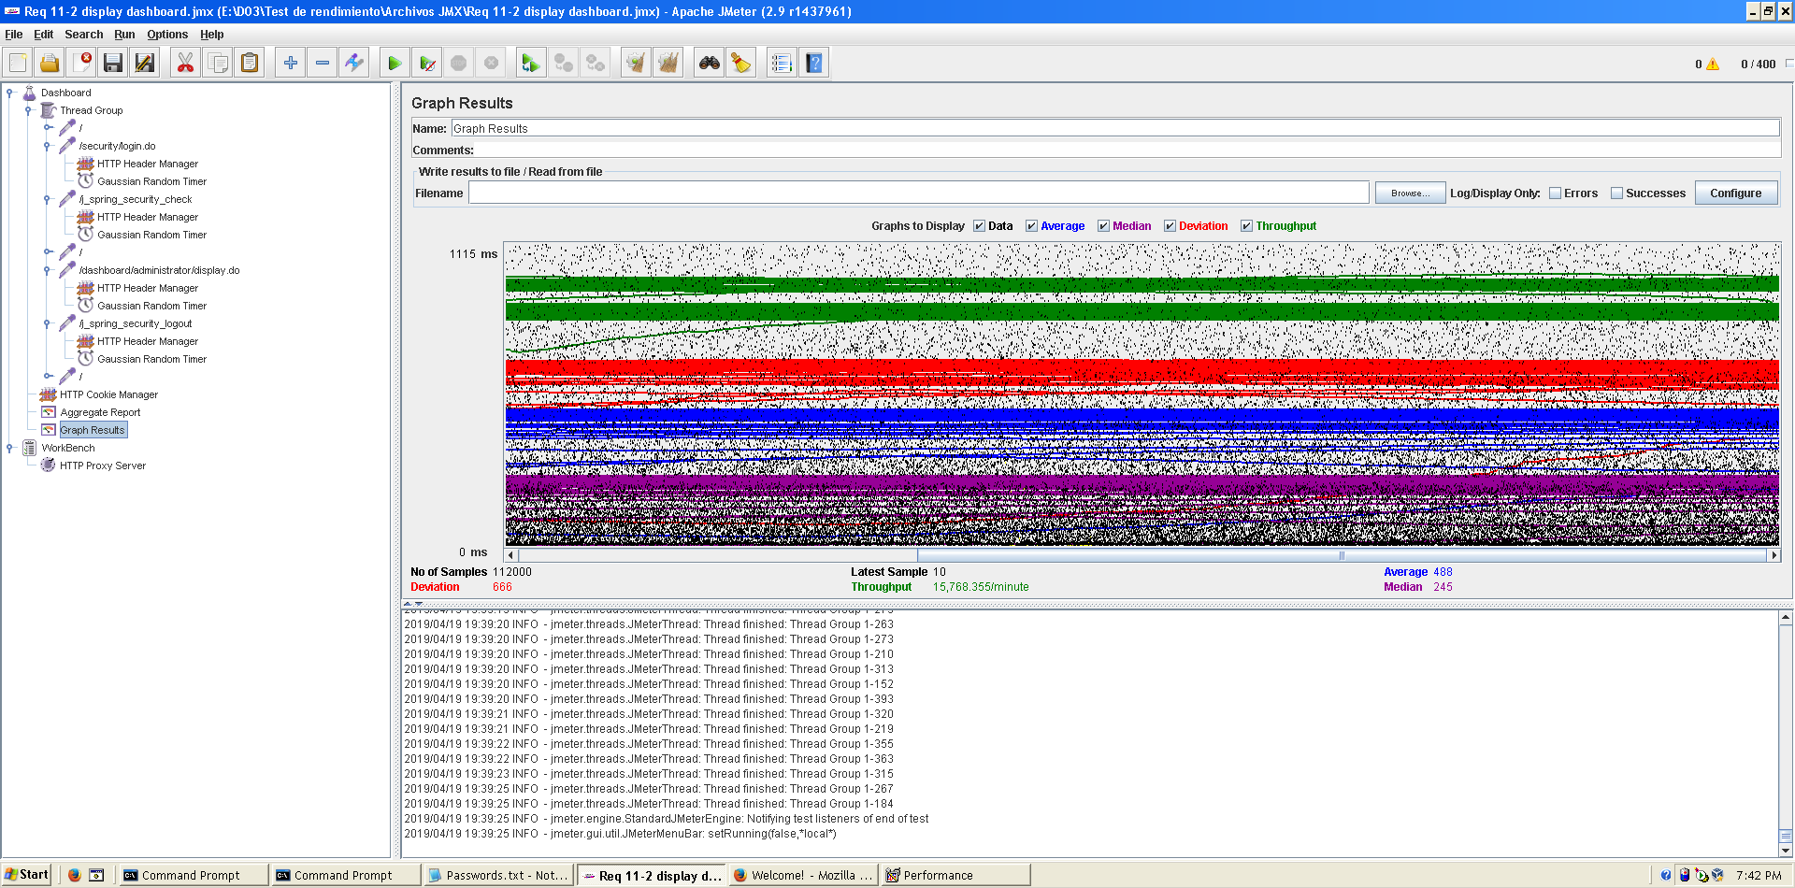

As we can see in the graph below, there is a bottleneck with the CPU. Probably we could improve the maximum workload of the application if we assign more processors to the virtual machine.

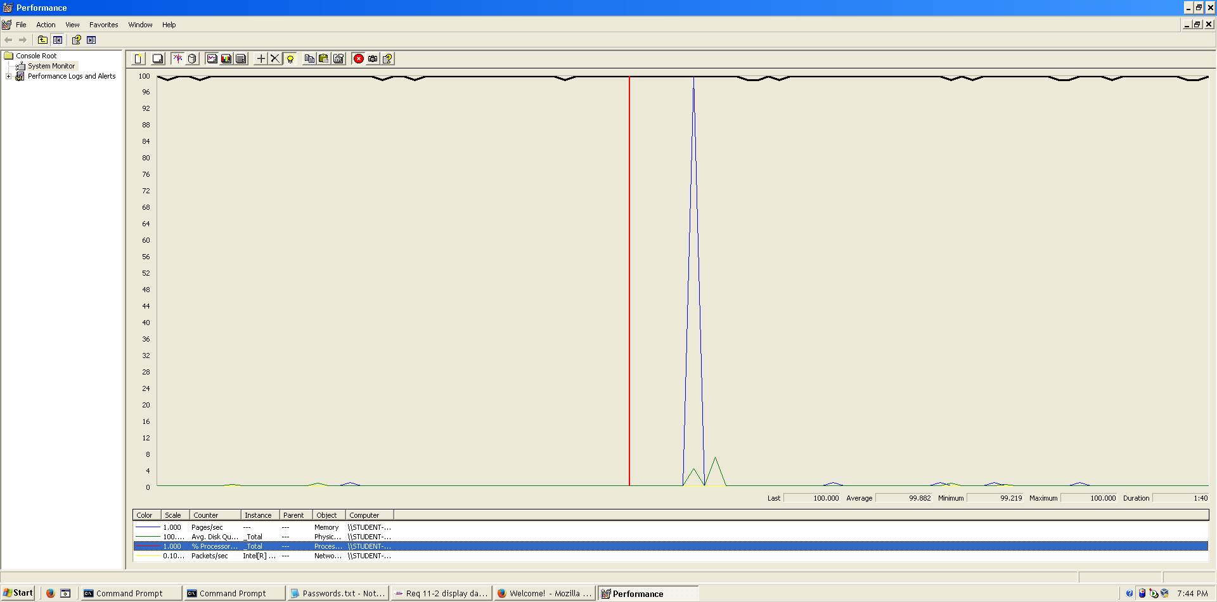

**Conclusion:** The maximum number of concurrent users supported by this test case is 390 and we could improve it by assigning more CPU’s resources to our system.

**Req. 14 -** The system must be easy to customise at run time. The customisation includes, but is not limited to: the name of the system (it’s “Acme Hacker Rank” by default); the banner shown at the header (it’s the one available at https://i.imgur.com/7b8lu4b.png by default); the message that is shown on the welcome page (“Welcome to Acme hacker Rank! We’re IT hacker’s favourite job marketplace!” is the default welcome message in English; “¡Bienvenidos a Acme Hacker Rank! ¡Somos el mercado de trabajo favorito de los profesionales de las TICs!” is the default welcome message in Spanish); and the default country code in tele-phone numbers (it’s “+34”by default).

**Req. 19 -** The results of a finder are cached for one hour by default. The administrator should be able to configure that period at will in order to adjust the performance of the system. The minimum time’s one hour and the maximum time’s 24 hours. When a user requests to clear his or her finder, the system must re-compute its results immediately.

**Req. 20 -** The maximum number of results that a finder returns is 10 by default. The administrator should be able to change this parameter in order to adjust the performance of the system. The absolute maximum is 100 results.

**Req. 26 -** The default list of spam words includes “sex”, “viagra”, “cialis”, “one million”, “you’ve been selected”, “Nigeria”, and their corresponding Spanish translations.

Technical details of the computer on which the test has been executed:

* Memory RAM: 16 GB DDR4 Memory
* CPU: Intel(R) Core (TM) i7-7500U CPU @ 2.70 GHz (4 CPUs) ~ 2.90 GHz
* Hard Disk: 256 GB SSD + 1000 GB HDD
* Interface network: Ethernet: Realtek PCIe GBE Family Controller | Wi-Fi: Qualcomm Atheros QCA9377 Wireless Network Adapter

**Test case description:** first, an user logs in as administrator. Then, the administrator displays customisation. Later, the administrator edits customisation’s parameters. Finally, the administrator logs out.

**Maximum workload test case:** 180 concurrent users, 20 of loop count and 1 of ramp-up period.

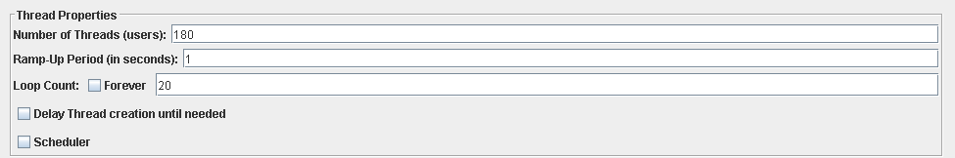

According to the performance test, this is the maximum workload that can be supported by the system without errors and failures or insufficient performance.

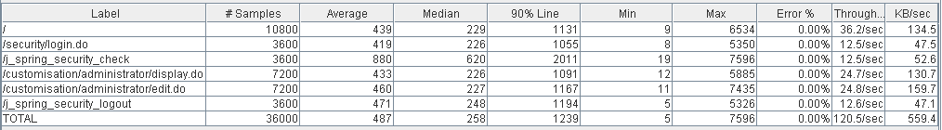

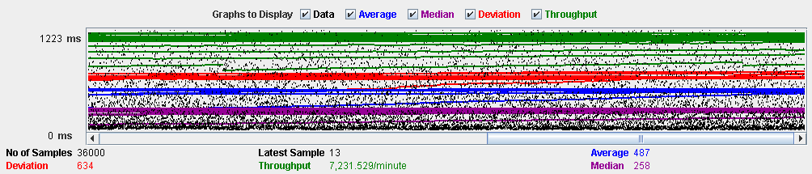

**Overload test case:** 190 concurrent users, 20 of loop count and 1 as ramp-up period.

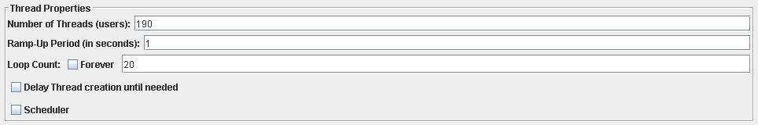

Although there aren’t errors, the average time per request is not acceptable. The request with highest time is “j_spring_security_check”, this is an internal unit of Spring. That’s means that we cannot improve the performance by refactoring the code. Surely, that event is due to a bottleneck component.

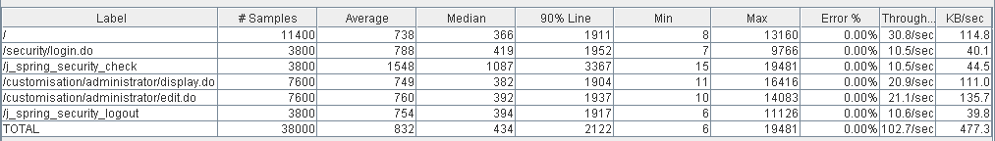

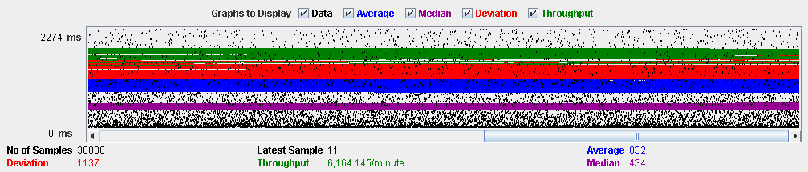

In the following performance analysis, we can appreciate that CPU is saturated. So, there is a bottleneck with CPU. If we increase the units of processor to the virtual machine, the maximum workload would be higher.

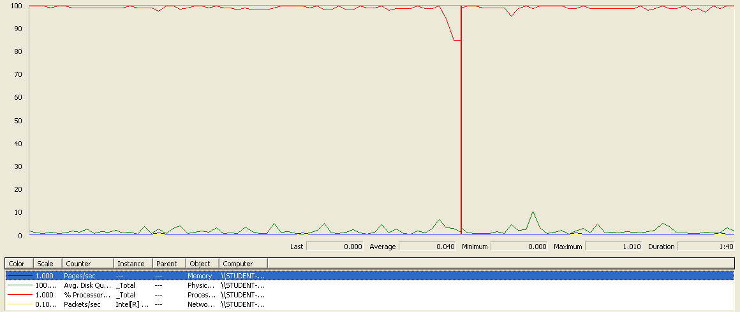

**Conclusion:** The maximum number of concurrent users supported by this test is 180 because the current CPU can handle more workload.

**Req. 17.1** – An actor who is authenticated as a hacker must be able to manage his or her curricula which includes listing, showing, creating, updating, and deleting them.

Technical details of the computer on which the test has been executed:

* Ram: 8,192 (1x) MB, DDR3L RAM (1,600 MHz)
* CPU: Intel Core i7-5500U
* Hard disk: 1 TB HDD - 5,400 rpm
* Interface network: Gigabit Ethernet LAN - 10BASE-T/100BASE-TX/1000BASE-T

**Test case description**: In this test case, we test the entire use case in only one script. This is not ideal, since the tests should as specific as possible. However, since we don’t use a CSV in jMeter to record the data used in the tests, the only way to test the performance of “delete” actions (delete curriculum for example) we need to create an object and then delete it. If we don’t do in this way, a thread can delete an entity and when the following thread try to delete the same entity, it will produce some errors (not related with performance) because is trying to delete a non-existing object in the database. So here it is the test case:

* Log in as hacker
* List his curriculum
* Create a curriculum
* Edit the title of the curriculum created
* Edit the personal data of the curriculum
* Create a position data in the curriculum
* Edit the new position data
* Delete the position data
* Create a new position data (we leave a position data created to make a more realistic test when we remove the curriculum.)
* Create an education data
* Edit the new education data
* Delete the education data
* Create a new education data (we leave an education data created to make a more realistic test when we remove the curriculum.)
* Create a miscellaneous data in the curriculum
* Edit the new miscellaneous data
* Delete the miscellaneous data
* Create a new miscellaneous data (we leave a miscellaneous data created to make a more realistic test when we remove the curriculum.)
* Delete the curriculum
* Log out

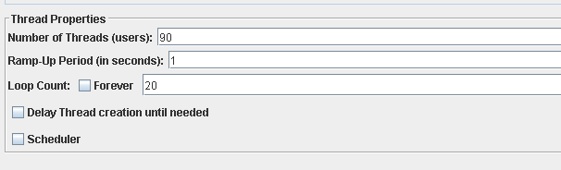**Maximum workload test case.** 90 concurrent users and 20 of loop count:

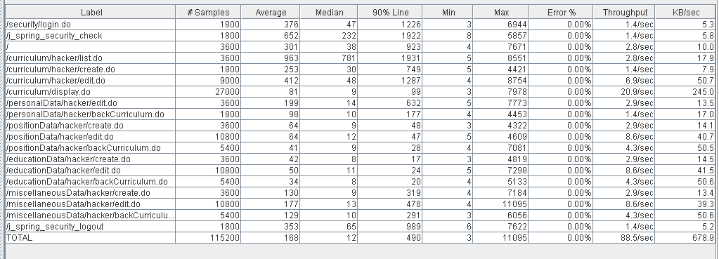This is the maximum workload of the test case without any crash or excessive delay. As we can see in the picture below, we don’t have any errors and the average time per request is acceptable.

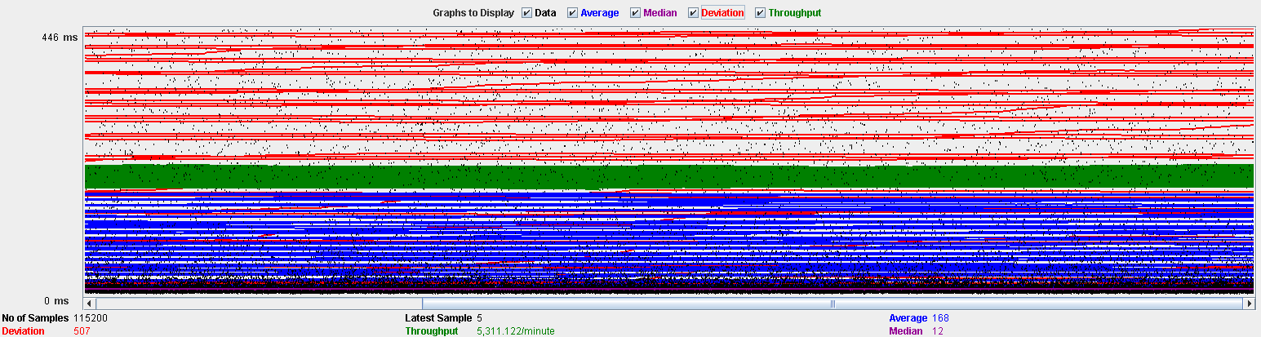

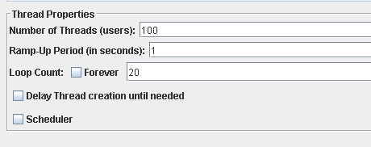**Overload test case:** 100 concurrent users and 20 of loop count:

We don’t have any errors, but the system works with excessive delay.

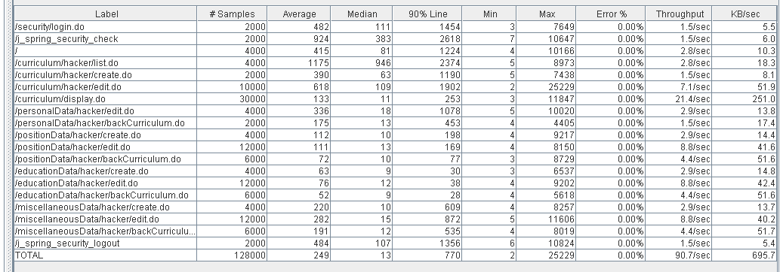As we can see in the table below, the request with the highest average time is /j_spring_security_check. This URI correspond to an internal implementation of spring, so we cannot improve the performance by refactoring the code.

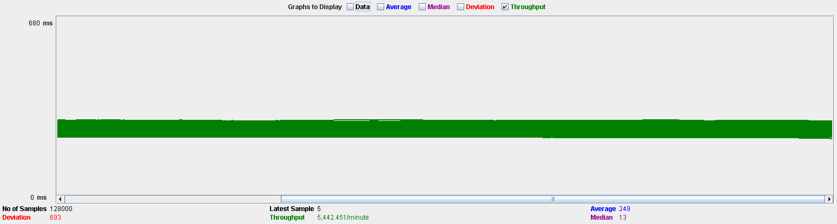

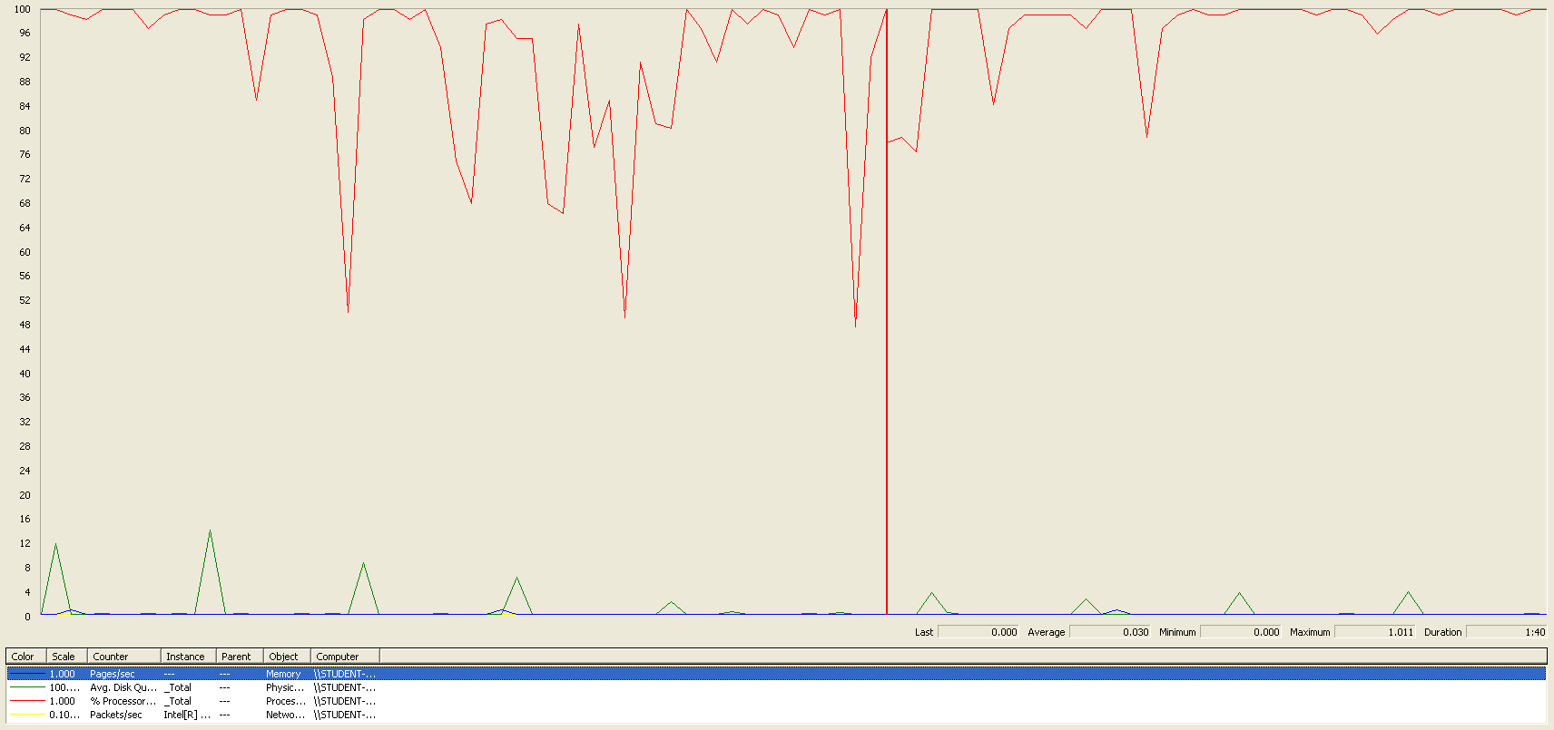In the following graphic, we can see that there is a bottleneck in the CPU. We could get a better performance improving CPU’s resources but not too much because, as we can see in the graphic, the CPU is not always working at 100%.

**Conclusion:** The maximum number of concurrent users supported by this test case is 90. We have three alternatives to improve the performance:

1. Assign more CPU’s resources to our system. But as we said previously, this probably won’t do too much.
2. Update the components of our system (tomcat for example). Updated components could have better performance.
3. Improve the Pre-Production environment quality. Using a virtual machine with windows XP could not be the best idea because Windows XP is an outdated operating system and there are much better operating systems for holding a Production environment. Using a virtual machine also reduces the real potential of the hardware of the computer.

**Req. 17.2** – An actor who is authenticated as hacker must be able to manage his or her finder, which involves updating the search criteria, listing its contents and clearing it.

Technical details of the computer on which the test has been executed:

* Ram: 8,192 (1x) MB, DDR3L RAM (1,600 MHz)
* CPU: Intel Core i7-5500U
* Hard disk: 1 TB HDD - 5,400 rpm
* Interface network: Gigabit Ethernet LAN - 10BASE-T/100BASE-TX/1000BASE-T

**Test case description:**

* Log in as hacker
* Go to Finder view
* Clear the Finder
* Edit Finder with key word “56”, maximum deadline “12/12/2019” and minimum salary “5.0”.
* Log out

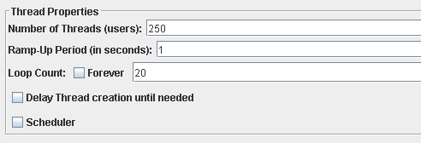**Maximum workload test case.** 250 concurrent users and 20 of loop count:

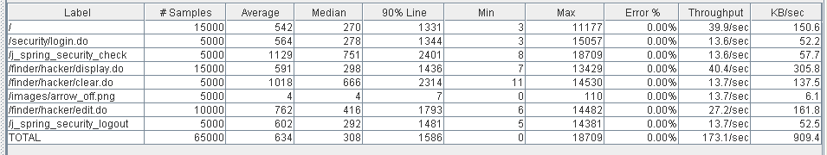This is the maximum workload of the test case without any crash or excessive delay. As we can see in the picture below, we don’t have any errors and the average time per request is high for some requests, but still acceptable.

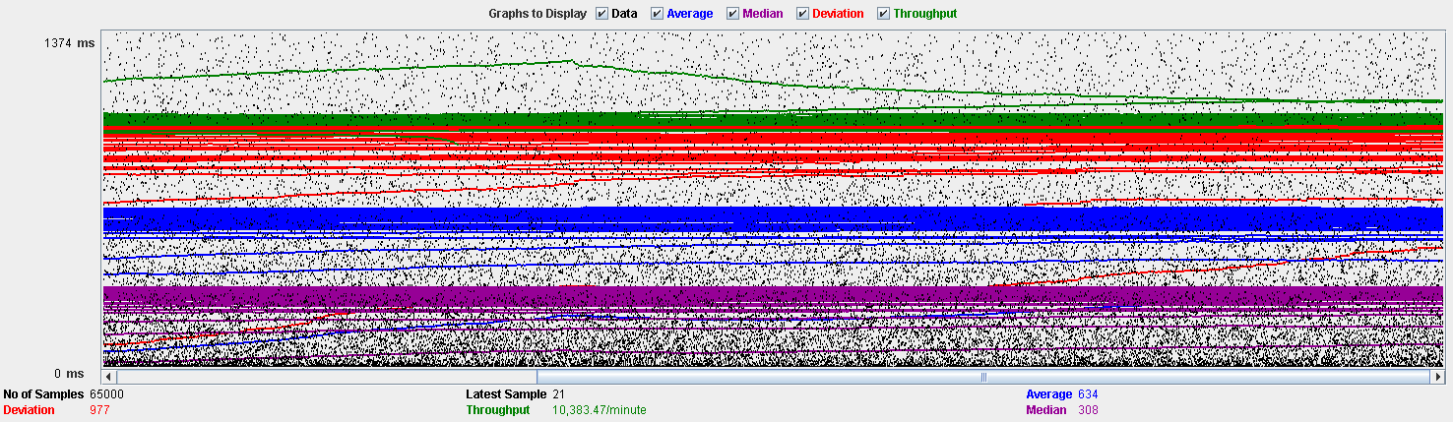

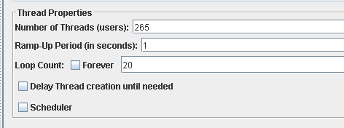**Overload test case:** 265 concurrent users and 20 of loop count:

We don’t have any errors, but the system works with excessive delay.

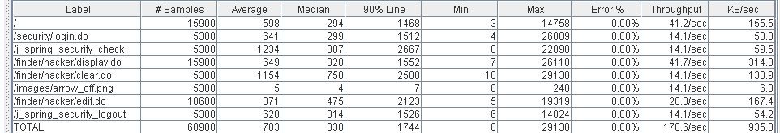As we can see in the table below, the request with the highest average time is /j_spring_security_check. This URI correspond to an internal implementation of spring, so we cannot improve the performance by refactoring the code.

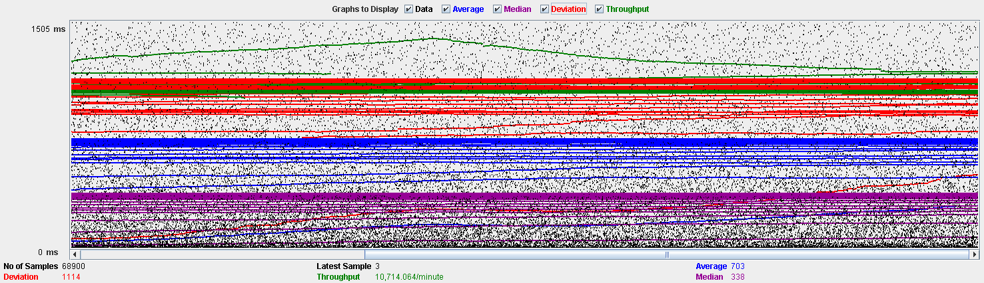

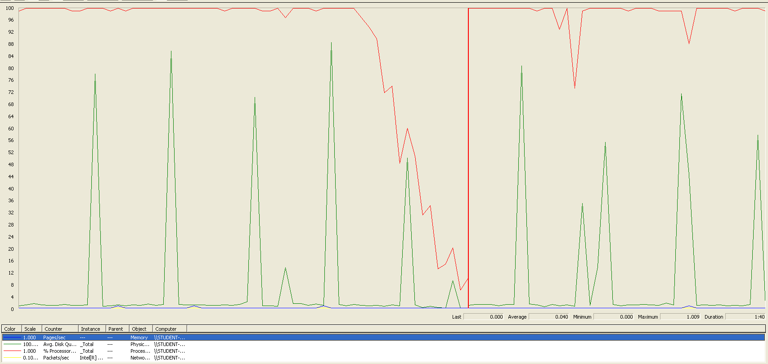In the following graphic, we can see that there is a bottleneck in the CPU. We can see also some spikes of the hard drive, but it’s not important since the spikes never reach the 100% of capability. So, we could improve the maximum workload of the application if we assign more processors to the virtual machine.

**Conclusion:** The maximum number of concurrent users supported by this test case is 250. We could improve the performance by assigning more CPU’s resources to our system.

**Req. 21 -** The actors of the system can register their social profiles. The system must store the following data regarding them: a nick, the name of the social network, a link to a profile in that social network.

**Req. 23.1 -** An actor who is authenticated must be able to: Manage his or her social profiles, which includes listing, showing, creating, updating, and deleting them.

Technical details of the computer on which the test has been executed:

* Memory RAM: 16 GB DDR4 Memory
* CPU: Intel(R) Core (TM) i7-7500U CPU @ 2.70 GHz (4 CPUs) ~ 2.90 GHz
* Hard Disk: 256 GB SSD + 1000 GB HDD
* Interface network: Ethernet: Realtek PCIe GBE Family Controller | Wi-Fi: Qualcomm Atheros QCA9377 Wireless Network Adapter

**Test case description:** first, an authenticated user logs in to the system. Next, he or she goes to his or her profile. Later, the user lists their social profiles and creates a new social profile. Below, the user edits the newly social profile. Then, a social profile is displayed. Immediately, the edited social profile is deleted from the system. Finally, the user is logs out. The entire use case is tested by means of a unique script. It’s not a recommendable strategy.

**Maximum workload test case:** 170 concurrent users, 20 of loop count and 1 as ramp-up period:

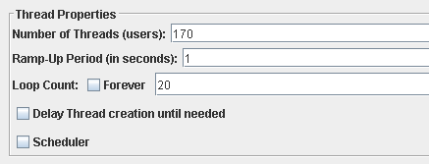

As we can check with the next report, there are not errors and the performance is acceptable.

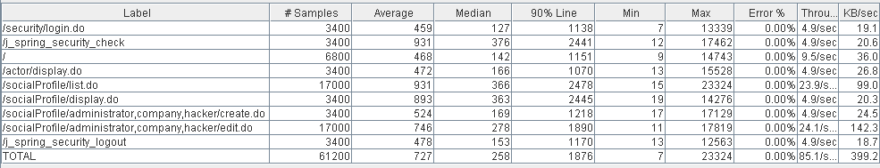

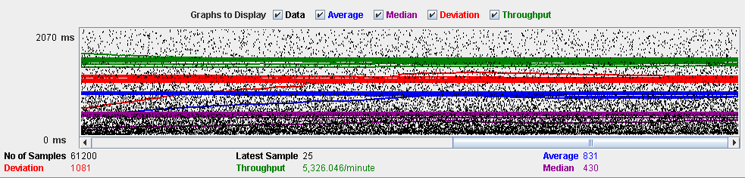

**Overload test case:** 175 concurrent users and 20 of loop count and 1 as ramp-up period:

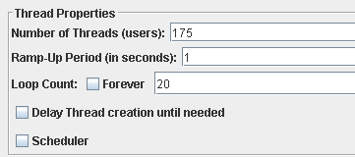

Even though it doesn’t produce any errors, the average time per request is not acceptable. It very possible that a component or several components are bottleneck.

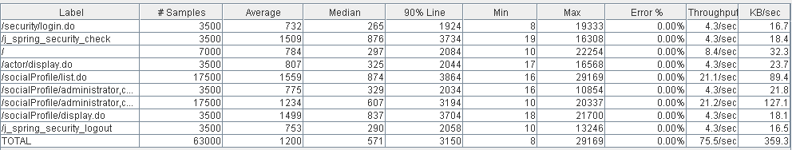

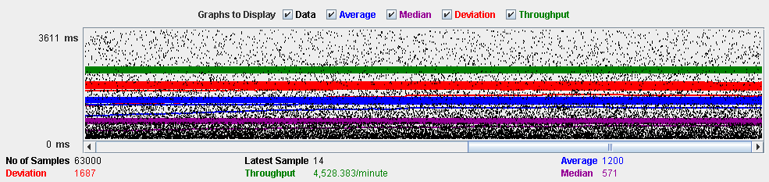

We can see in the figure 14, the CPU is saturated (it’s running at 90%-100% all the time) and hard disk presents frequently spikes at 100%.

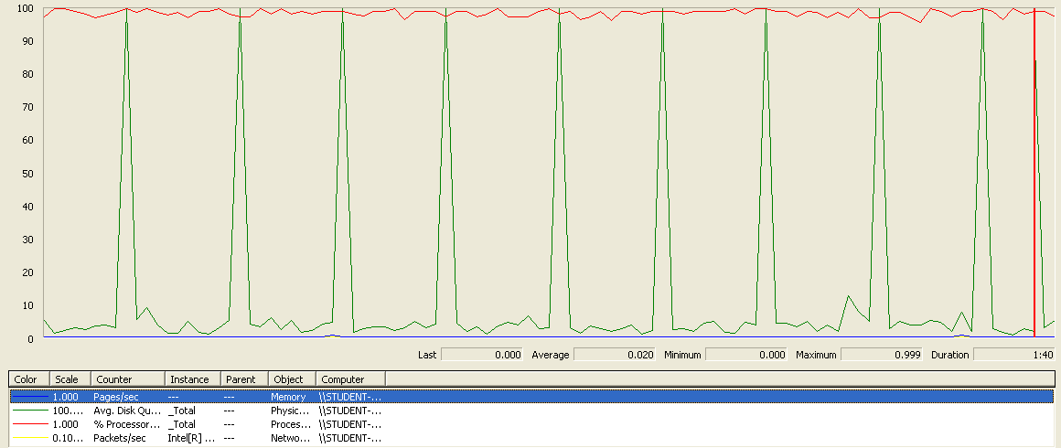

**Conclusion:** it seems that the bottleneck are CPU and Hard disk: replacing them with more powerful components might boost the system. It’s not necessary to update the interface network and memory.

**Req. 22 -** Every actor has a pool of messages. For every message, the system must keep track of the sender, the recipient, the moment when it was sent, the subject, its body, and some option-al tags.

**Req. 23.2 -** Manage his or her messages, which includes listing them grouped by tag, showing them, sending a message to an actor, deleting a message that he or she’s got. If a message is deleted and it doesn’t have tag “DELETED” then it gets tag “DELETED”, but it’s not actually deleted from the system; if a message with tag “DELETED” is deleted, then it’s actually removed from the system.

Technical details of the computer on which the test has been executed:

* Memory RAM: 16 GB DDR4 Memory
* CPU: Intel(R) Core (TM) i7-7500U CPU @ 2.70 GHz (4 CPUs) ~ 2.90 GHz
* Hard Disk: 256 GB SSD + 1000 GB HDD
* Interface network: Ethernet: Realtek PCIe GBE Family Controller | Wi-Fi: Qualcomm Atheros QCA9377 Wireless Network Adapter

**Test case description:** first, an authenticated user logs in to the system. Then, the user lists their messages. Immediately, he or she sends a message. Next, a message is displayed. Later, a message is tagged as “DELETED” by the user. After, the message is deleted. Lastly, the user logs out. As happened in social profile’s use case, we use a unique script to test the entire use case.

**Maximum workload test case:** 10 concurrent users, 20 of loop count and 1 of ramp-up period:

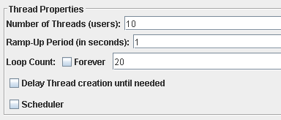

The below reports allow us to check that this is the maximum performance of the system. There are not errors and the performance is good.

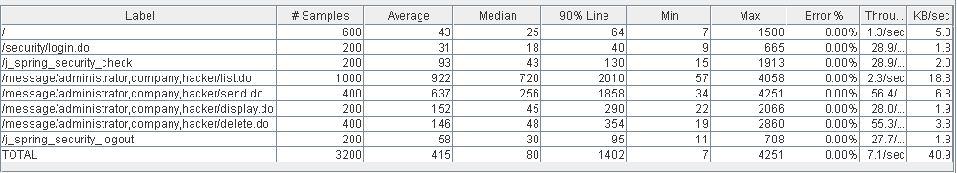

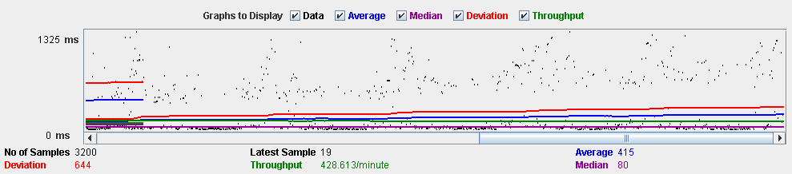

**Overload test case:** 12 concurrent users, 20 of loop count and 1 as ramp-up period:

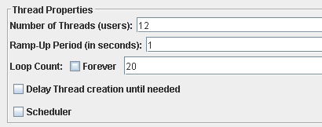

We have not any errors, but the system works with excessive delay. The system takes so much when the messages are listed and a message is sent. Analysing the code, the method MessageService::messageIsSpam is very inefficient due to we must check word by word that the message doesn’t contain a spam word. This method is invoked when a message is sent or when an administrator broadcasts a notification message.

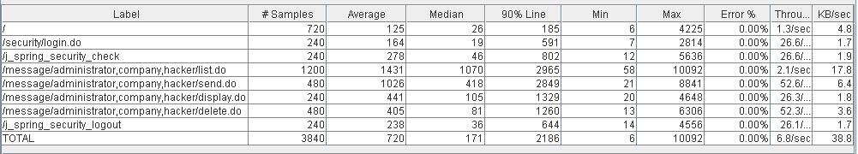

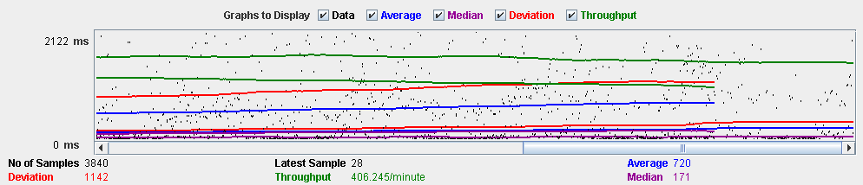

The following picture allow us to check that the CPU works at 100% several time. If we assign more CPU resources, we would get a little improvement. Regarding hard disk, it doesn’t compromise the performance of the system. The other components are idle.

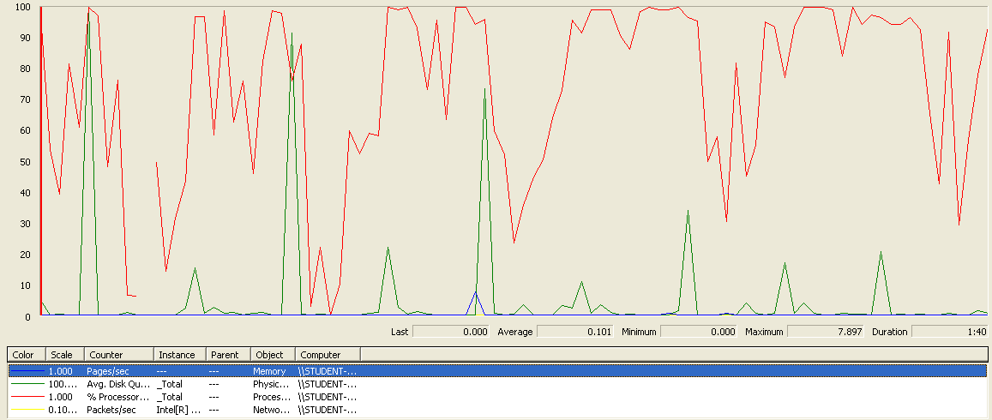

**Conclusion:** we would a little improvement if we replace the current CPU by other more powerful. But we get essential progress if we refactor the code (the method MessageService::messageIsSpam principally).

**Req. 24.1 -** Broadcast a notification message to the actors of the system. The message must have tag “SYSTEM” by default.

Technical details of the computer on which the test has been executed:

* Memory RAM: 16 GB DDR4 Memory
* CPU: Intel(R) Core (TM) i7-7500U CPU @ 2.70 GHz (4 CPUs) ~ 2.90 GHz
* Hard Disk: 256 GB SSD + 1000 GB HDD
* Interface network: Ethernet: Realtek PCIe GBE Family Controller | Wi-Fi: Qualcomm Atheros QCA9377 Wireless Network Adapter

**Test case description:** first, an administrator logs in to the system. Then, an administrator goes to his or her messages list. Later, an administrator broadcasts a notification message. Finally, the administrator logs out.

**Maximum workload test case:** 11 concurrent users, 20 of loop count and 1 of ramp-up period:

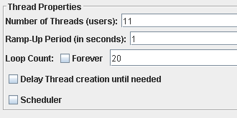

This is the maximum performance of the system without errors and failures or notable delays.

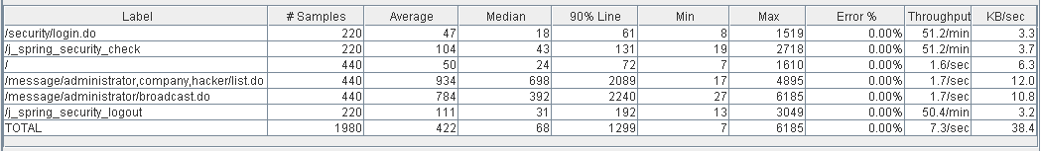

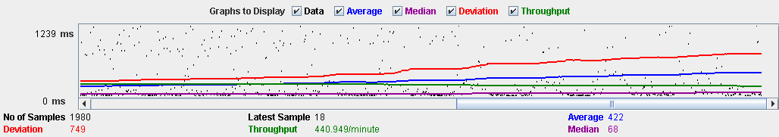

**Overload test case:** 12 concurrent users, 20 of loop count and 1 as ramp-up period:

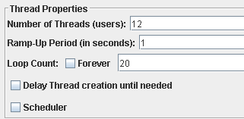

Apparently, there are not errors but the average time per request is not enough good as we can check in the next reports. The system suffers to retrieve the message list of the administrator and when system must send the notification message to all the actors. We have the same problem with the previous performance test (Message’s test performance). The method MessageService::messageIsSpam is not efficient.

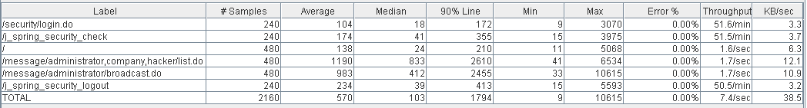

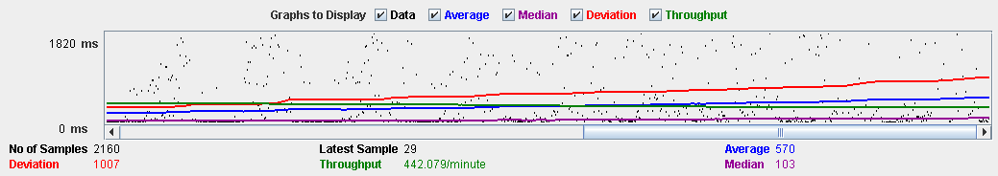

In the next graph, we can see that CPU and hard disk are running at 100 % frequently. If we replace them by other components, we can appreciate a minor progress.

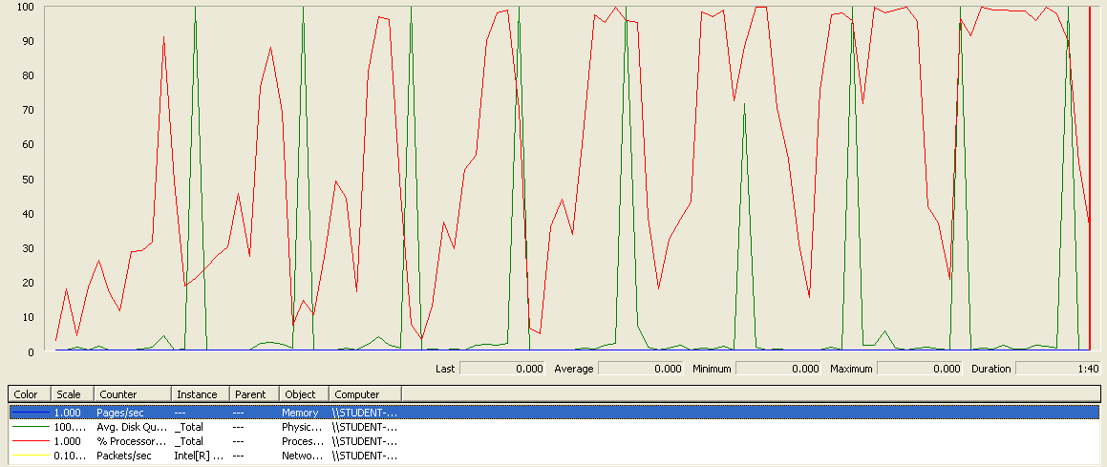

**Conclusion:** the current CPU and hard disk can’t handle the current workload. if we would use a more powerful CPU and hard disk, the system would support a higher workload. The other components have not to be updated. Besides, if we improve the code (MessageService::messageIsSpam principally), the system would support a higher workload.

**Req. 24.2 -** Launch a process that flags the actors of the system as spammers or not-spammers. A user is considered to be a spammer if at least 10% of the messages that he or she’s sent contain at least one spam word.

Technical details of the computer on which the test has been executed:

* Memory RAM: 16 GB DDR4 Memory
* CPU: Intel(R) Core (TM) i7-7500U CPU @ 2.70 GHz (4 CPUs) ~ 2.90 GHz
* Hard Disk: 256 GB SSD + 1000 GB HDD
* Interface network: Ethernet: Realtek PCIe GBE Family Controller | Wi-Fi: Qualcomm Atheros QCA9377 Wireless Network Adapter

**Test case description:** first, an administrator logs in to the system. Then, an administrator goes to actor list. Later, an administrator launches the process. Finally, the administrator logs out.

**Maximum workload test case:** 120 concurrent users, 20 of loop count and 1 of ramp-up period:

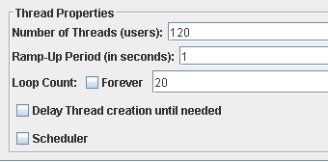

By means of this report, we can appreciate the maximum performance of the system. It doesn’t produce errors and the performance is acceptable.

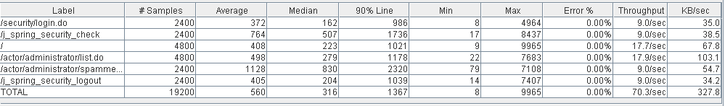

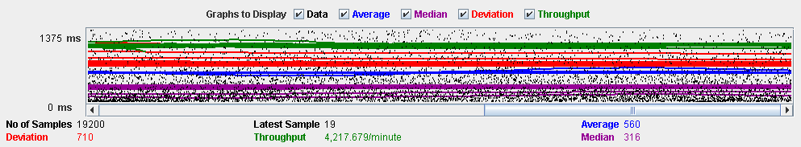

**Overload test case:** 130 concurrent users, 20 of loop count and 1 as ramp-up period:

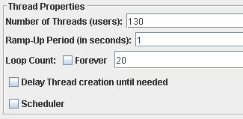

There are not errors but the average time per request is not good. The higher average time corresponds to /actor/administrator/spammer.do. This is an implementation of our application. If we refactor the code, the system would support more concurrent users.

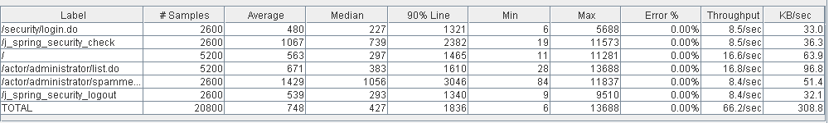

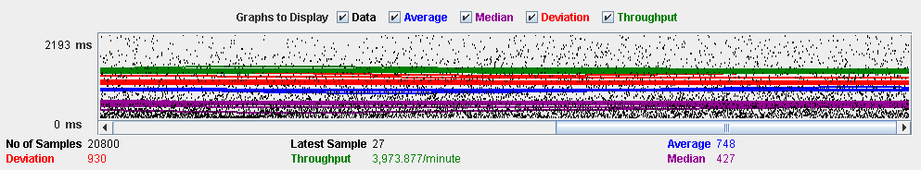

As we can see, CPU is running at 90-100 % all the time. So, CPU can’t handle this workload (bottleneck).

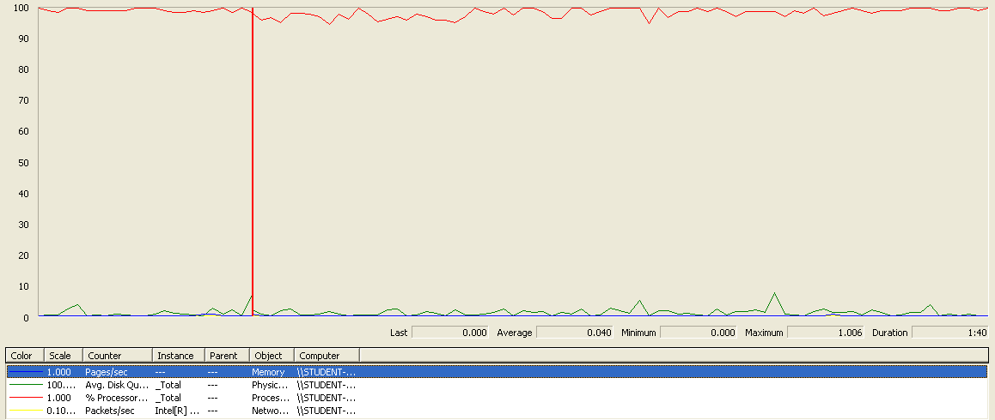

**Conclusion:** if we increase the CPU resources and we refactor the code, the maximum workload would be higher than the current maximum workload.

**Req. 24.3** – An actor who is authenticated as an administrator must be able to: Ban an actor with the spammer flag.

Technical details of the computer on which the test has been executed:

* Ram: 8,00 GB
* CPU: Intel Core i7-7700HQ
* Hard disk: 256 GB SSD + 921 GB HDD
* Network card: Intel(R) Dual Band Wireless-AC 3168

**Test case description**:

* The user logs in as an administrator.
* The user goes to actor list view.
* The user launchs spammer process.
* The user display the profile of actor who has spammer flag.
* The user bans the actor
* The user logs out the system.

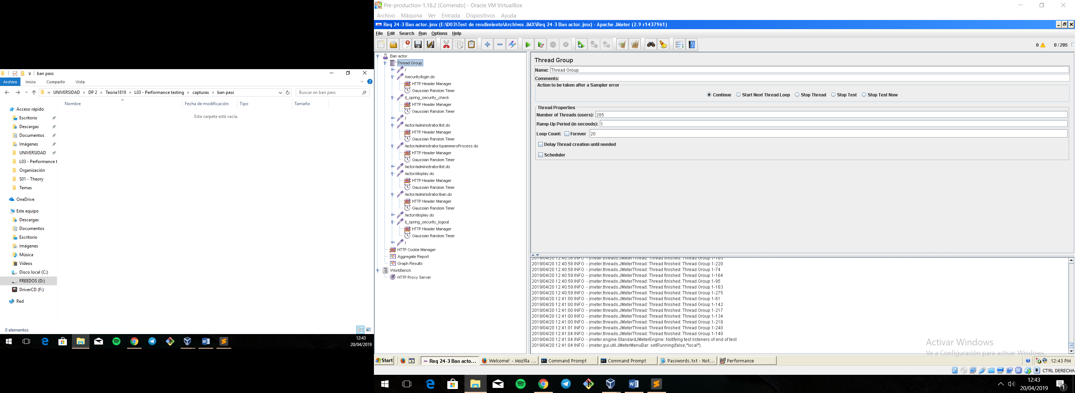**Maximum workload test case.** 285 concurrent users and 20 of loop count:

Figura 53. Configuration

This is the maximum workload of the test case without any crash or excesive delay. As we can see in the picture below, we don’t have any errors and the average time per request is pretty acceptable.

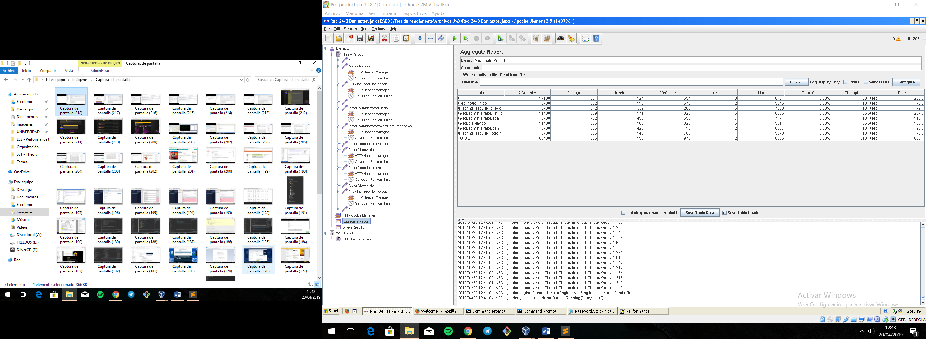

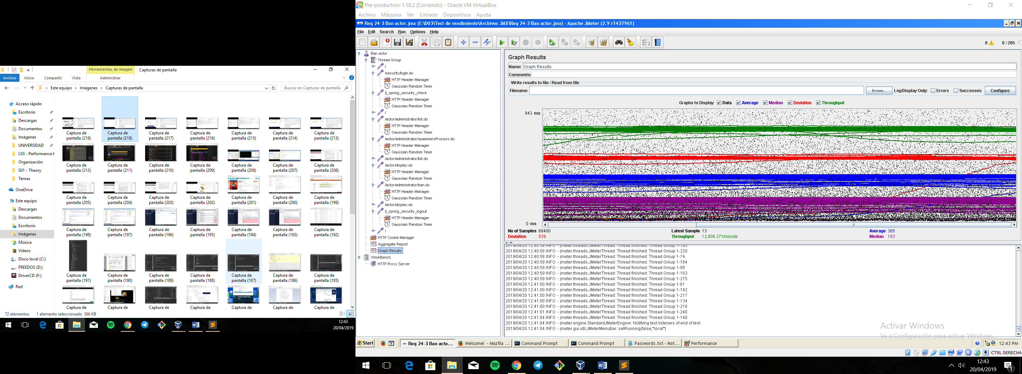

Figura 56. Graph result

**Overload test case:** 295 concurrent users and 20 of loop count:

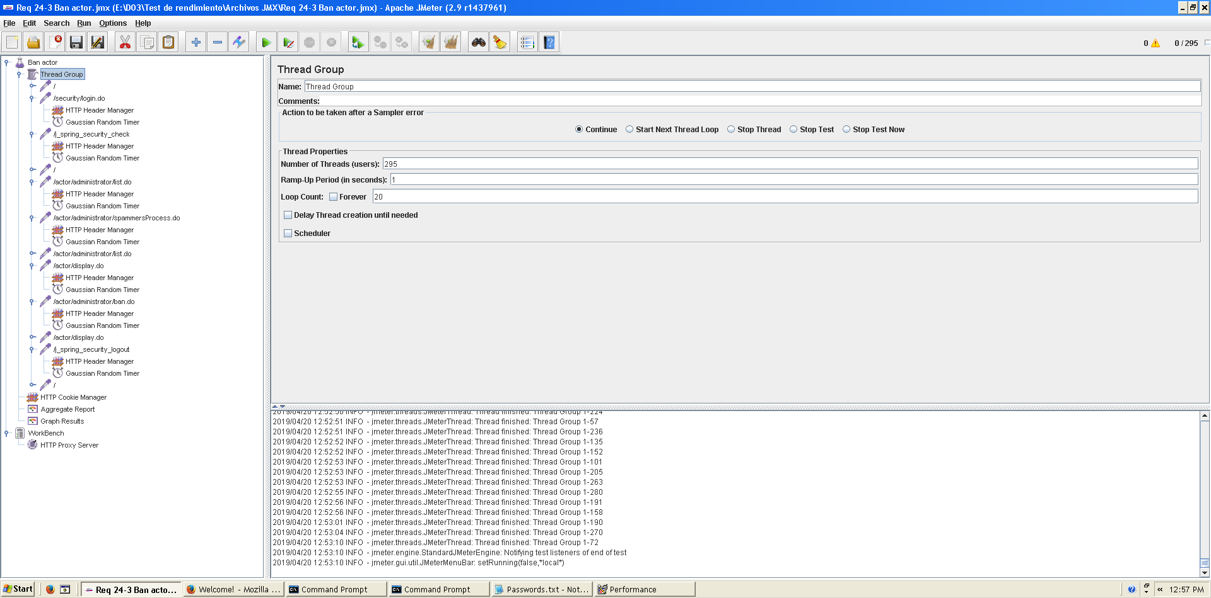

We don’t have any errors, but the system works with excessive delay.

As we can see in the table below, the request with the highest average time is /actor/administrator/spammerProcess. This URI correspond to a method that goes over all the actors of the system and analyze their messages to set spammer flags so we can improve and refactoring the code to increase the users.

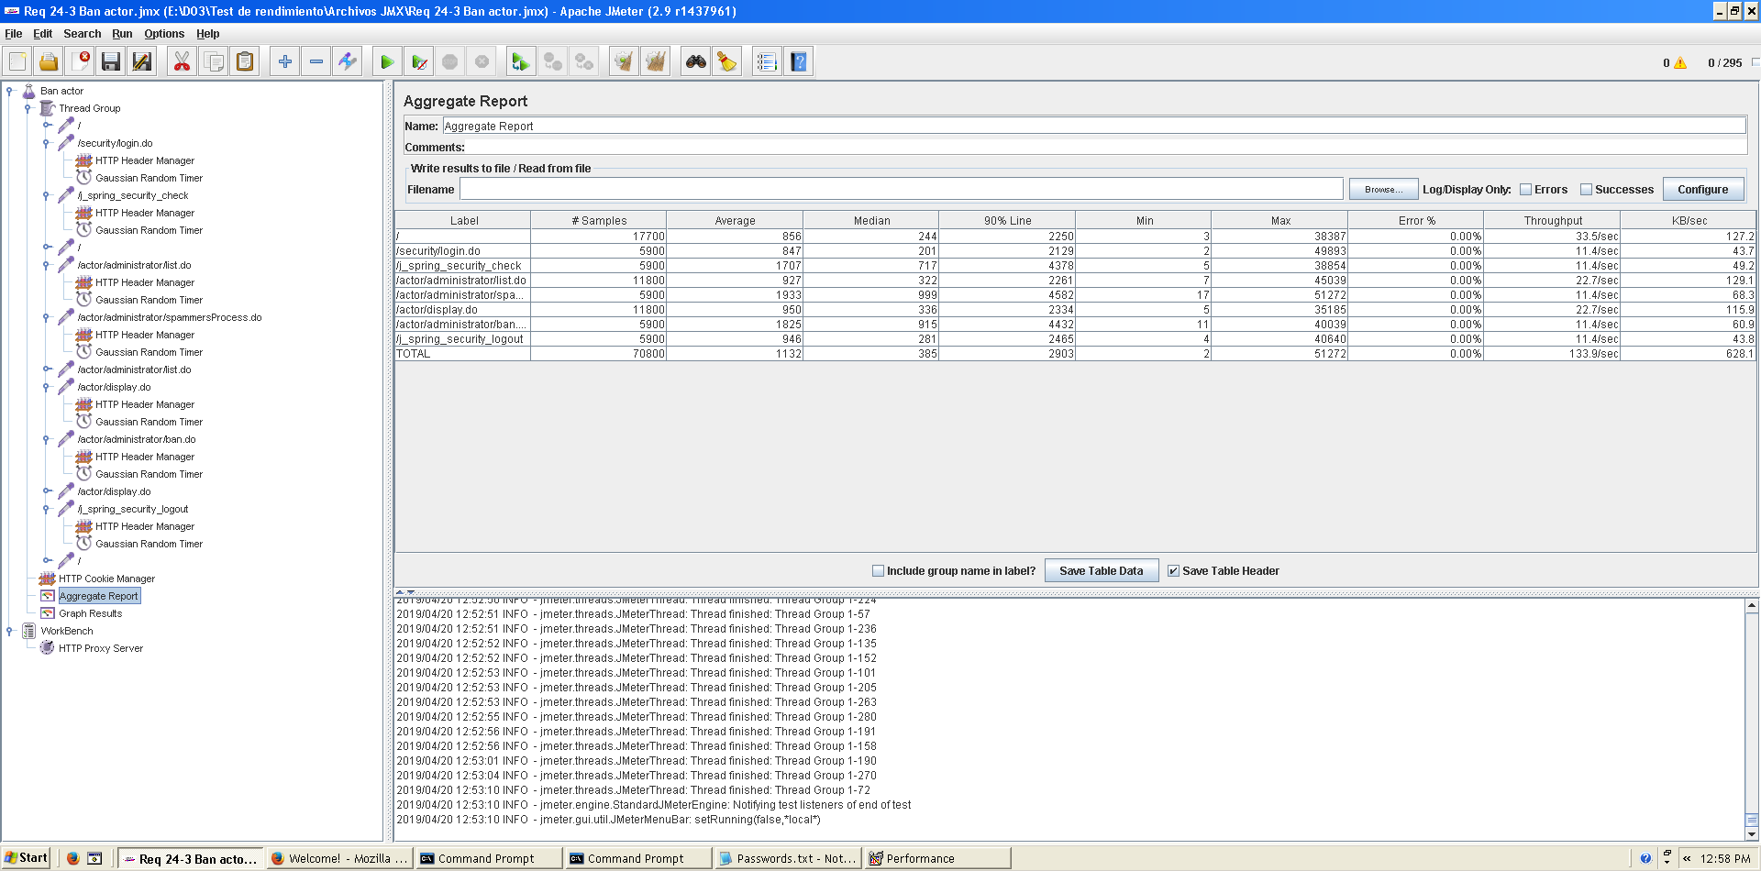

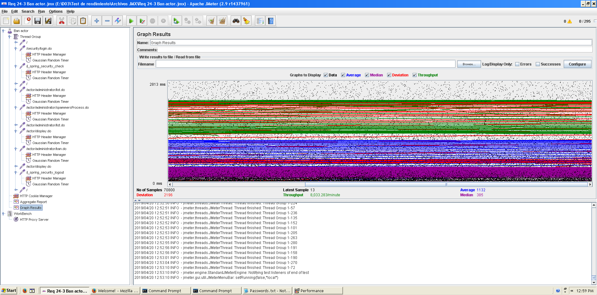

As we can see in the graph below, there is a bottleneck with the CPU. Probably we could improve the maximum workload of the application if we assign more processors to the virtual machine.

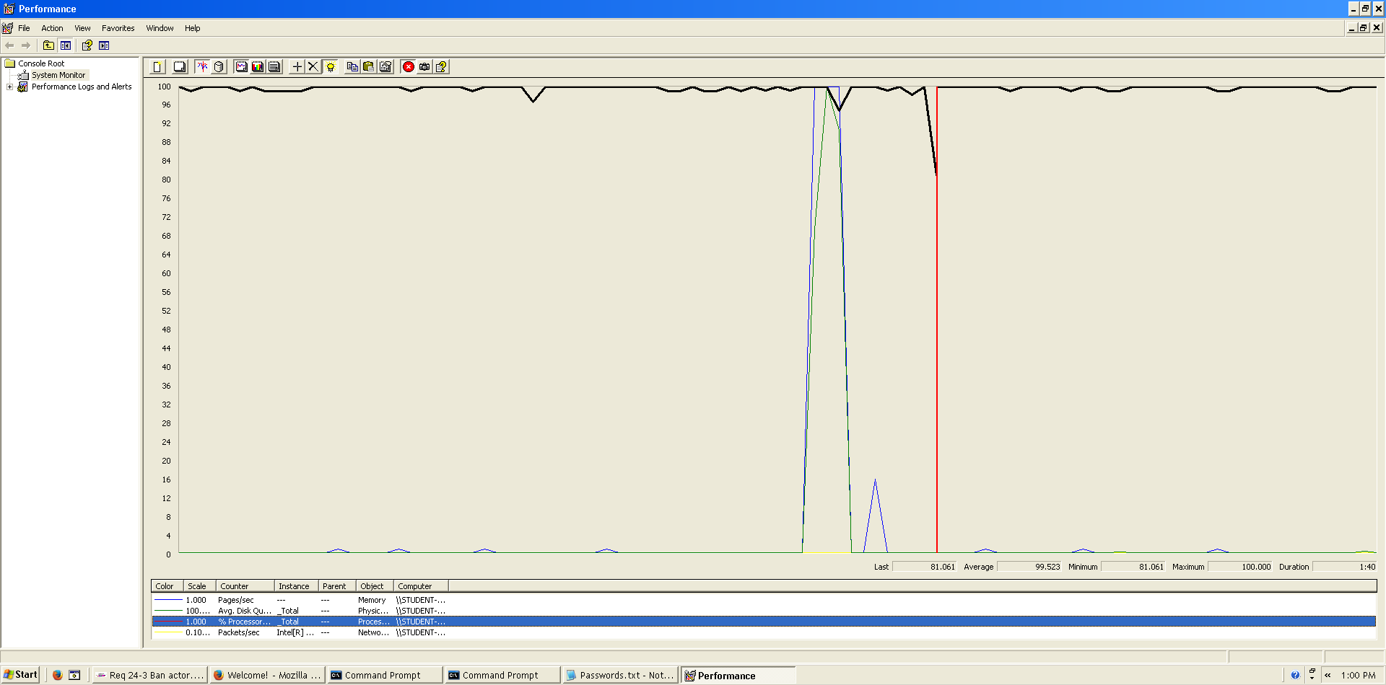

**Conclusion:** The maximum number of concurrent users supported by this test case is 285 and we could improve it by assigning more CPU’s resources to our system and refactoring our code to try to increase the number of concurrent users.

**Req. 24.4** – An actor who is authenticated as an administrator must be able to: Unban an actor with the spammer flag.

Technical details of the computer on which the test has been executed:

* Ram: 8,00 GB
* CPU: Intel Core i7-7700HQ
* Hard disk: 256 GB SSD + 921 GB HDD
* Network card: Intel(R) Dual Band Wireless-AC 3168

**Test case description**:

* The user logs in as an administrator.
* The user goes to actor list view.
* The user display the profile of actor who has banned previously.
* The user unbans the actor
* The user logs out the system.

**Maximum workload test case.** 400 concurrent users and 20 of loop count:

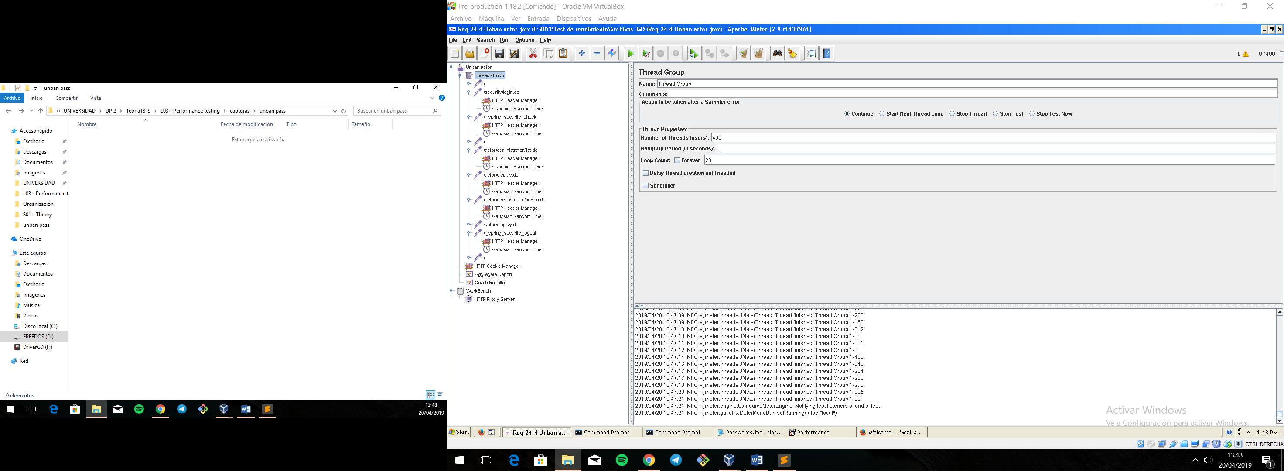

This is the maximum workload of the test case without any crash or excesive delay. As we can see in the picture below, we don’t have any errors and the average time per request is pretty acceptable.

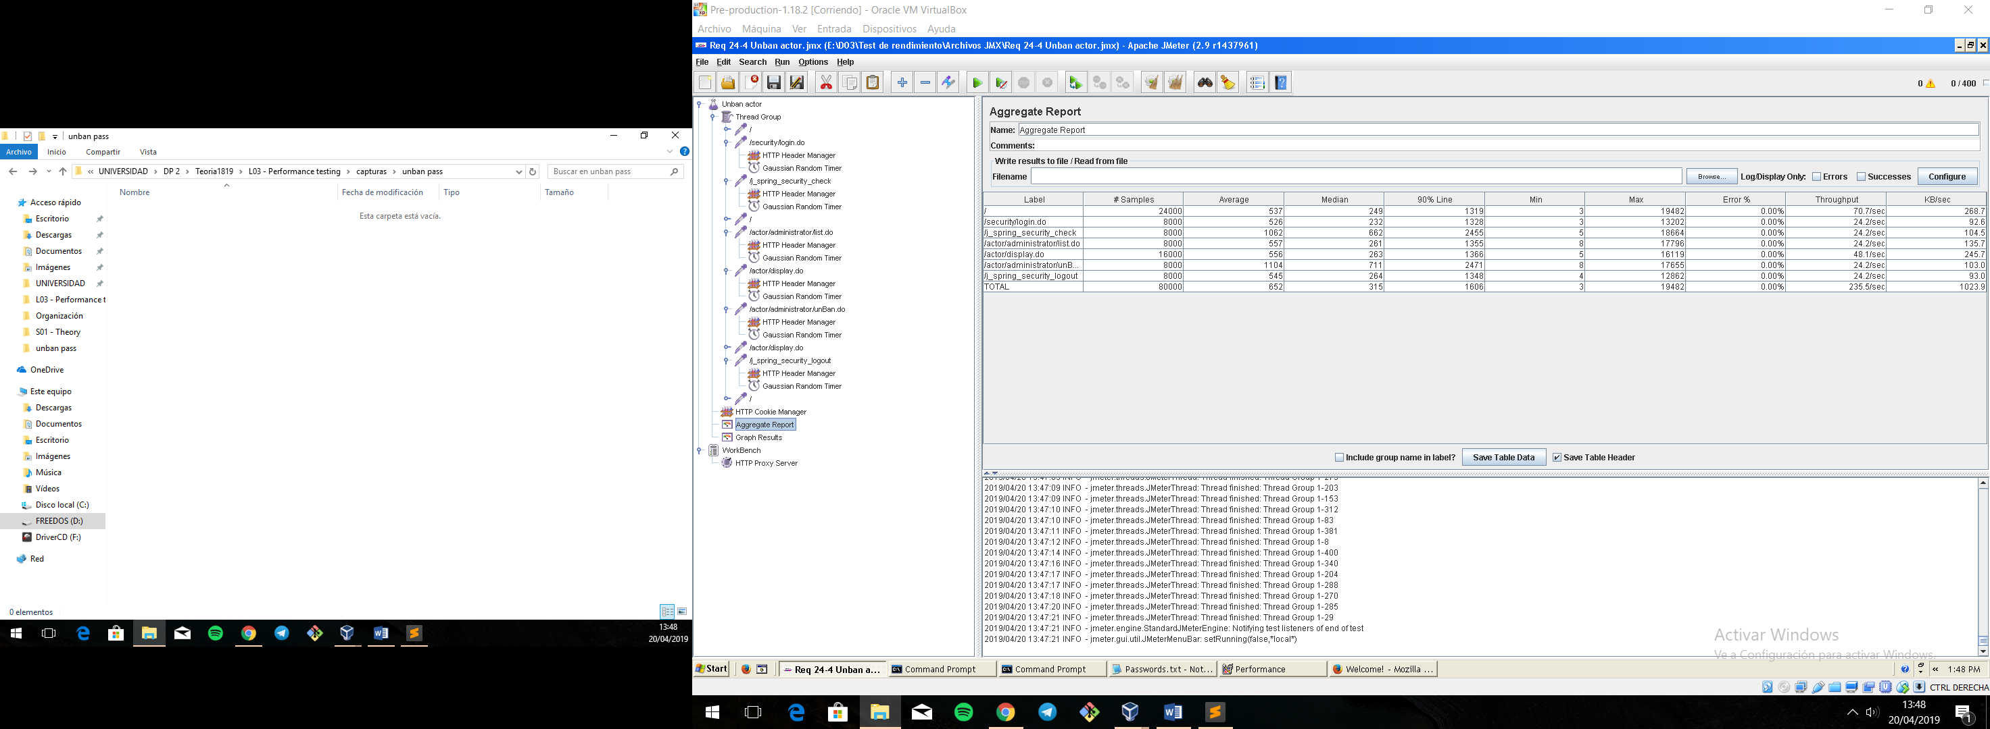

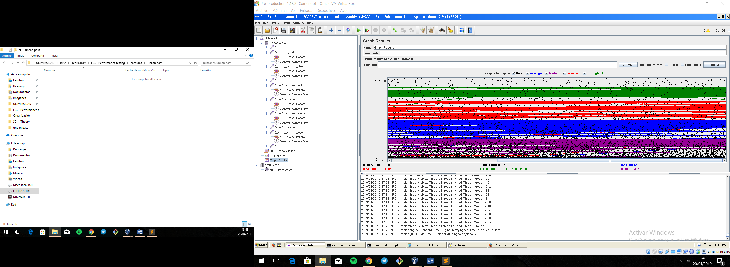

**Overload test case:** 410 concurrent users and 20 of loop count:

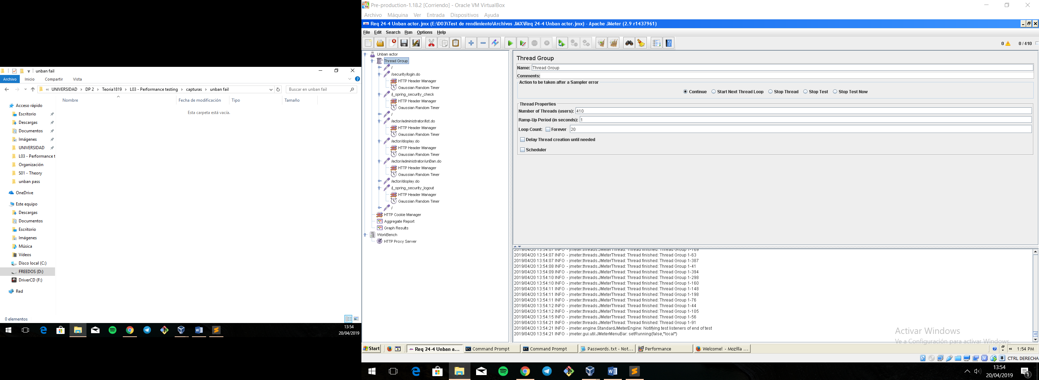

Even though the average time per request is still acceptable, it begins to produce some errors as we can see in the following picture. The errors are always the same: I/O exception (java.net.SocketException) caught when processing request: Connection reset by peer: socket write error This exception is not related with the implementation of our application, but with tomcat. The system can’t handle this number of concurrent users properly.

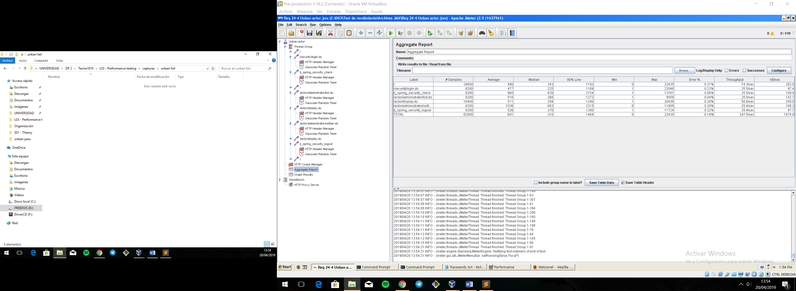

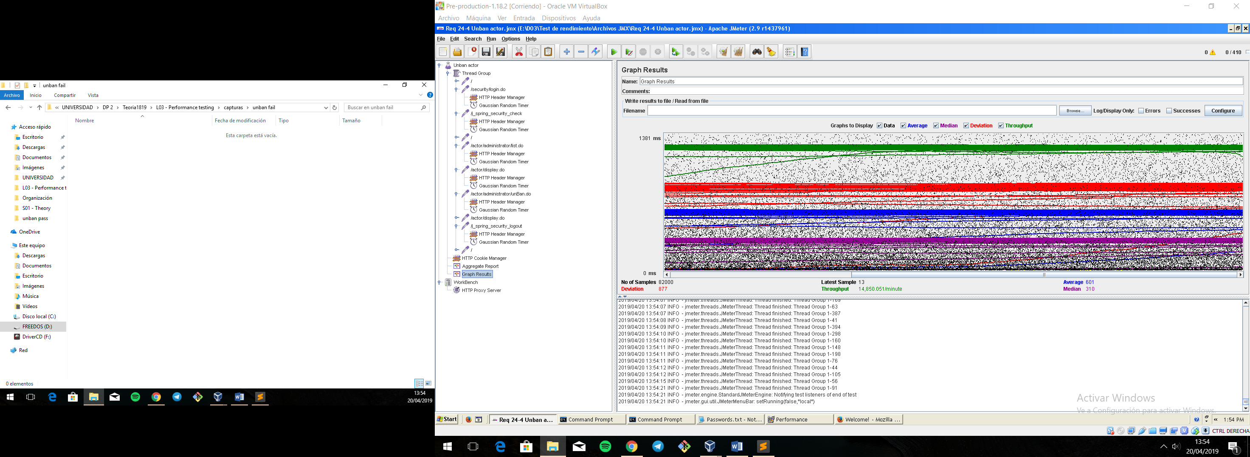

As we can see in the graph below, there is a bottleneck with the CPU. Probably we could improve the maximum workload of the application if we assign more processors to the virtual machine.

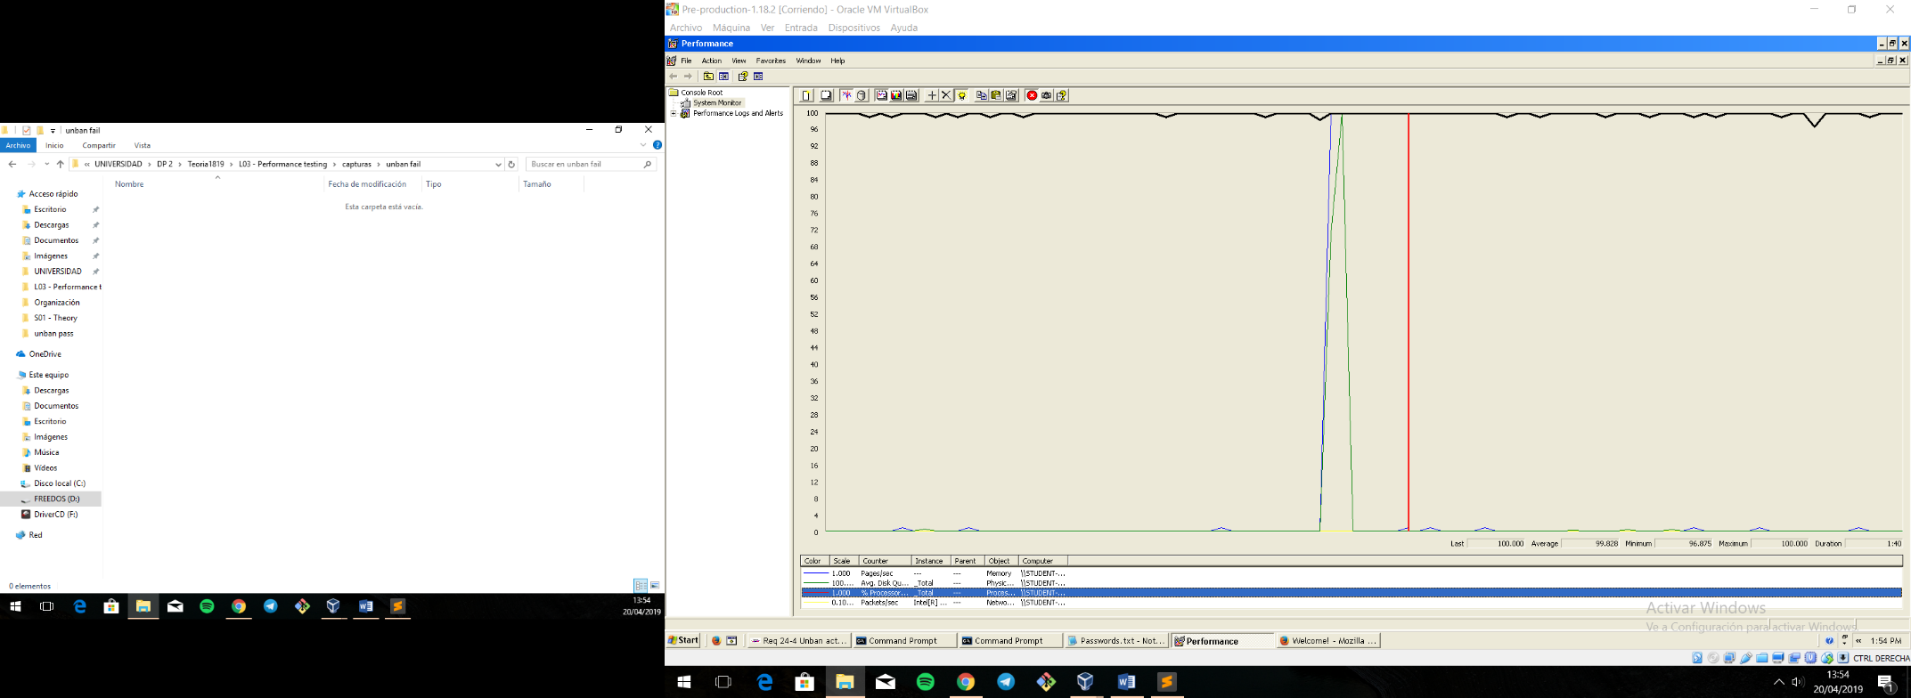

**Conclusion:** The maximum number of concurrent users supported by this test case is 400 and we could improve it by assigning more CPU’s resources to our system.

# CONCLUSIÓN

As we can see the system offers an acceptable performance that could be improved if we increase the resources of the machines.

We can verify that not all use cases admit the same number of users concurrently. They can range from more than 400 to 10 in case of handling the messages. The latter being the maximum number of concurrent users that our system supports. Although it seems a low number, it must be said that this use case is not widely used.